
K&M Tire

Accounts Receivable SOP
11/12/2025

Table of Contents
1. K&M Tire 4
2. Accounts Receivable 6
2.1 Transfer Items between Locations 6
2.2 Inter-Company Mail – Inbound 6
2.3 Inter-Company Mail – Outbound 8
2.4 Creating a K&M Transfer Invoice in MaddenCo 8
2.5 Phone Queue Status – Logging In and Out 10
3. Posting Payments 13
3.1 Cash Receipts Procedure 13
3.2 Cash Posting Procedure 14
3.3 Mobile Deposit 19
3.4 Petty Cash Reimbursement 25
3.5 Discrepancies 26
3.6 Payment Notes Procedure 28
3.7 Processing Mail Payments 31
3.8 Driver Authorizations (Phones) 41
3.9 Phone Call Credit Card and Check Procedure – Merchant 48
3.10 Phone Call Credit Card and Check by Phone Procedure 51
3.11 Credit Card Fee Processing 55
3.12 Misapplied Payment 57
3.13 Credit Card Posting Procedure 59
3.14 Pulling the Remittance File for Weblink payments 65
3.15 AR Pending Payments #868686 71
3.16 Weblink Payments Posting Procedure 72
3.17 Morning Reports 75
3.18 End of Day Reporting 79
4. Customer Inquiry 82
4.1 Allowable Adjustments 82
4.2 Customer Account Balance Inquiry 84
4.3 Discrepancies 85
4.4 Statements at Customer Request 88
4.5 Payment History at Customer Request 89
4.6 Order Entry Inquiry 92
4.7 Service Charge Waivers 93
4.8 DocRecord Review Procedure 94
4.9 Statement Day Procedure 95
4.10 Refund/Check Request Procedure 96
4.11 How to Tell if a Customer Account is Inactive 97
4.12 Issuing Refunds via Merchant Partners 98
5. General Ledger 102
5.1 Balance Individual Daily Deposit 102
5.2 Electronic Deposit Procedure 103
5.3 General Ledger Entry Procedure 106
5.4 General Ledger Entry Correction 108
5.5 General Ledger Inquiry Procedure. 111
6. Miscellaneous 113
6.1 Billing Employees for Concur Personal Expenses 113
7. Desktop Scanners 116
7.1 Desktop Scanner Cleaning SOP 116
7.2 Desktop Scanner Replacement Process 117
Appendix H: Revision History Tracking 120

List of Tables
Table 1 - Support Points of Contact Error! Bookmark not defined.
Table 2 - Acronyms Error! Bookmark not defined.
Table 3 - Glossary Error! Bookmark not defined.
Table 4 - Referenced Documents Error! Bookmark not defined.
Table 5 - Approvals Error! Bookmark not defined.
Table 6 - Revision History Tracking 120

K&M Tire




Accounts Receivable

Transfer Items between Locations
To save on postage, non-urgent, paperwork is organized in blue lockable bags and is sent on our daily transfer trucks.

Inter-Company Mail – Inbound
Items that arrive “from” the warehouse locations that needs distributed between the departments at corporate. The transfer drivers will deliver the blue bags to the Delphos Warehouse manager. The warehouse manager will deliver the bags to A/R each morning.

- All inter-company correspondence arriving from locations 2 through 88, as well as some daily route customer correspondence will be delivered to Accounts Receivable via the transfer system.
  - If the manager does not deliver the blue bags, call or walk down to the main office in the warehouse.

- Location 1 daily paperwork from the drivers are in a safe at the West Docks. Someone in A/R should go down and get the items out of safe by 8:15 a.m.

Sorting Papers That Arrive via Transfer
- Checks place with Payment Notes in alphabetical/numeric order by route code on a pile by location to be applied

- Cash place with Payment Notes on a pile by location to be applied

- Green/Blue Money Bags go to HR

- Log Books go to Logistics, along with intercompany envelopes labeled Logistics

- Invoices and Receipts go to Accounts Payable Clerk

- Receiving Reports deliver to Accounts Payable Clerk
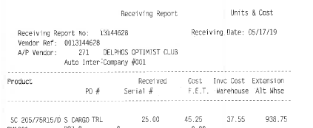

7. Bill of Lading deliver to Accounts Payable Clerk. (See below example)
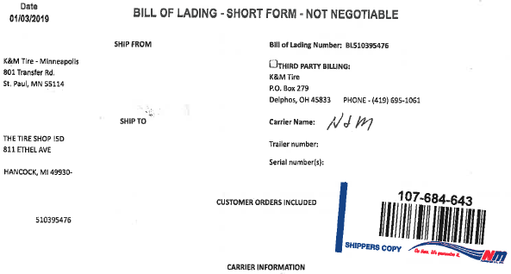

9. Pickup Summary Barcode Report and Daily Shipment Detail Report deliver to Accounts Payable Clerk.
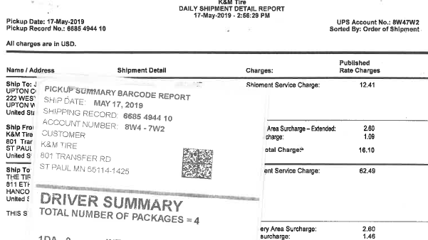

10. Intercompany invoices and intercompany credit invoices should be recycled.

Inter-Company Mail – Outbound
Transferring paperwork/items to other locations.

- All inter-company correspondence, as well as some daily route customer correspondence is on transfer trucks in order to save postage.

- Mail slot cabinets are located across from the mail machine. This serves as the inter-company mail station for all of corporate.

- At 4:00 pm each day, gather the contents of each of the slots and fill the corresponding location’s blue transfer bag.

- Transfer bags for location 15 set aside and do not put in plastic box.

- Transfer bags for locations 2, 4, 6 & 7 go into the white postal box.

- Transfer bags for locations 3, 22, 24 & 27 go in their own gray plastic box.

- Transfer bags for locations 31, 33 & 42 go into their own smaller grey plastic box.

- Transfer bags for locations 38, 43, 47, 48, 49, 51, 52, 53, 55, 56, 57, 59, 80, 82, 83, 84, 86 & 88 go into the large grey plastic box / or rolling black bag.

- Location 1’s route envelopes are to be placed in the corresponding route code boxes next to the Warehouse Manager’s office in the appropriate driver mailbox.

- Deliver the transfer plastic boxes to the Manager Office in the warehouse and the warehouse team will make sure the boxes are loaded on the correct truck.

- Place transfer bag 15 on the table marked Columbus next to pop machine where the box trucks park for loading.

Creating a K&M Transfer Invoice in MaddenCo
An invoice is created when a package or item is too large to put in a transfer bag. The invoice prompts the warehouse to load the item on the truck.

1. Log into MaddenCo
  - 1 - Tire Dealer
  - 8 – Point of Sale
  - 4 – Counter Billing

- Enter the Store Number to be used = “001” since the package is being shipped from Delphos.

- F6 to create a new invoice

- Enter the Customer Number which is the location number, followed by “0”.
  - Example – Loc 15 = 150
  - Example – Loc 24 = 240
  - Example – Loc 02 = 201

- F6 to generate an invoice number – Hit Enter

- Enter your Salesman number – Hit Enter

- On the product line type “Package” – Hit Enter

- Enter quantity “1”

- Enter Price “always be $0.00” – Hit Enter

- Key in the contents of the package and Hit Enter
  - Example – Clipboards

- F3

- F3

- Is Invoice to be closed Y/N (defaults to Y) Hit Enter

- Enter

- Your Invoice is closed

- Invoice will print out automatically to your default printer

- Tape it to the package being sent via transfer and deliver the package to the warehouse office and sit beside the grey plastic boxes that contain the blue bags.

Phone Queue Status – Logging In and Out
This SOP provides step-by-step instructions for logging in and out of queues within the 3CX system, ensuring proper queue management and user availability.
1. Logging In/Out of a Queue:
- Open Panel in the 3CX system.
  - 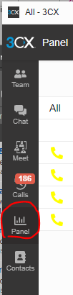
- Navigate to the “All” drop-down menu to locate the appropriate queue.
  - 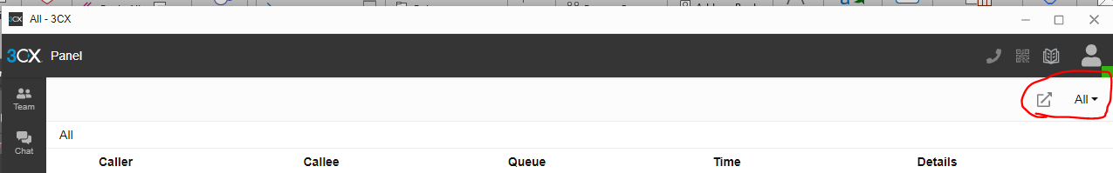
- The drop-down will display all queues the user is part of or has access to.
  - 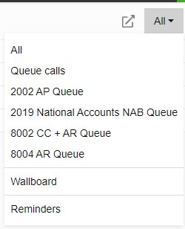
2. Viewing Logged In/Out Status:
- Use the interface to view who is Logged In or Logged Out of a queue.
  - 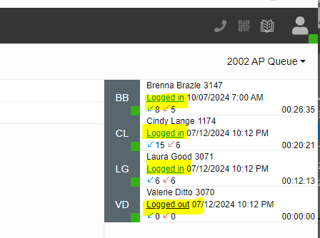
- The colored square next to each user’s initials represents their status:
  - Green for Available.
  - Red for Do Not Disturb.
  - Yellow for Away.
  - 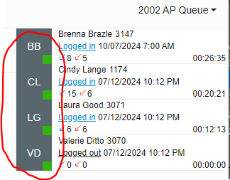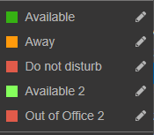
3. Status and Queue Impact:
- Changing status to Away, Out of Office, etc., will log a user out of the queue if they were previously logged in.
- If Logged In, changing the status to Away, Do Not Disturb, or Out of Office will automatically log the user out of the queue.
- To log back in, change the status to Available, and it will reinstate the user’s queue login.
- If Logged Out of the queue, changing the status to Available will not automatically log the user back in.
4. Logging In/Out Actions:
- To log in, click on the Logged Out button.
- To log out, click on the Logged In button.
5. Example Scenario:
- If a user, e.g., Valerie Ditto, is made Available, it does not automatically log her into the queue.
  - However, if Valerie logs into the queue and later changes her status to Away, she will be logged out of the queue.
  - When Valerie changes her status back to Available, as long as her original status was Logged In, she will be available in the queue again.
  - 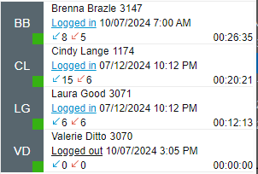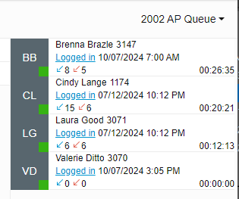
  - 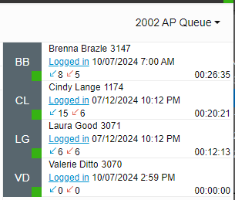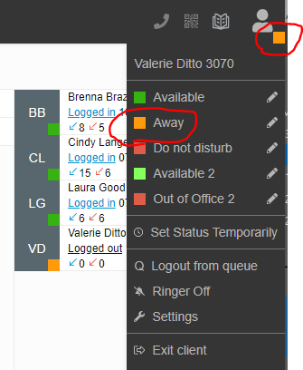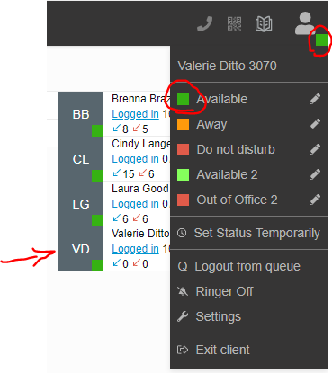

6. Queue Manager
a. Accounts Receivable and Credit & Collections Managers & Team Leads are given the entitlement of “Queue Manager” by IT which allows them the ability to change anyone’s status in that specific queue.

Posting Payments

Cash Receipts Procedure
We receive several different types of payments from customers on a daily basis. They include Checks/Mobile Deposit/Cash/Credit Cards and Web pay.

Payments are applied through the C&C Dashboard or via the Intranet and detailed instructions for each application type are listed in each section.

The first set of instructions are how to enter payments into Madden Co in case required to do so. Please do not utilize Madden Co for processing payments unless checking with your direct Manager or Supervisor.

General Madden Co Applications (Only as needed with management approval)
- To record payments received from customers in Madden Co.

- Open Madden Co
  - 1 – Madden Co Tire Dealer System
  - 1 – Tire Dealer System
  - 1 – Accounts Receivable Menu
  - 3 – Cash Receipts

- “Enter Store Number to be Used” = ‘001’ always because we are posting payments from corporate/Delphos location where we physically are.

- F6 to add new payment.
  - Enter customer number.
  - Select F5 to verify the name matches the name on the check received from the customer.
  - Enter check number, or the date followed by cash (ex: 02/21 CASH)
  - The system will scan the last 30 days of history to prevent a duplicate check number entry.
  - Enter (check or cash) dollar amount received.
  - If a discount customer (view share drive F:\Accounts Receivable\Shared\List\Customers Receiving Cash Discounts) Enter discount amount; plus add a “d” after the check # in order to better identify discount payments.

- Select F9 to add a memo such as notes concerning payment arrangements.
  - If payment does not match remit give an explanation of how you posted the payment.
    - Example:
      - Posted per credit and collections.
      - No remittance provided, applied payment to the oldest invoices.
  - Enter to exit the application screen.

- Select invoices to pay.
  - Mail payments follow the Processing Mail Payment procedure.
  - COD payments follow Payment Note Procedure

- F3 to end payment.

- Repeat steps 4. – 7. Until all (mail and COD) payments have been posted.
9. Verify all entries are in “Ready” status to ensure all payments process overnight in Madden Co.
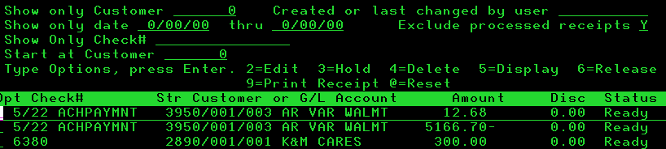

- Data entry errors that create an under payment have an ‘Out of Balance’ status.
In order to correct this, follow these steps:
  - Put a ‘2’ in the field next to the line to edit.
  - Put a ‘5’ in the field next to every line to view each until the discrepancy is found.
  - Put a ‘2’ in the field next to the line to edit.

- Follow Balance Individual Daily Deposit Procedure

Cash Posting Procedure
Purpose: The purpose of this SOP is to demonstrate how to apply cash payments on customer accounts.
Background: Several of our COD customers chose to pay Cash directly to the driver when a delivery is made. Each location then deposits these Cash Payments directly into the bank. The Accounting Team records all Cash deposits received in the bank ledgers and the Warehouse Manager/Assistant Warehouse Manager is responsible for sending AR information on how to apply those payments as deposits are being made.
Note: Cash Deposit details will come via email for each Location: Emails should come from the Warehouse Manager or Assistant Manager and will be printed by whomever is covering the email folder.

- Verify that each deposit is in K&M Inc. (F:\Accounting\Shared\Bank Ledgers\K&M Inc.).
- Verify the cash deposit is for CHASE (1013-1), WELLS FARGO (1012-1), OR PNC (1016-1)
- Highlight your deposit and add the MaddenCo date to the spreadsheet.
Note: The MaddenCo date is the date you are entering the payment, generally today’s date.
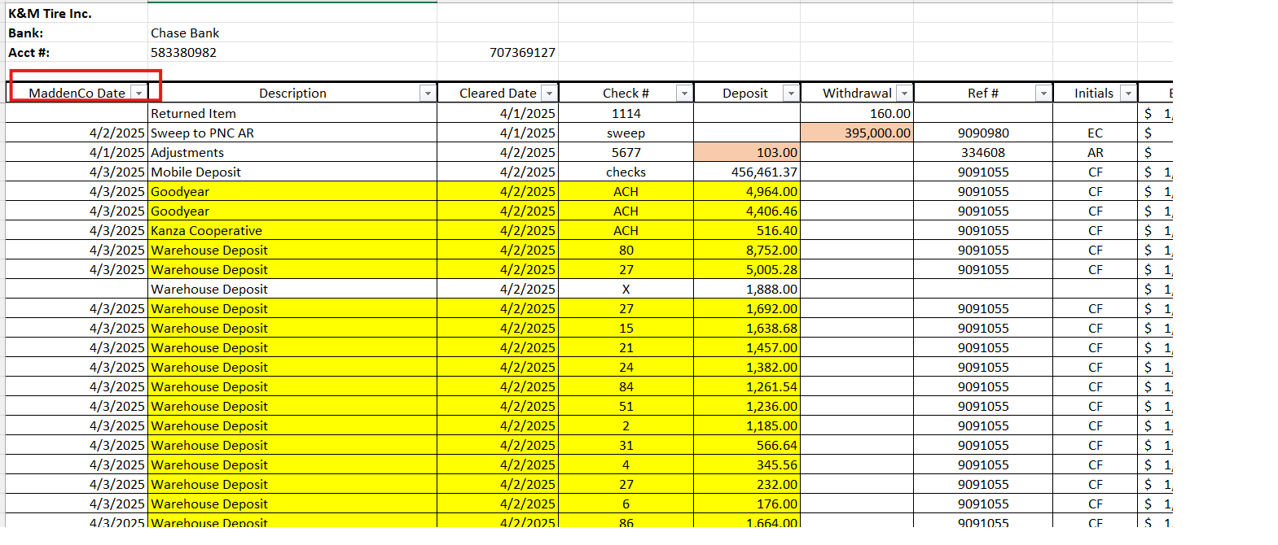

- Open the Intranet – Accounts Receivable – Cash Payments on the left-hand side.
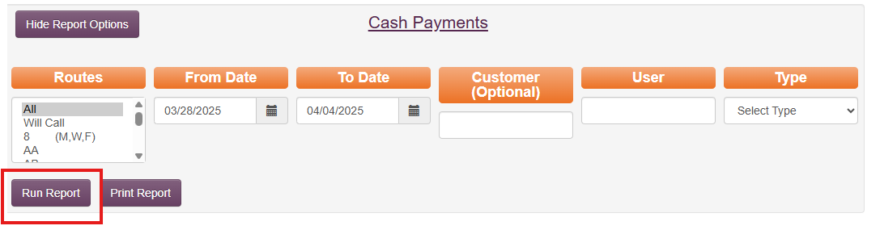
- Click on Run Report
- Click on Exceptions Tab
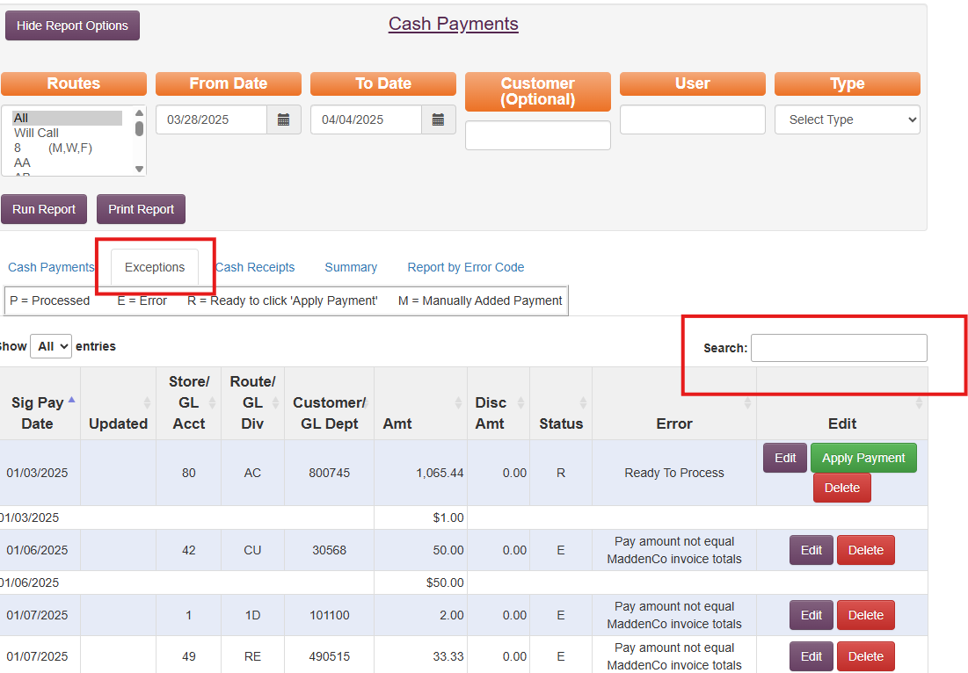
- Under “Type” select the bank you are entering. This will populate in MaddenCo later under Step 12.
Note: You will need to update the bank under Type every time you enter a new location.
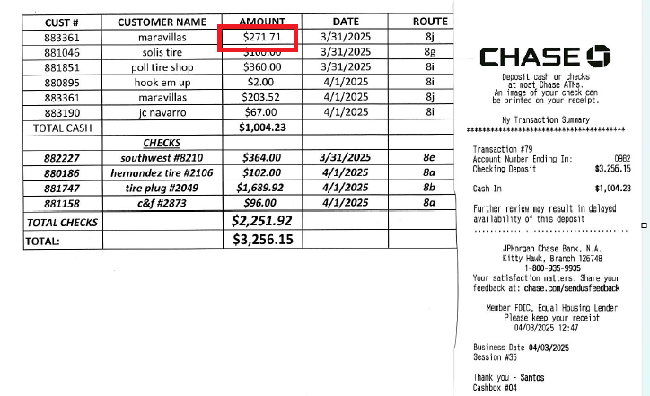
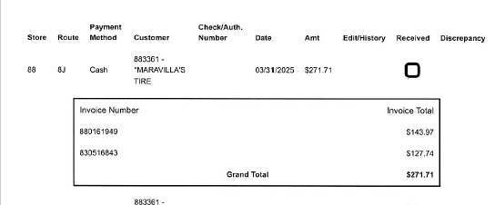
- In the Search bar right above the “Edit Option”, enter the customer number from the Cash email
received from the Warehouse.

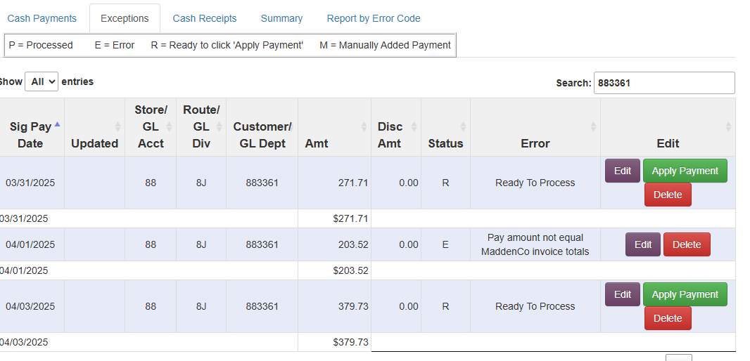
- Find the amount for your specific deposit and clink on the purple Edit box. (See box above.)
- A pop up will appear then find the invoices that are being paid by the deposit – click on the purple arrow to the right of the invoice amount to select the invoice for payment.
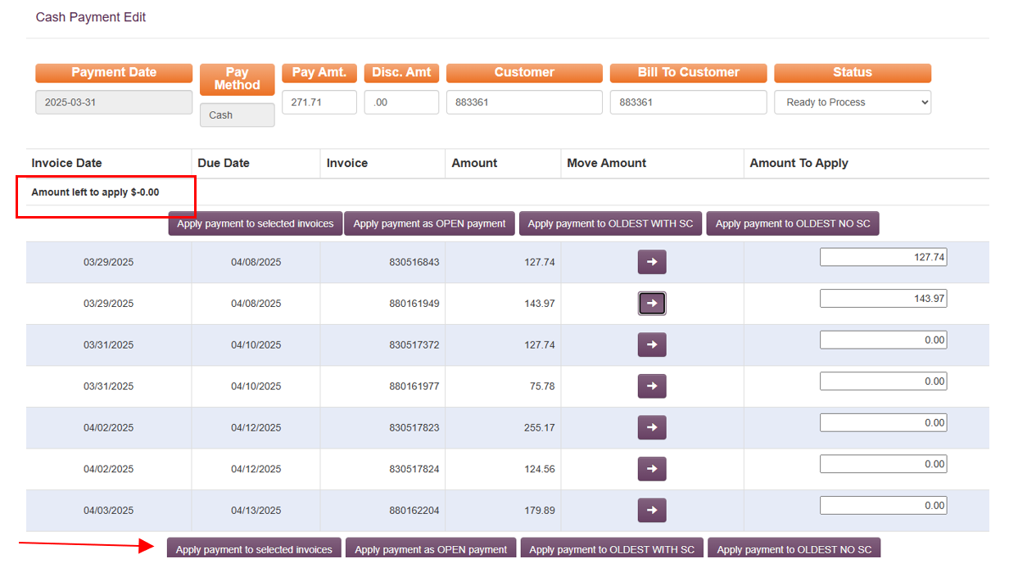
- Verify that “Amount Left to Apply” is 0.00.
- Click on ‘Apply payment to selected invoices’ to finalize the payment.
- Continue this process until all of your payments have been processed.
- Log all location deposits on your daily task tracking sheet. (See screenshot below for example). Note: Each cash deposit should count as 1 under # of Checks. (See screenshot in Step 5, which shows 10 entries for location 88.
  - Your cash will populate into MaddenCo with the bank tag (CHC = Chase, WFC = Wells Fargo, PNC = PNC, FFC = First Financial).
- Verify that all cash balances to MaddenCo. This total should match your daily sheet and should match the total you highlighted on K&M Inc (completed in Step 1).
  - 1-Tire Dealer System
  - 1-Account Receivable
  - 3-Cash Receipts
  - Store Number is 1
  - Put your name under “Created or Last Changed by user”
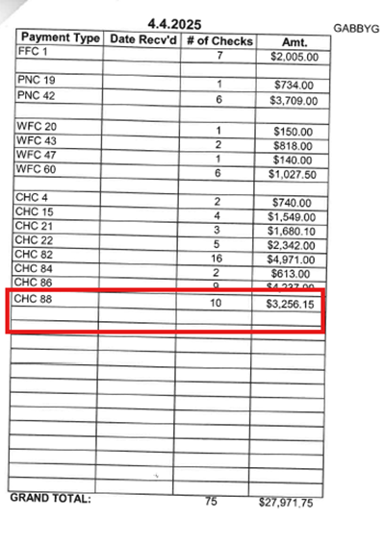
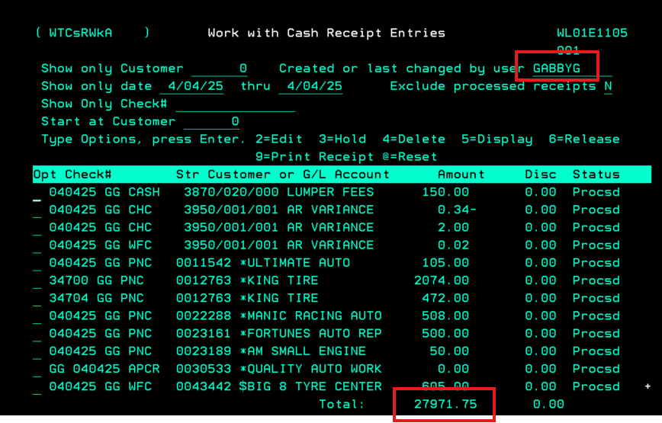
- Give to AR Team Lead for End of Day Processing.
- Once all cash has been posted, you will need to go through all Warehouse Payment Notes to make sure there is no missing cash. To do this follow the Discrepancies SOP.

Mobile Deposit
When our drivers are delivering products to our customers, many customers are COD, or Cash on Delivery. When the Driver receives a check for payment, they log that information into payment notes and makes a deposit via JP Morgan Chase Access on his phone. When Payment Notes and the Check information line up, they are deposited automatically and don’t need to be touched by the AR team. However, we do end up with Exceptions, either the customer is making a payment on their account, a payment note is not correct, or Chase Bank sees it as a duplicate. These exceptions need to be pushed through daily as part of the AR Team job responsibilities.

- Log into the Intranet –

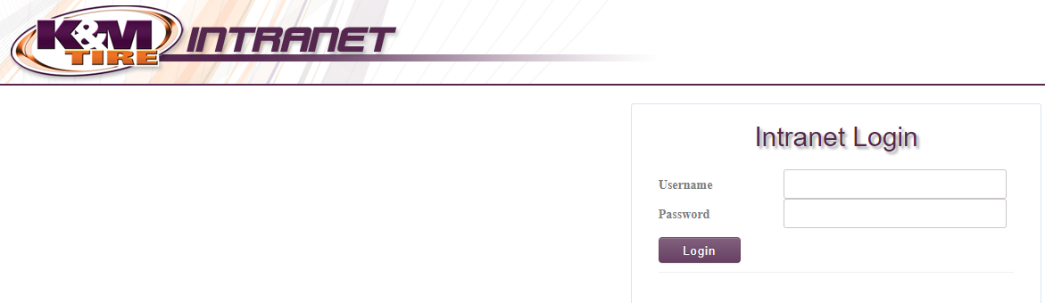
- Select AR Mobile Deposits –
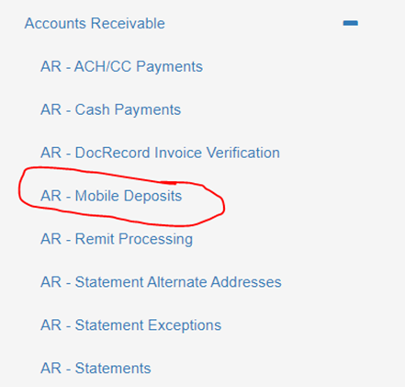

- Choose your date range and then select ‘Run Report’ –
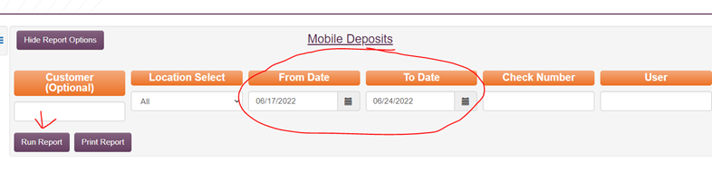
- Click on the Exceptions Tab
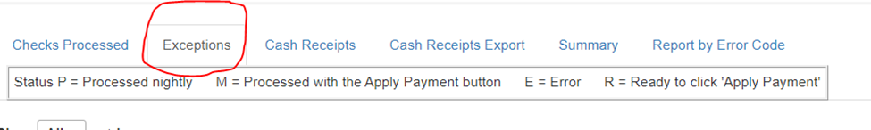
This is going to bring up all the checks that will need to be processed for the day.

- In a separate tab, Log in to JP Morgan Access.
- https://access.jpmorgan.com/jpmalogon?TARGET=$SM$https%3a%2f%2ftssportal.jpmorgan.com%2fpp%2fpp%2fWSQ%2flanding%2fclassichome&brand=jpma)
- See below for log on screen.
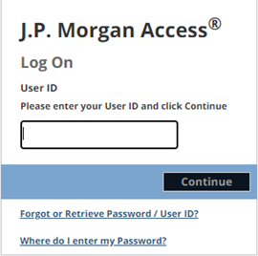

- Enter your user ID – Hit Continue.

- Check off the site phrase for user, type in password, token code (Administrators only) click log on (token code is supplied by Chase)
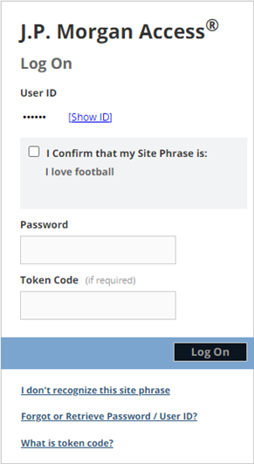

- Click the Receivables Tab:
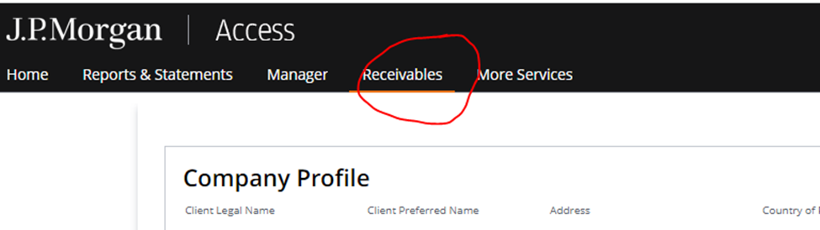

- Click OK at the bottom of the Receivables Notices:

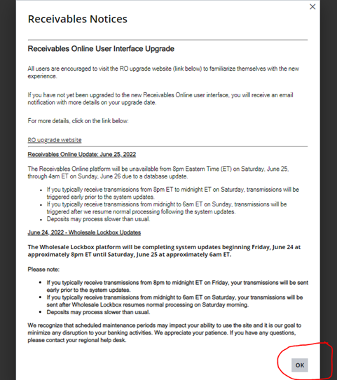

- Enter the Transaction value date range and the amount in the From and To Column:

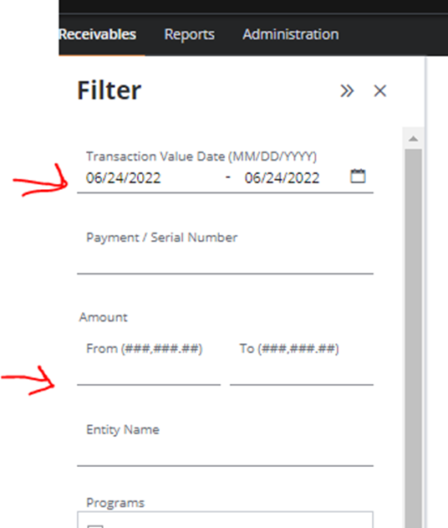

Example – Looking at this check for $343.98.

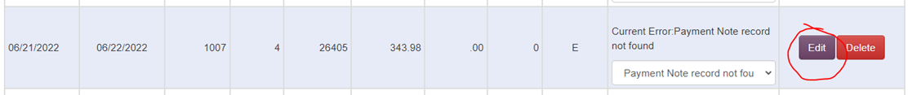

- Date ranges entered 6/20-6/23 and the amount TO and FROM total $343.98 in both fields. It pops up this check information.

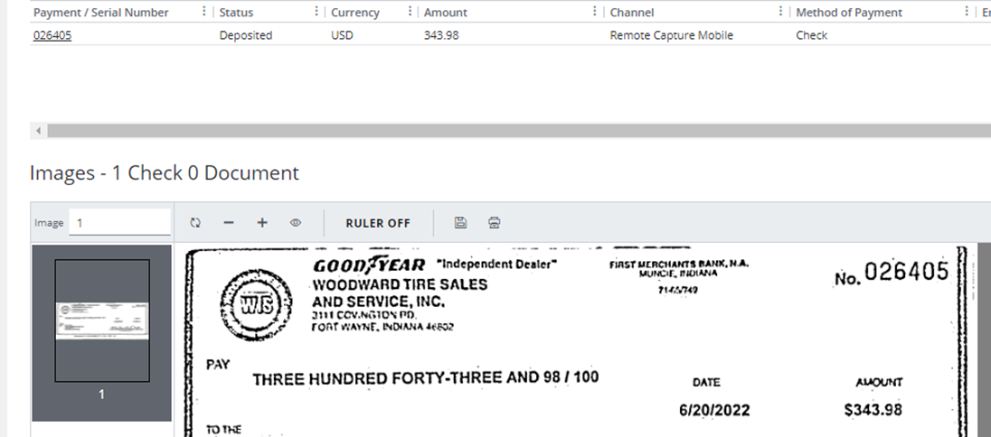

- The top will tell you the User that Scanned the check:

- Based on this information – You will have an idea of the customer’s location. Type the customer’s name in the Dashboard – It will pop up the customer information.
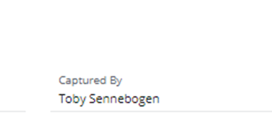
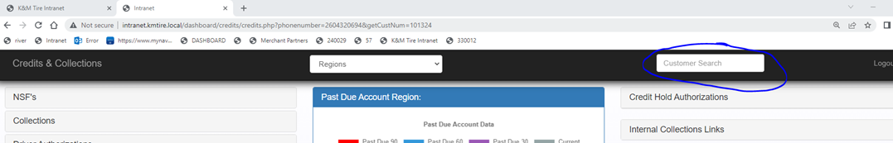

- This brought up customer # 101324. If you scroll down to that date range, you can see they have some open invoices in the date range.

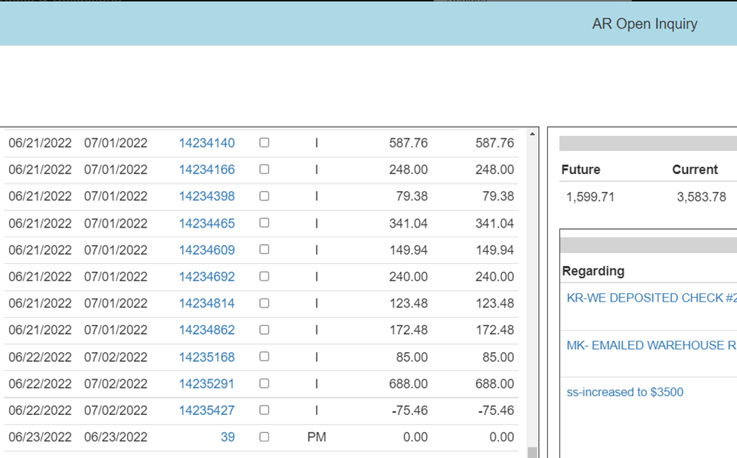

- Bring up another Internet Tab and open a new K&M Intranet Page, go to Payment Notes. Under the Warehouse. For this account, select location #1, the start and end date and the customer # - Also select ‘Not Received’. Click SEARCH.

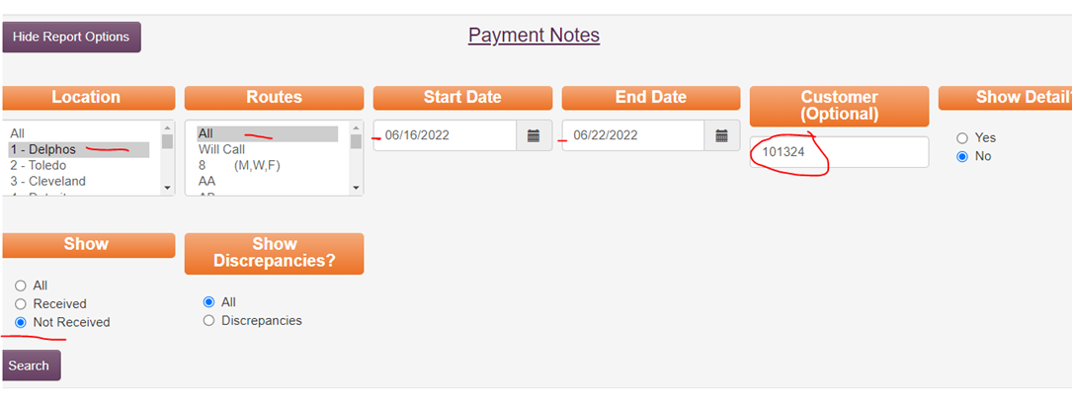
- The Check information in this example is NOT entered into payment notes. (If the check is listed in Payment Notes, it has the check # and the amount listed).
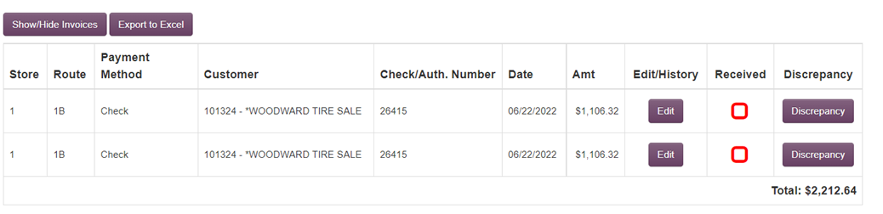

- Go back to your exception on Mobile Deposit Exceptions - Change the error to Payment Notes that have not been entered and then select Edit.
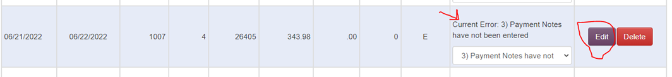
- Add the customer # and then the customer’s information will be populated for you. Apply the check to the invoice that matches if there are no payments notes listed.
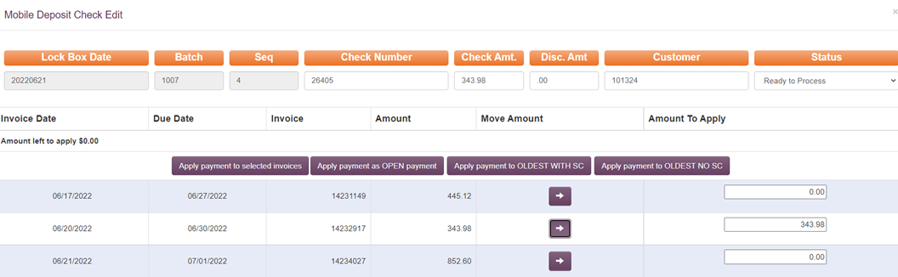
- Then chose Apply Payment. A box will pop up that asks for Verification – Double Check and click OK. Another box will pop up to let you know that it was applied correctly. Click OK. Payment has now been successfully applied to the customer’s account.
- Then chose Apply Payment. A box will pop up that asks for Verification – Double Check and click OK. Another box will pop up to let you know that it was applied correctly. Click OK. Payment has now been successfully applied to the customer’s account.
  - Payment notes have incorrect information – Use this if the check amount does not match the total due or the check number is incorrect.
  - Chase has deposited with incorrect information – Use this if Chase has a different amount deposited than what is on the check. These will also need to be emailed to the Staff Accountant for correction with Chase.
    - If the amount of the difference is over/under $10, process the check as is and make an adjustment to 3950-1-1. Use the reference JP Variance.
  - Payment note has not been entered – Use this if there is no payment note information for the COD customer.
  - Payment notes show duplicate entry – Use this if there are more than one payment notes for the check.
  - Payment notes check doesn’t match invoice total (Refused or Credit Applied) – Use this if a credit memo is needed to clear the invoice completely.
  - Payment notes Charge Customer (ROA option for depositing) – Use this if the customer is a charge account and is just making a payment.
  - Check looks correct. Some checks will not deposit – Use this option if you can’t find any reason for the check to not have processed automatically.

Petty Cash Reimbursement
Purpose: To establish a standardized process for reimbursing petty cash expenditures.

- Petty Cash Reimbursement Process:
  - The warehouse manager will reimburse petty cash using customer cash on hand.
- Documentation Submission:
  - When submitting the deposit slip via email to AR, the warehouse manager must include the petty cash form and receipts for the reimbursed amount per Operations Petty Cash SOP 6.3.

Note: Petty Cash Reimbursements should only be for Fuel and should be used minimally by each warehouse. If we see reimbursements for expenses other than fuel, please forward the original email to the Director of Operations or the VP of Operations for review.

- MaddenCo Process:
  - Open MaddenCo:
    - 1 – MaddenCo Tire Dealer System
    - 1 – Tire Dealer System
    - 1 – Accounts Receivable Menu
    - 3 – Cash Receipts
- Store Number Entry:
  - Enter Store Number: Always use ‘001’.
- Adding a New Payment:
  - Press F7 to add a new payment.
- Check Number Format:
  - Enter the check number as follows: MM/DD/YY CF XXC [your initials] [bank location cash]
    - Bank Location Codes:
      - WFC: Wells Fargo Cash
      - CHC: Chase Cash
      - PNC: PNC Cash
- Check Amount Entry:
  - Enter the check amount followed by a minus sign (e.g., $42.00-) to deduct from the daily cash deposit.
  - The full customer payment will be applied, and the cash amount will offset to GL account 5410.
- Discount Amount:
  - No discount amount.
- General Ledger (GL) Account Entry:
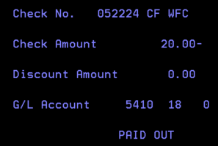
  - Enter the Petty Cash GL as 5410 XX (XX = location number).

- Finalize Payment:
  - Press F3 to finish the payment.
- Record Keeping:
  - Place the petty cash form and receipts with your daily tracking paperwork for record-keeping.

Discrepancies
This process is followed to identify and resolve open balances on COD deliveries.
- Go to payment notes on the intranet, pick the location you’re working on, all routes. State date should be the first day of the previous month and the end date should be 3 business days prior to today. Show “Not Received” and click “ALL” under discrepancies.
- For example, if today is December 23, 2021, and reviewing Toledo:

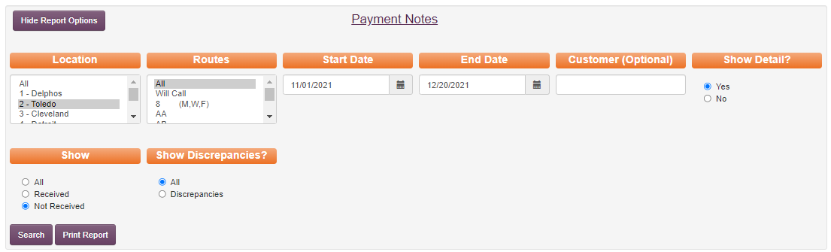
- Click search and every payment that is unchecked will appear.

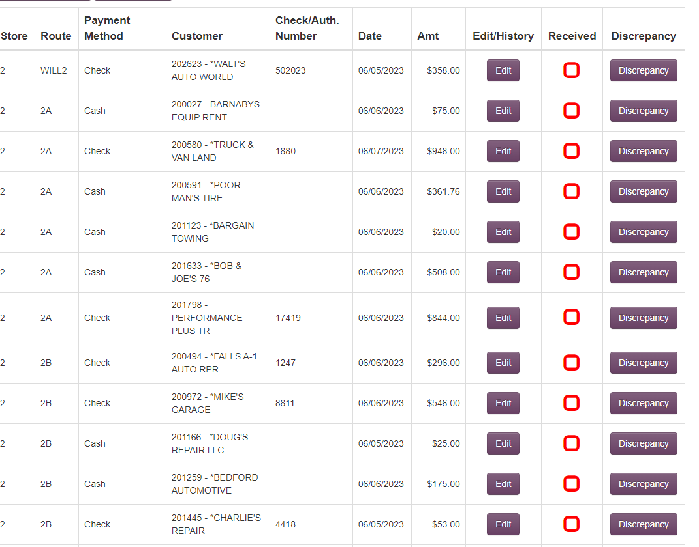
- Sort this list by payment method, then by date.
  - CASH- Should be at the top.
    - After applying offsets, If there are any that have no credits for rejected/short tires- hit discrepancy and specify that a credit may need issued.

    - For the rest of the unchecked cash (with amounts). If it should have been applied already, check the customer balance screen to make sure it hadn’t been applied already.

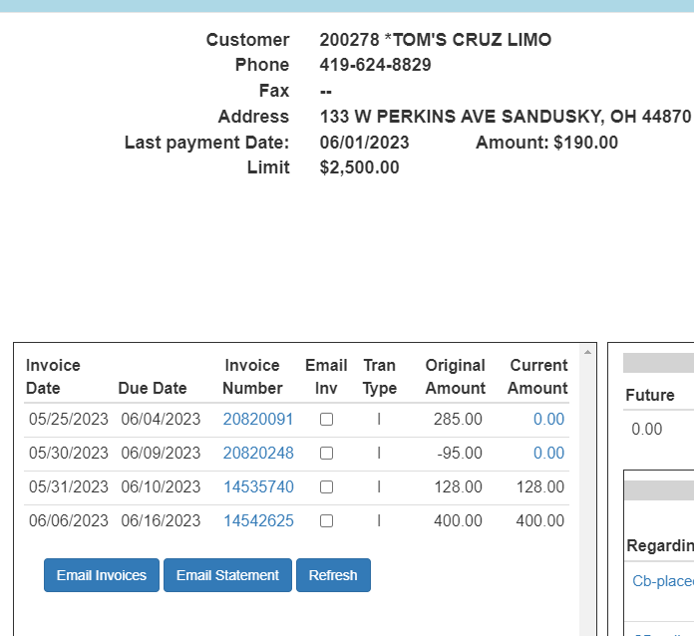

    - Sometimes customers will round up, leaving a small credit. In this case, check off the payment note and move the small amount to variance.
    - If no cash has been applied, make sure that the invoice is signed and doesn’t say rejected/short before hitting discrepancy.
Note: “Cash not yet received, please send for processing.”
  - Checks- According to your end date, the location should have had at least 2 days to scan their checks into the Chase app. Before clicking the discrepancy button – Review the following to ensure checks aren’t getting deposited twice.
    - Mobile deposit exceptions- was he check scanned but didn’t match payment notes or the invoice delivered.
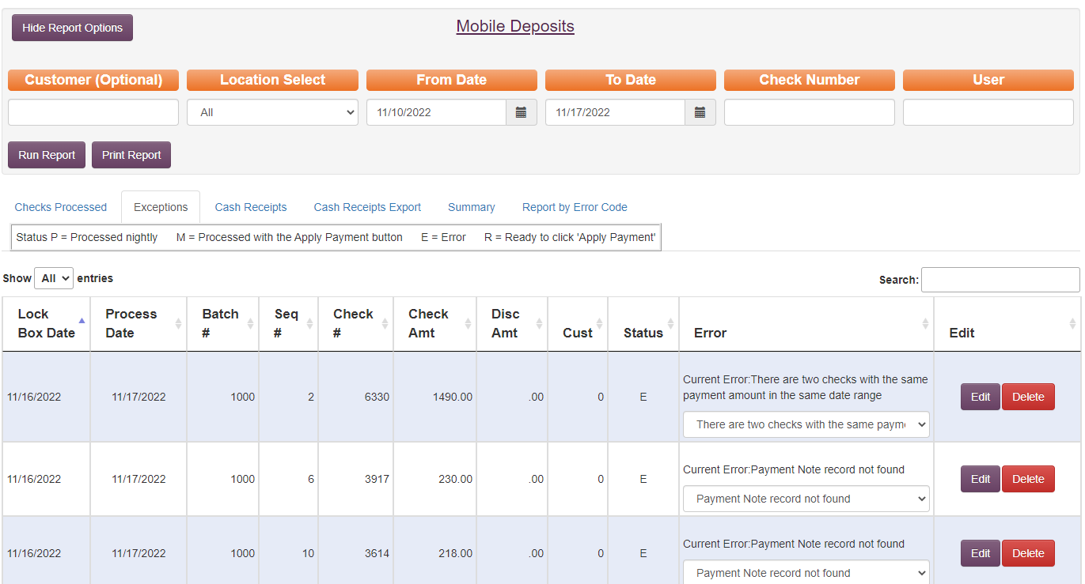

    - Review cash receipts if the check was received in the current month- check to ensure the check wasn’t deposited. If the check has been deposited review to see why its showing up as not received. In Maddenco- 1. Tire dealer system, 1. Accounts Receivable, 3 Cash Receipts, Store Number is 1, you can enter the customer number and put an” N” on “Exclude Processed receipts”. This will bring up all payments processed for that customer.

    - Look up the check number if the check was received in the prior month-look up the check number on the customer account number or look up the check number to see if it has been applied to an incorrect account. 1. Tire Dealer System, 1. Accounts Receivable, 8. Customer Inquiries, by reference #.

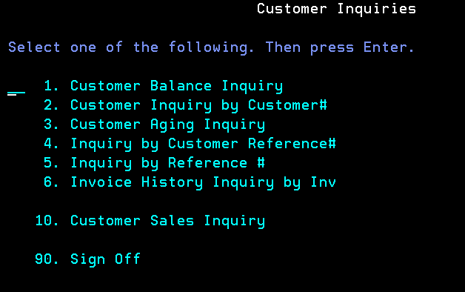

    - If the check cannot be found in the previous 3 spots, hit discrepancy to have the warehouse re-scan it. Add note: check not in mobile deposit, please rescan.
      - If the Warehouse has already sent to corporate the checks for the month you are reviewing, the original check must be found and applied to the account manually.
  - Credit card/ Credit Department /prepaid.
    - Credit cards- these are payments that are made through Merchant Partners. If these payments are checked by phone, it could take 3-5 days to process.
    - Credit Department- These are usually driver authorizations where credit should be applied.
    - Prepaid- These are usually employee purchases. Verify that the payroll deduction is being taken out by viewing the employee's account and then they can be marked off.
- Every location should be reviewed weekly. Discrepancies that are “hit” should be followed up on every 2-3 business days until resolved. If you do your discrepancies on Monday you should do them again on Wednesday and then again on Friday.

Payment Notes Procedure
The route drivers collect payment from the customers and documents the transaction on their phones to Payment Notes. This procedure is used to confirm where the payments are to be posted in MaddenCo through Cash Receipts.

Applying Payments
- Go to the K&M Intranet
- Go to the left-hand side and click Warehouse Department (WH)

- Select (Warehouse) WH – Payment notes.
  - Select the location.
  - Route should always be set to “all.”
  - Select the Start and End dates- based on the dates of physically received payments.
  - Show Detail – check yes- To show invoice detail for each payment.
  - Show – “Not Received”- Payments not yet received and still need entered.
  - Click on the Search box- To bring up all of the selected info/payment info.
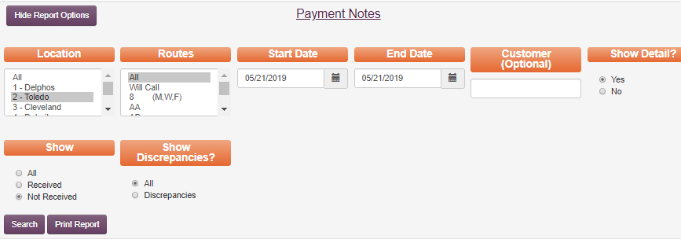


- Click “Show/Hide Invoices” to bring up the invoice details.
  - Open Maddenco, apply COD payment per what is received from the location. Payments made by check apply exactly what is written out or the dollar amount on the check.
- Apply payment in MaddenCo (see Cash Receipt Procedure on applying payment)
  - Verify the customer’s number/name in Payment Notes so it matches the check received.
  - Verify the check number matches – edit if needed – make sure to put a reason each time an edit is made.
  - Verify the dollar amount – edit if needed – make sure to put a reason each time an edit is made.
    - Example:
      - Received $400 instead of $1004.00.
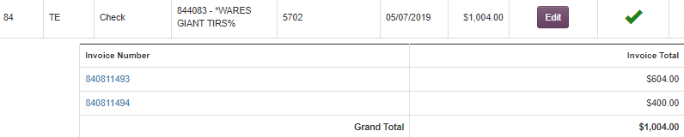

- Review all the invoices listed under each entry is paid in full.
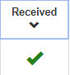
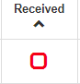
a. If all invoices are paid (as shown above) in full click the Red Box. It will then show as completed with a green check mark.

- If all invoices listed under each entry are “Not” paid in full (as shown below), do not click the Red Box and mark as received.
  - The reason invoices may not be paid in full would be due to tires were rejected or not signed for. Payment received will typically short pay these invoices, and a credit will be applied or created to offset the difference.
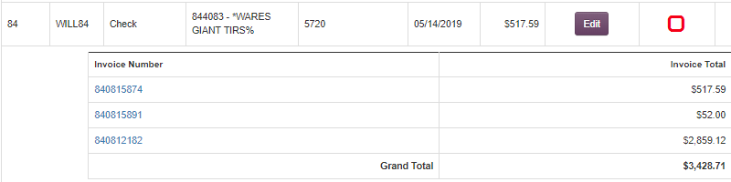

Reviewing Payment Notes & Discrepancy
-This is to follow up with payments that were not paid in full, from previous days.
- Review the transfer schedule for each location.
  - example Location 4 takes 2 days to arrive in Delphos through transfer.
  - example Location 80 takes 5 days to arrive in Delphos through transfer.

- Go to the K&M Intranet
- Select payment notes.
- Choose location reviewing.
- Choose date range (based on transfer schedules)
- Click “Show detail” = Yes
- Select = Not Received
- Discrepancies select all (this will pull all invoices that were short paid)
- Pull up MaddenCo (see Customer Account Balance Inquiry) and compare Payment Notes with MaddenCo to see if the invoice is paid.
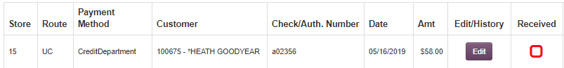
Payment Notes

MaddenCo Customer Inquiry Screen
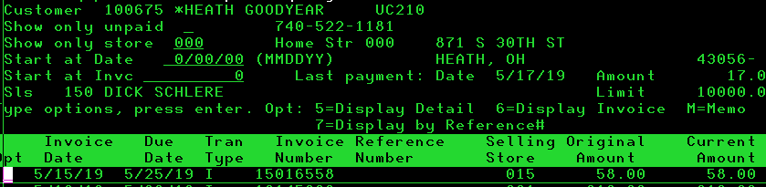

- Verify a payment was not applied in Cash Receipts because customer inquiry reflects the account status from the end of the previous day whereas cash receipts is the most daily accurate reflection.
- If all invoices listed are paid in full – check the Received box
- If any of the listed invoices are not paid in full – click on the invoice to see if it was short/refused and needs credit issued.
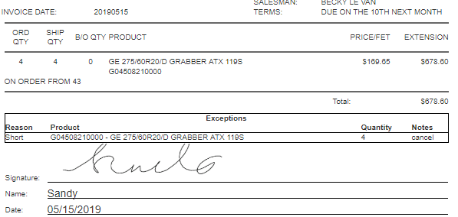

- If an invoice is not paid or not paid in full – click the purple discrepancy button.
- Only select the discrepancy if it is a COD (collect on delivery) customer.
- In the Note box put why you are hitting discrepancy- Be specific
    - (Ex. Invoice 880064228 not paid. Balance due $177.00)
    - (Ex. Invoice 880064228 short paid. Balance due $50.00)
    - (Ex. Payment not received. Balance due $177.00)
    - (Ex. Invoice 880064228 refused – credit not yet issued for $177.00)
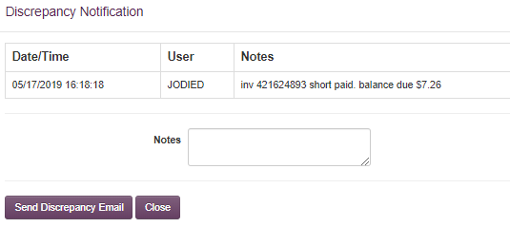

- Click “Send Discrepancy Email”
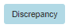
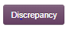
- Refresh the screen and the Discrepancy button will turn the purple button to the color blue upon refresh

Processing Mail Payments
Purpose: The following SOP addresses how to post customer payments that have been sent directly to the K & M Tire Corporate location (Accounts Receivable).
Please note the following customer status and terms before moving into the mail payment process.
            - Customer Status
  - “$ “= Cash Only
  - “* “= COD (Collect on Delivery)
  - “# “= Collections (give to C&C Manager)
  - “=” = Enterprise Accounts
- Customer Terms
  - Current Due - Balance up to the 28th of the current month
  - Future Due - Balance after the 8th of the current month
  - Service Charge - Billed at 2% if payment is not received by the last day of the month

- All Mail Payments can be processed using the CC Dashboard
  - http://intranet.kmtire.local/dashboard/credits/credits.php?phonenumber= undefined
  - Enter Customer number
  - Click on Apply Payment – Bottum right of the screen
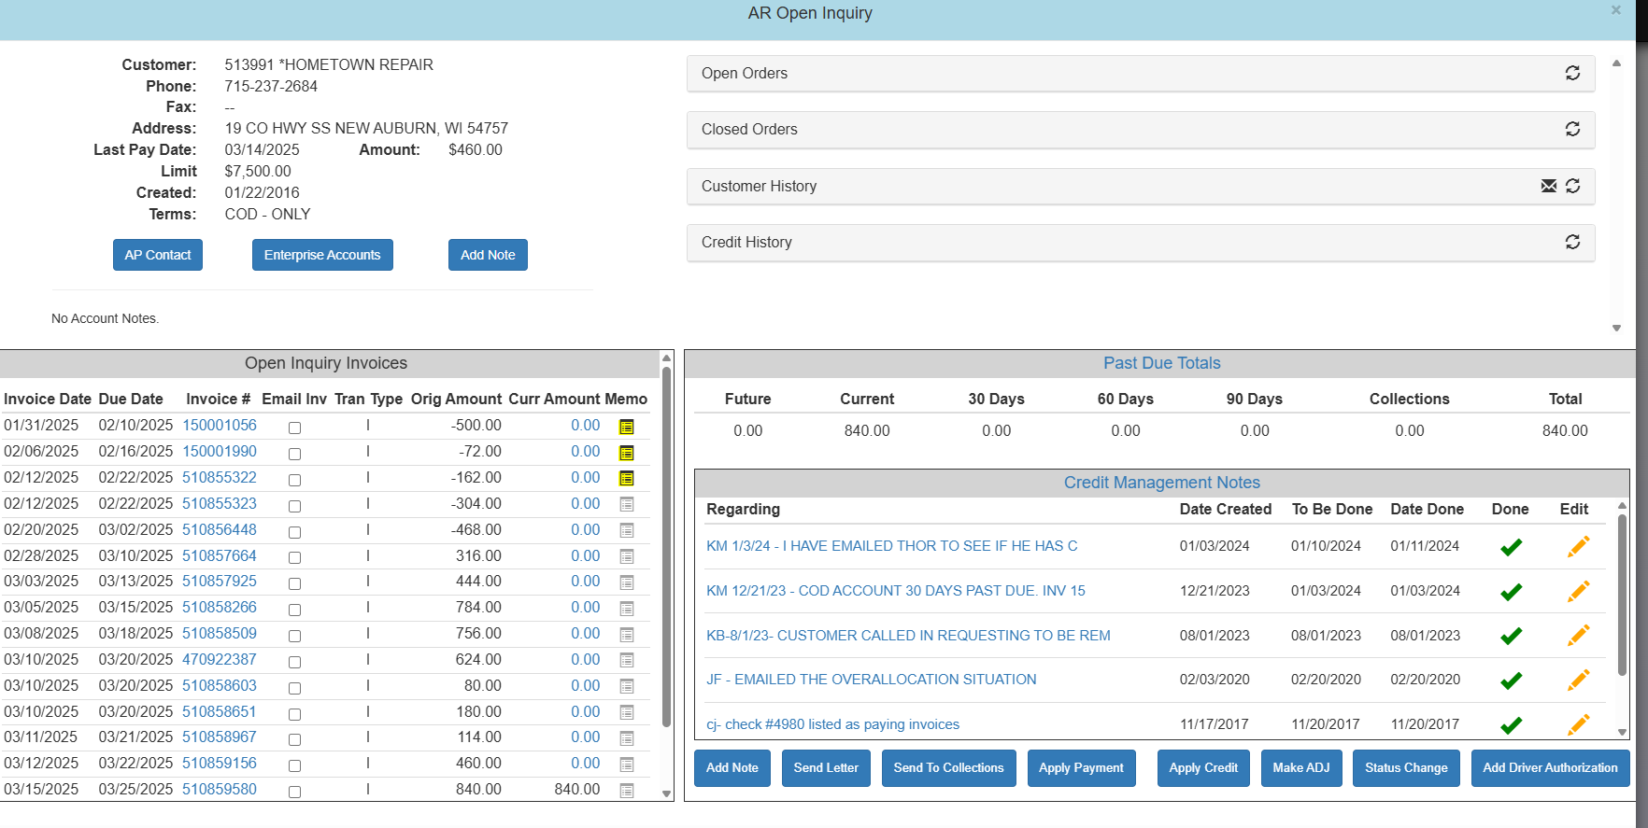

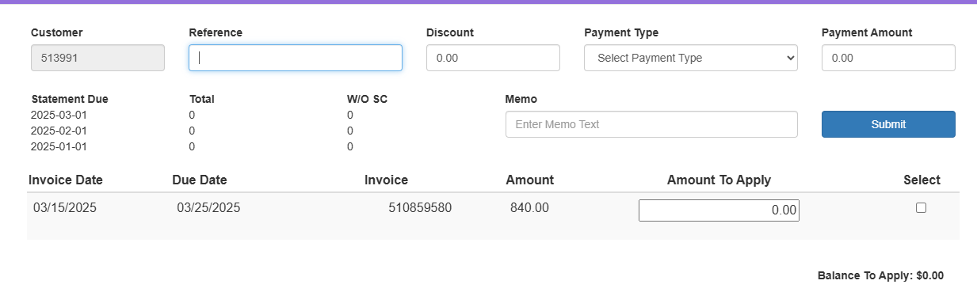
  - Reference = Check number
  - Payment Amount = Total Amount of Check
  - Click the box under Select to choose all invoices being paid.
  - Verify the “Balance to Apply” is $0.00 and click Submit.
  - There are different types of payments requiring additional steps:
    - Remit – Go to Step 4
    - Multiple Accounts – Go Step 5
    - No Remit – Go to Step 6
    - Discount – Go to Step 7
    - GL Account – Go to Step 8

- Remit Included:
  - Apply payment per invoice(s) listed on remit or check stub
- Customer Paying Multiple Accounts
  - Post the payment per remit using the same check number for each customer number. **Note: You will need to go into each Customer on the Dashboard once you enter all invoices for the prior customer number. **
  - Verify the grand total at the bottom of Cash Receipts (in MaddenCo) matches the dollar amount of the customer’s check.
    - 1 - Tire Dealer System
    - 1 – Accounts Receivable Menu
    - 3 – Cash Receipts
    - Store Number = 001
    - Tab down to “Show only Check #” and enter the check number to verify
    - Enter
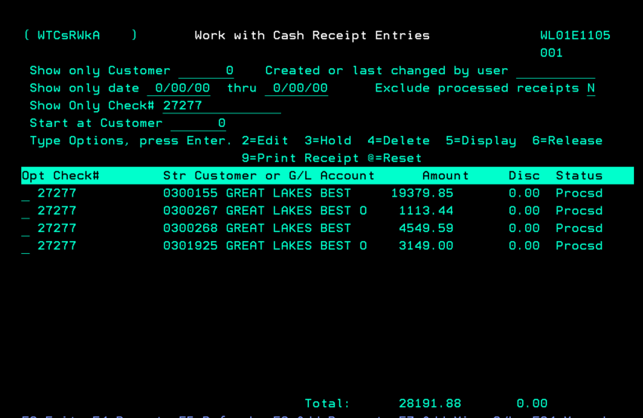
- Remit Not Included:
  - Verify payment matches Last EOM Balance
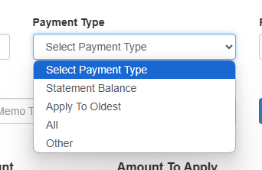

    - Select Apply to Oldest
    - Verify all invoices are paid in full
    - Review last invoice paid and confirm if it was paid in full
    - If it is not paid in full, review statement on the intranet to check for a service charge fee.
  - If Payment does not match Last EOM Balance; research the following potential solutions for a clear match before calling customer.
    - Apply payment to current due
    - Apply current due plus future due from current statement
    - Check for applied credits
    - Check for multiple accounts (Enterprise account)
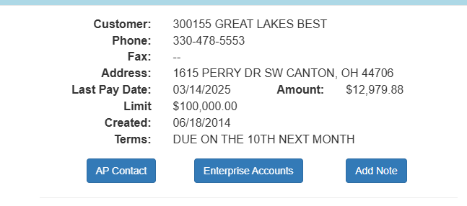
    - Review previous statement to verify how the customer normally pays
      - Lump Sum = apply payment to the oldest invoices
      - Partial Payment = apply payment to the oldest invoices
        - **In either of the above scenarios, we must verify this is how the customer intends for payment to be applied. Start by looking in credit notes, then by contacting their account specialist. Customers on a repayment plan will typically pay this way.
    - Review Credit Management notes to see if there is a repayment plan or notes from the Credit Department
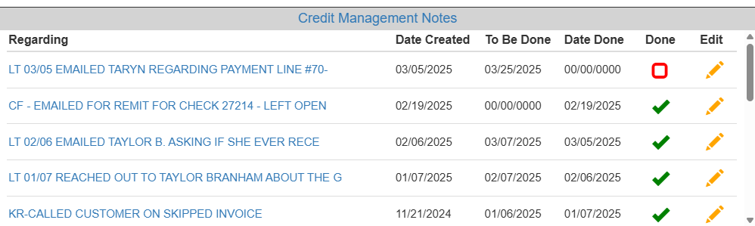
    - Call the customer to confirm how they would like their payment posted **Note if the customer does need to be contacted – go to and follow the “Missing Remit Processing SOP” ** (This is a new SOP that is being written for AR binder. Current status is that Sam S has sent to Katie for feedback, and will be submitting shortly.)
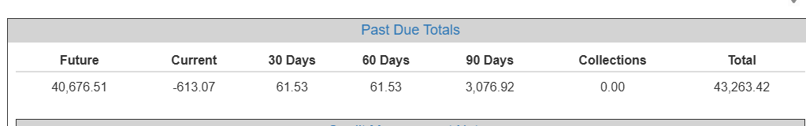

- Discount Customers:
  - Review customers receiving approved discount listing. F:\Accounts Receivable\Shared\List\Customers Receiving Cash Discounts
    - These customers are approved by VP of Sales & President to receive a cash discount.
  - When entering the payment, put a “D” after the check number to confirm the discount was given to the customer.

  - When entering the payment, put the discount amount in the Discount box.

- GL Account Payments
  - GL account number should be provided by Controller.
  - On the CC Dashboard, Click on Post Payment to GL
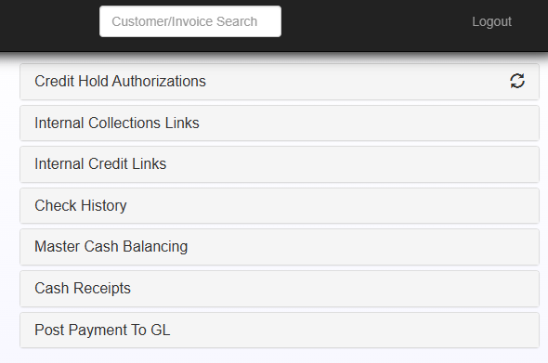
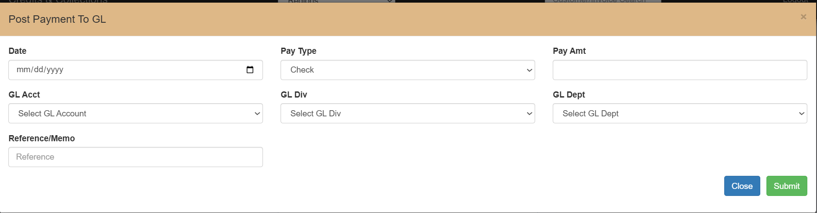

  - Date = Date you are posting the payment
  - Pay Type = Will be a check
  - Pay Amount = $ Amount of the check
  - GL Account = GL Account #
  - GL Division = Location (Will always be 1 unless otherwise stated on the check remittance.
  - GL Department = Should always be “0” unless posting directly to Corporate (1), Amazon (3950-1-2), or 4080/4085 (Vendor Specific).
  - Reference = Quick Note if you need it.
  - Hit Submit
- Once all checks have been entered into the system, run a calculator tape to verify that your check totals match what you have input into the system.
- Checks are then run through the PNC Scanner under Corporate and then filed in monthly check box.
- A screen will pop up specifically tied to the customer’s account, scroll to the bottom, and select “Apply Payment.”

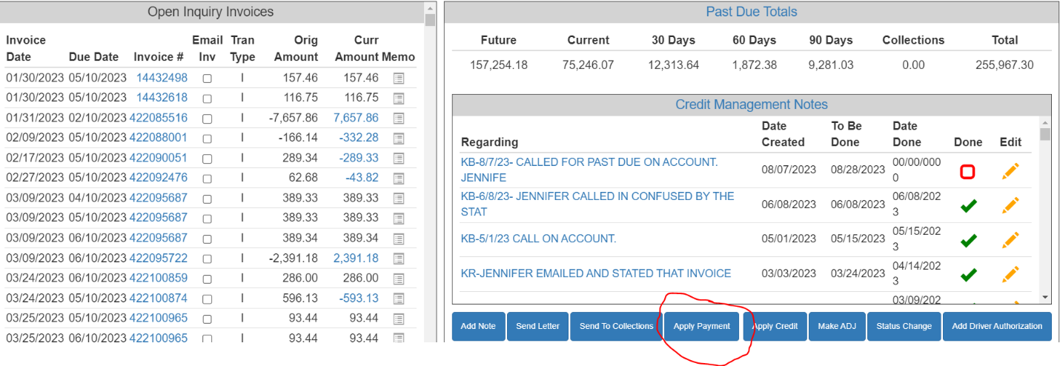

- A new screen will pop up where you can enter the check information:
Under Reference, enter the check number-If the customer takes a discount, enter the amount of the discount, and the amount of the check.

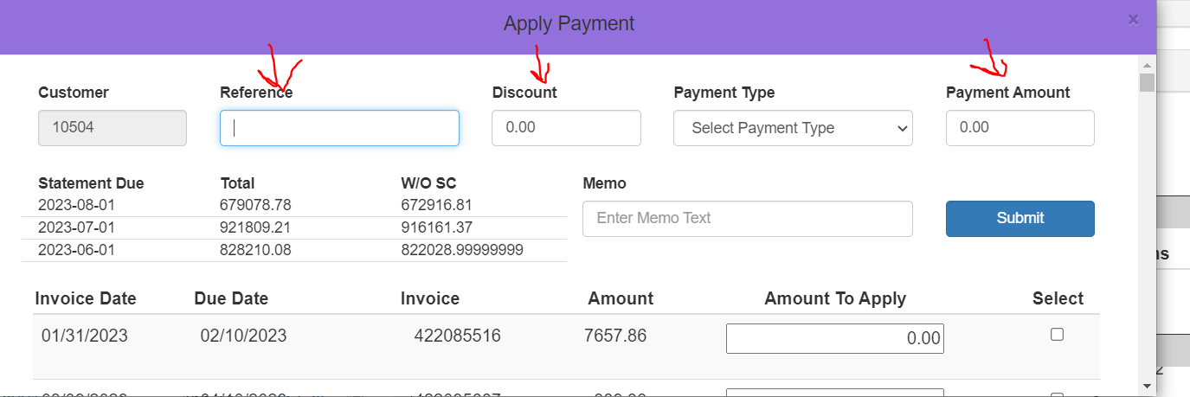

- Then Select your payment type-
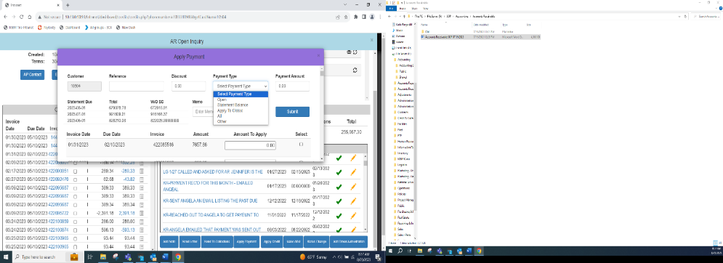

- Open Payment- This is approval based- Our Goal is to not leave amounts on customers’ accounts if they don’t owe us money. Every user does not have this option as we want to send back the check if the customer doesn’t owe us money versus applying it to their account and leaving it as an open credit.

- Statement Balance- This would apply the entire payment automatically to what was listed on the customers last statement. To help guide you, there is a total with the statement dated listed. If the check amount matches exactly, feel free to select “Statement Balance” for ease of application.

- Apply to Oldest- Several customers choose to pay lump sum amounts without remittance advises several times a month. This option will apply payment automatically to those invoices with the older date.
- All- This would select ALL invoices.
- Other-This would allow you to select invoices the customer wishes to pay If they sent in a remittance by choosing those specific invoices.

For this example, I have a check for $5000.00 and I choose “Other” to select a specific invoice on my own.

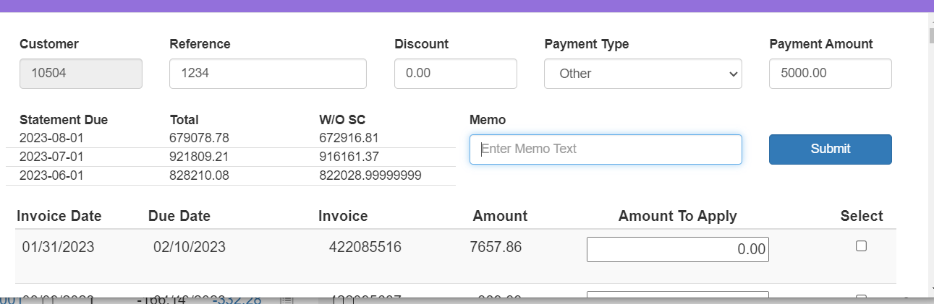

- If I choose the “Select” button for the invoice for $7,657.86 and hit Submit- I will be informed that there is an error because my check is only for 5,000.00.
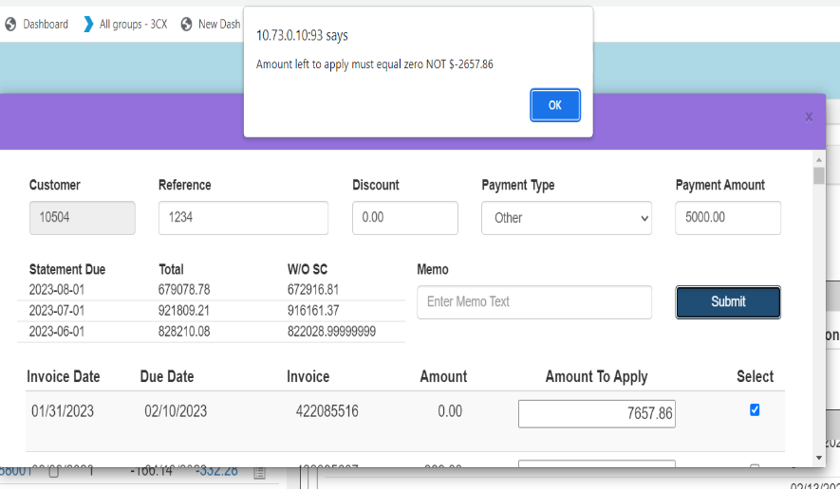

- When you click OK, it will not save your payment data and you will need to re-enter.

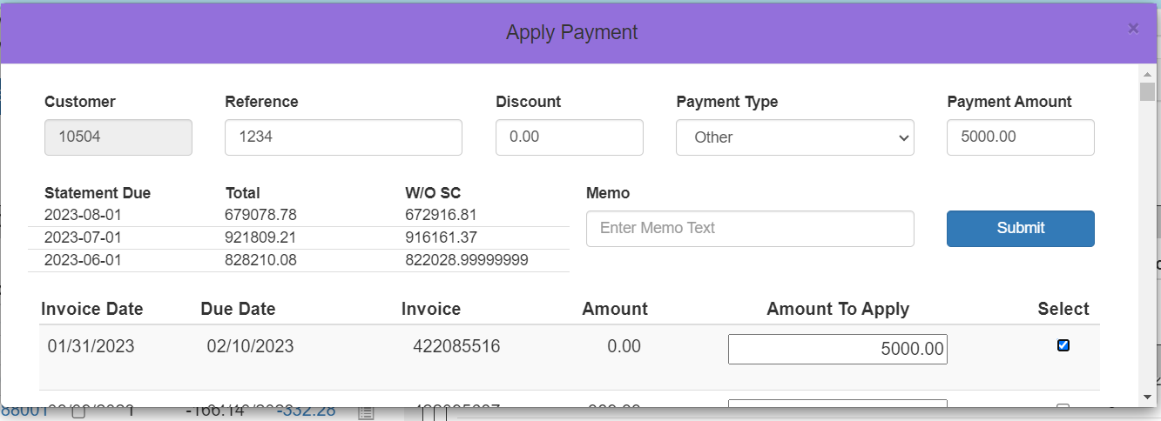
- Re-click on “Apply Payment” and the check information you previously entered will pop up as it has not been processed through. Select the invoice the ‘Amount to Apply’ to $5,000.00.
- Then hit Submit.
- A button will pop up automatically asking if you are “Sure you want to apply”, Hit OK.
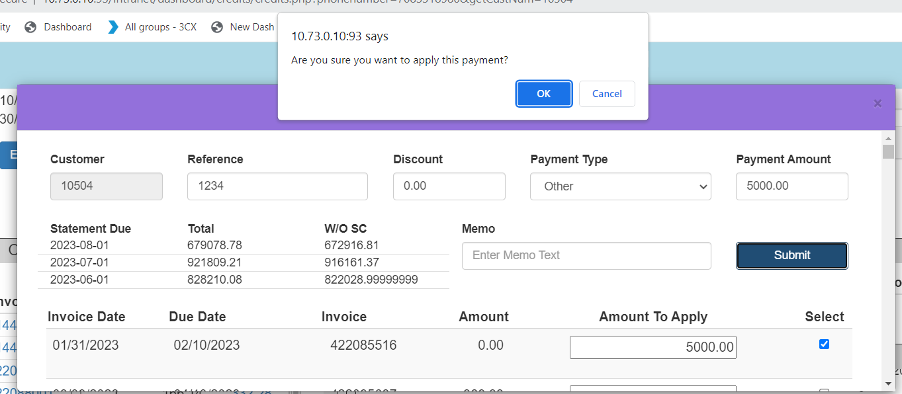

- Another pop-up will appear to let you know that your payment was posted successfully into Madden Co.
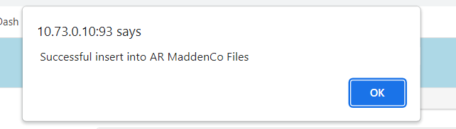

- Once you have finished entering in a batch of checks. Place the checks in size order for easy scanning.

- Turn your calculator so that it will run a total on tape for you and total the amount of checks that you have in that batch. You will need both the numbers of checks and the total. Your calculator has a setting to count both totals for you.

- Go to the Dashboard main screen and select “Cash Receipts”- This is tied to your specific user.

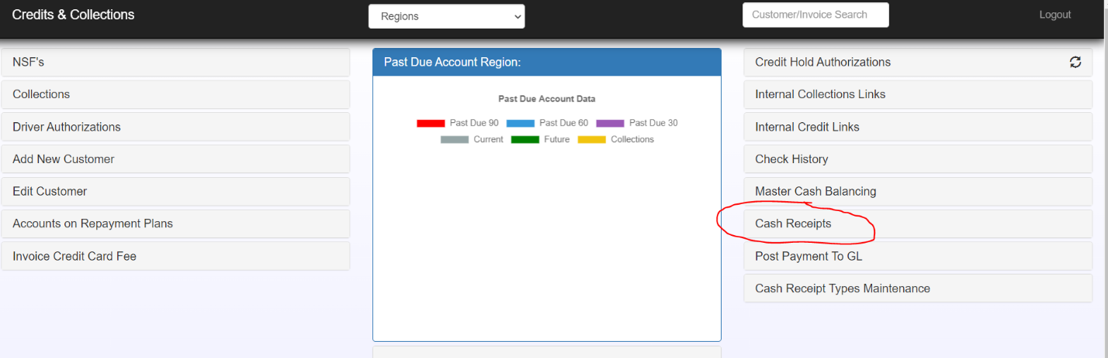

- Your check totals need to be entered manually- The number of checks under Count and the Dollar Value under Amount.
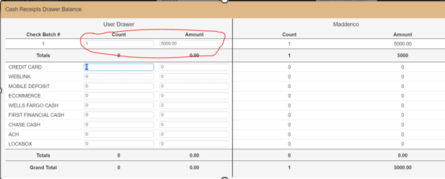

- After entering in the information, select “Update” to update your individual totals:
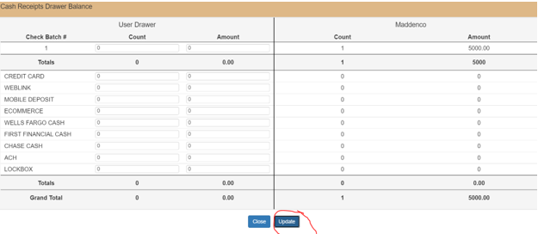

- The information will update for you- Make sure your individual totals tie back to the Madden Co totals. If it does not, something is wrong, and you need to work with your Team Lead or Level 3 to ensure that the error is found before balancing.
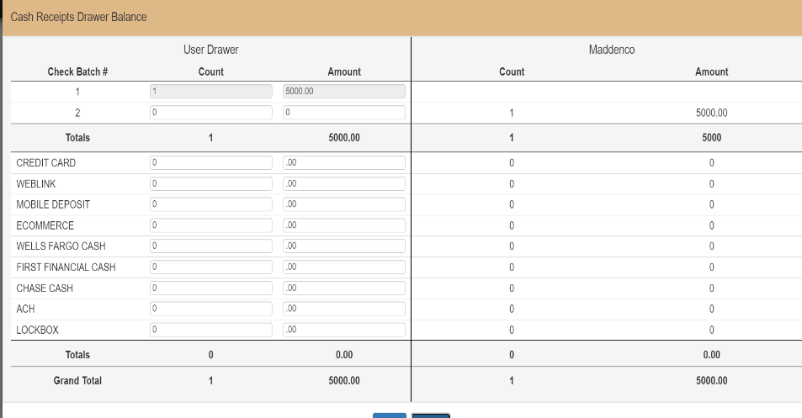

- You will also notice that you now have an option to make another batch. It’s suggested that you do several batches throughout the day to ensure that everything balances at the end of the day.

Driver Authorizations (Phones)
Purpose: Driver Authorizations are given when a customer would like to use open credit on their account. This allows COD (Collect on Delivery) customers to use open credits while the driver validates that a credit is available on a specific customer account.
Note: If you're ever unsure how to handle a situation, it's best to briefly place the call on hold and confirm with someone in the department. It's always better to make someone wait for the correct answer than to risk giving the wrong one.

- Customer is on COD and wants to use an open credit that is available on the account.
  - If the customer calls, verify that the driver is on site with the customer
    - If not, instruct the customer to have the driver call when he arrives
  - Go to CC (Credit and Collections) Dashboard to look up the customer’s account
    - If memo next to credit is yellow, click to view memo – credit may not be available to use.
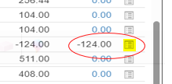

    - If there’s an open credit skip to Step 3.

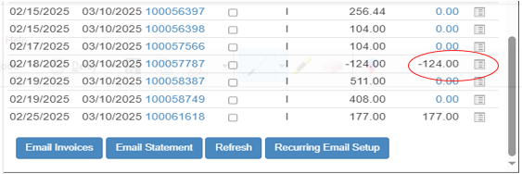

    - If there’s no open credit, click on Open Orders to see if a credit is listed
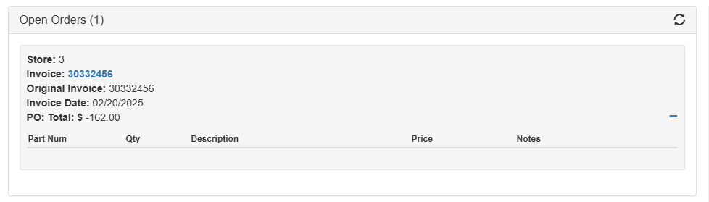
  - If there’s no open credit in Open Orders on CC Dashboard, ask the driver what tires or invoice they are picking up. You can verify the information by clicking on the invoice being returned.

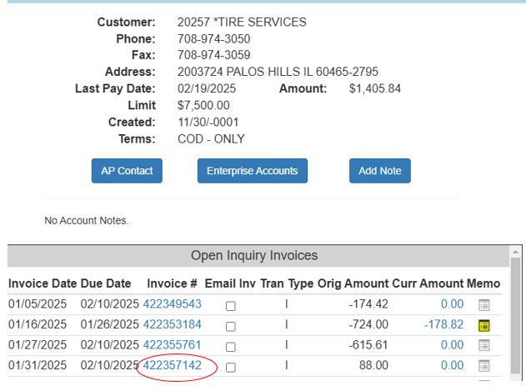

  - Date of invoice must be within last 3 business days to use credit (This is called “Instant Credit”.)
    - If the date is not within 3 business days, advise the driver to collect payment and the credit can be used when available on account.
  - If the quantity on the invoice is less than quantity of the Instant Credit, calculate amount of credit based on Instant Credit quantity & price on invoice in CC Dashboard

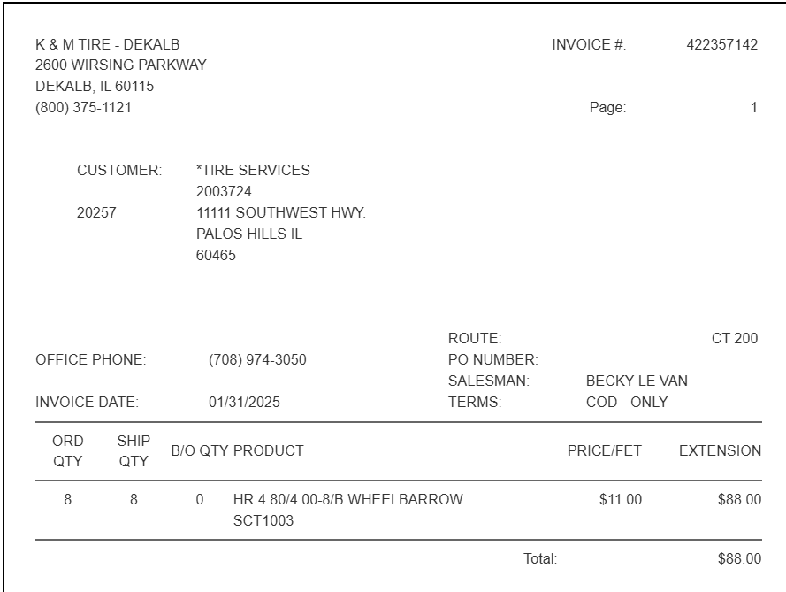

  - If Instant credit is available, Go to the CC Dashboard, Click on Driver’s Authorization, Select YES (This will need to be cleared the next day-See Step 6.)

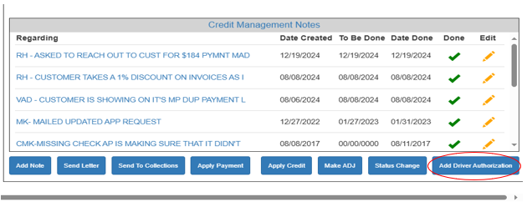

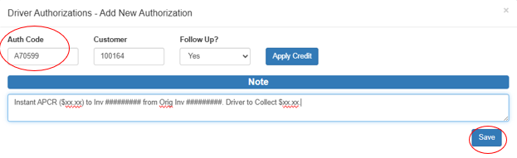

  - Enter Note (See above screenshot):
    - Instant APCR ($xx.xx) to Inv ######### from Orig Inv #########. Driver to Collect $xx.xx.
    - For clarity, enter “Driver to Collect $0.00” if credit covers full amount
    - Give driver Auth Code (ex. of the code above in screenshot) – AND give driver balance to be collected
    - Click SAVE
  - Once there is a CREDIT AVAILABLE on CC Dashboard, a Driver’s Authorization can be given.
    - Select Add Driver Authorization
    - Auth Code & Customer will prefill
    - Select NO (under Follow up?) if credit is on account
    - Click “Apply Credit”
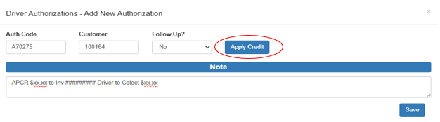

  - Select appropriate credit available & Open invoice that’s being delivered
    - Be sure to ask if more than one invoice is being delivered
    - Enter “Amount to Apply” (if different than full amount)

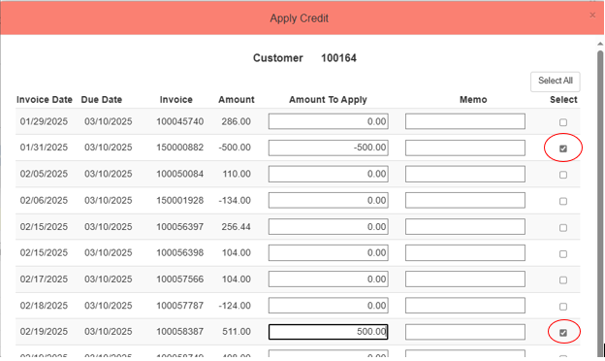

    - Click “Apply Credit to selected invoices” **Note** You will not be able to click “Apply Credit” if the Balance to Apply is not $0.
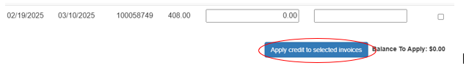

  - Give driver Auth Code AND give driver balance to be collected
    - Click SAVE
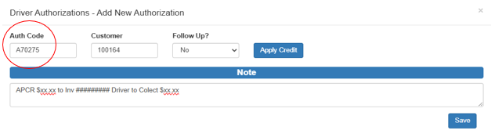

- If Customer is COD and driver needs authorization to leave tires. **Note** These are exception cases.
  - Go To CC Dashboard and look at Note
  - Only customers approved to make payment on the day following delivery can be given a Driver’s Authorization to leave tires without payment
    - If there is no note on the account, the Driver should be guided to collect payment or take the tires back to the warehouse
    - If there is a note regarding an approved payment plan follow the steps to give Driver Authorization Code
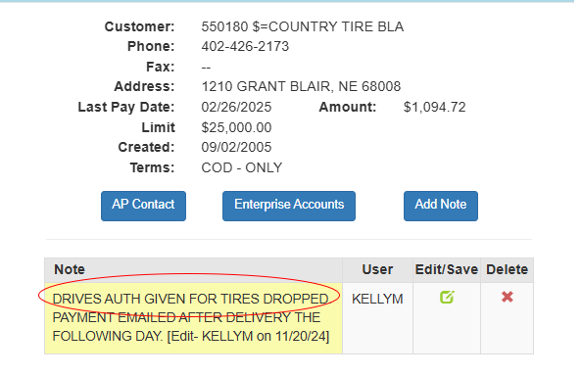
      - Select Add Driver Authorization


      - Auth Code & Customer will prefill
      - Select NO (under Follow up?)
      - Add Note: “Driver dropped tires. CC Pay Agreement”
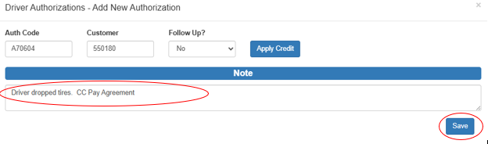
      - Give driver Auth Code
      - Click Save

- If Customer is CASH ONLY and wants to pay with a Check or ACH
  - A Driver’s Auth Code cannot be given for this, but you can use one of the following options below:
    - Offer to accept a credit card or debit card payment. Then follow the Processing Credit Card payments SOP.
    - Guide driver to collect only cash or take tires back to the warehouse
    - Transfer the call to the Acct Specialist as the CASH status cannot be lifted by AR.

- How to Clear Driver Authorizations - You will need to clear any driver’s authorizations that you marked as “YES”.
  - This should be done at the beginning of your shift.
    - Go to CC Dashboard – Driver Authorizations
    - Enter Dates (Usually a week – just to make sure you didn’t miss any)
    - Enter your Username
    - Hit Search
      - You will need to address anything with a Red Box as those are noted as “Open”.

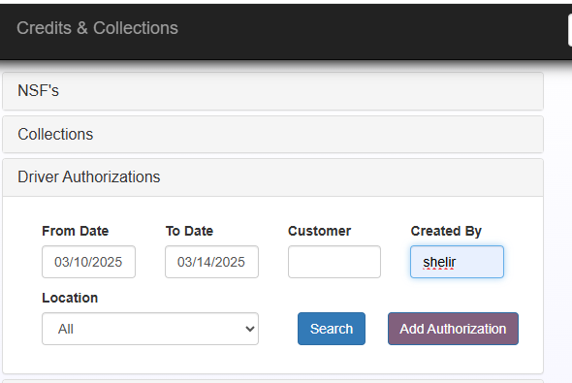

Phone Call Credit Card and Check Procedure – Merchant
Customer or route driver will collect payment at the time of delivery and will call in to process the payment over the phone. These payments are processed through Merchant Partner and a confirmation of the payment is given to the customer or route driver.

            - Credit Card Fees are not charged on the following:
  - Debit Card Transactions
  - “COD transactions” in the States of Texas, Colorado, Kansas, and Oklahoma.
  - “ALL transactions” in the States of Maine, New York, California, Connecticut, Florida, and Massachusetts.

            - Credit Card Fees are charged on the following:
  - 2% CC Fee must be processed on all other Credit Card Transactions including charge customers paying their statement in Texas, Colorado, Kansas, and Oklahoma.

Merchant Partners

- Log into Merchant Partners @: https://www.onlinemerchantcenter.co
- Account ID – will always be “MPTDM”.
- Username and Password are with permission only.
- Click Login
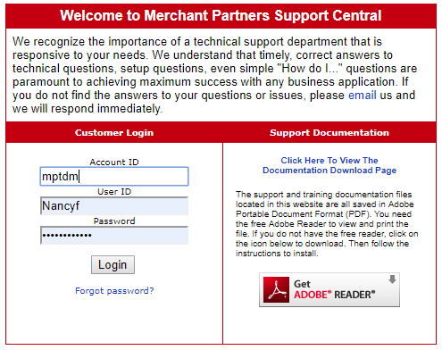

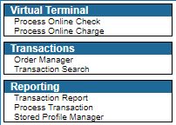

- Select the type of transaction.
- Process Online Charge for a credit card
- Process Online Check for a check
- Transaction search
            - Process Online Charge for a Credit Card Payment (First Time!)
- To charge an invoice on a credit card of a customer without Purchase History.
    - Enter the Amount to be charged. (Don’t forget the fee!)
    - Type in the Cardholders Name. (Must be in either the Owner of the business or the Business Name)
    - Enter the Credit Card number.
    - Enter the security code in the CVV2 field.
    - Enter the Expiration Date.
    - Under Invoice Number, Enter the Invoice(s) to be paid. If it’s a balance, please Enter something such as Statement, Oldest Balance or 4/10 Due.
    - Enter the Customer Number.

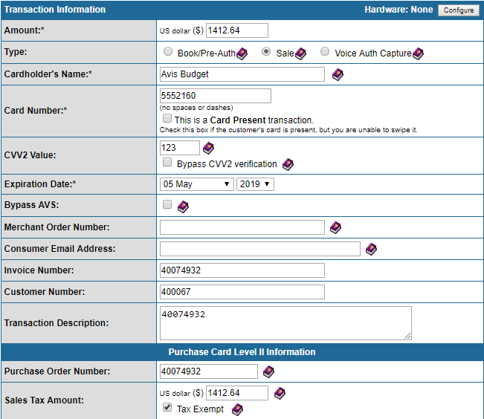

    - Click ‘Process Credit Card
    - Give the Order ID number to the caller or write it down on the invoice
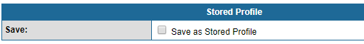

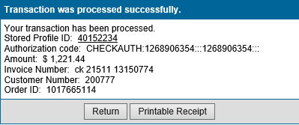

            - Process Online Charge for a Check (First Time!)
- To charge an invoice with a check of a customer without Purchase History.

    - Enter the Customer Name
    - Customer Name
    - Customer Address
    - Select Country
    - Customer Phone Number

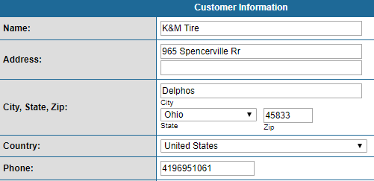

    - Entire Amount, including the change ($0.00)
    - Entire Description – This is where the remittance advice for the customer needs to be detailed. Ask the customer if there is a V# they want to use or today’s date 00000000.
    - Enter the Exact Name on the Checking Account
    - Enter the Checking Account Number
    - Enter the Checking/Bank Routing Number
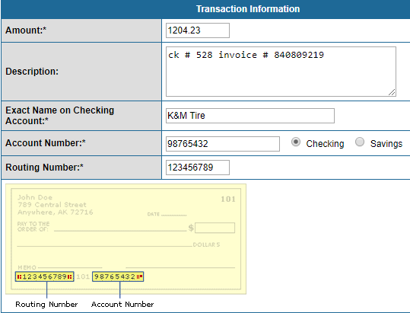

    - Under Invoice Number – Re-detail the remit as listed in the Description box including the check #
    - Enter the K&M Customer #
    - Click Process.

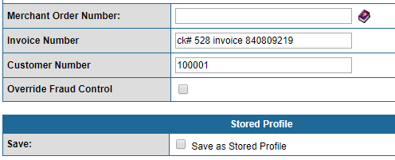

            - Process a Recurring transaction that has the customers information listed in merchant partner (Credit/Debit Card or Check)
- Select Transaction Search.
- Enter in the Customer Number and click Search.
- Verify the last 4 digits of the account number of either credit card or check that is to be processed. (cannot process without this) They must provide us with this or we cannot process the payment.
- Scroll to the bottom of the list of Transaction Search.
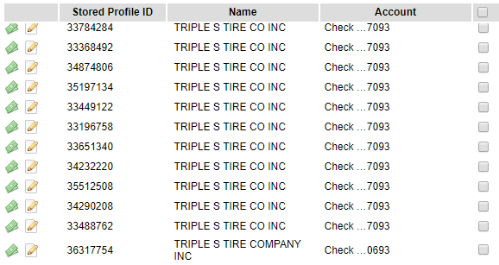

- Click on the order ID# of previous transaction.
- Enter the amount. (Don’t forget that there is a credit card fee and it is charged and needs to be added to the total at the time of processing the payment for credit card payments only!) *See Credit Card Fee Processing*
- In the Memo Line, put the information detailing where the payment is to be applied.
- Click ‘Process Transaction’

- Give the Order ID number to the caller or write it down on the invoice.

- A pop-up will show the transaction as either approved or declined.
    - If approved, a new Order ID number has been issued, and a receipt can be printed for the customer.
    - If declined, let the caller know; they will need to provide a different form of payment.

Phone Call Credit Card and Check by Phone Procedure
Purpose: To provide step-by-step instructions for accessing and processing payments through PNC Payer Express via Weblink, including selecting invoices, handling credits, confirming customer payment details, and processing refunds/voids.
- Finding and Using the Program
  - Navigate to https://weblink2.kmtire.com/
  - Login with your email and password.
- If you do not already have access to Weblink, then you will need to contact your manager to request access.
  - Once logged in, you can locate the program under “My Account” -> “Make Payment.”

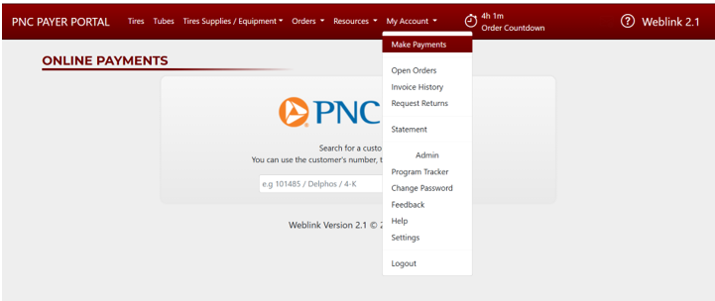

- Using the Program
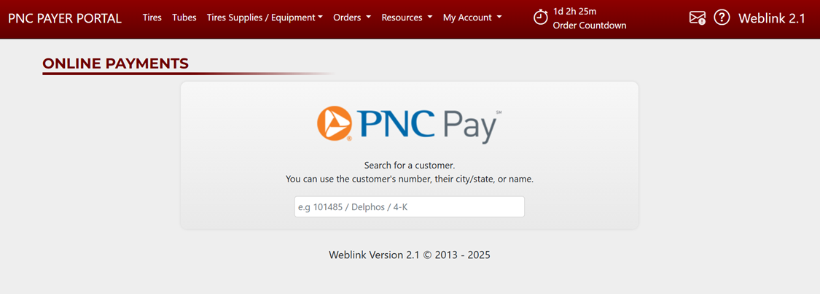
  - After navigating to the dropdown, a module will appear (see image above) that will accept user input. Acceptable search inputs are:
    - Customer #
    - Customer City
    - Customer Name
  - Once a customer is selected, a new screen to select payments will appear.
- Choosing Invoices
  - Two options will appear for you to choose, depending on how the customer would like to pay.
    - If the invoice is dated the same day as running the payment or a partial payment is needed, then you will need to select “Quick Pay” otherwise it is recommended that you select “Select Individual Invoices”
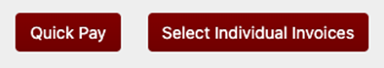
  - Quick Pay vs Select Individual Invoices
  - Quick Pay
    - Clicking the “Quick Pay” prompts you to choose from:
      - Lump-Sum
        - Note: Reference Number field will appear once a valid amount is entered into Lump-Sum
      - Total Account Balance
      - Statement Balance up to $500,000
      - Pay By Due Date
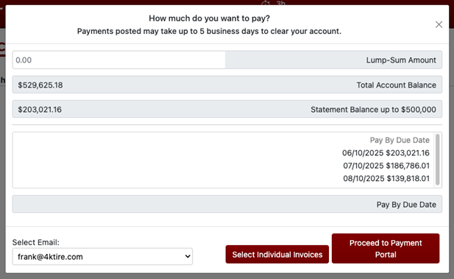

  - Select Individual Invoices
    - Clicking Individual Invoices will bring up a list of invoices to choose and pay.
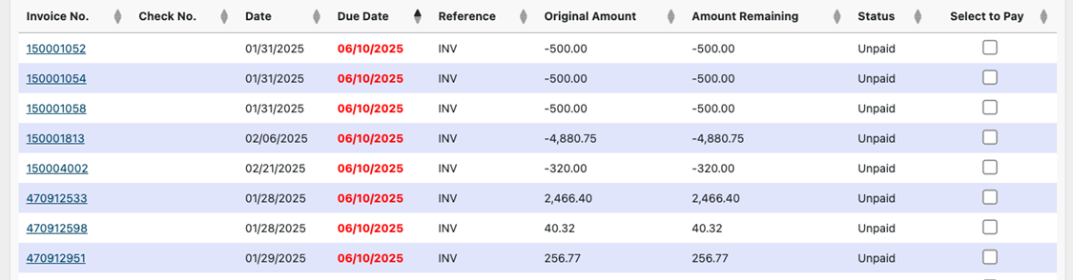

- Processing on PayerExpress
  - After choosing the payment amount, click “Proceed to Payment Portal.” You’ll receive a payment confirmation before proceeding into PNC’s Payment Processing.
Note: At this point, you should confirm that the amount entered is what the customer wants to pay.
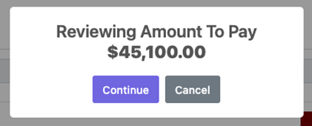
- The first time a payment is made for the customer using PNC’s portal, they will be asked to add a payment method. This is the time to add in a Bank Account or Credit / Debit Card and save it as the default.

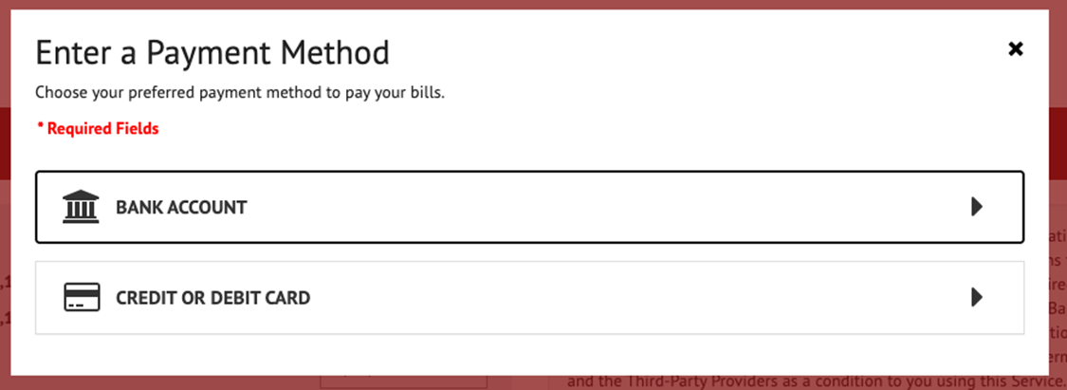
IMPORTANT: Only one saved payment decision (Card or Bank Account) can be kept at a time. Not both.
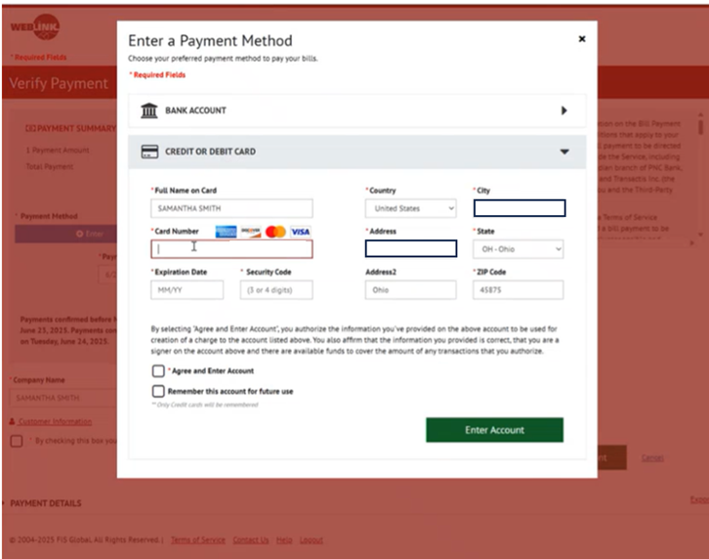
Important: If you have not already confirmed that the 3% service charge is alright with the customer – You need to do so here!
- After entering payment information and saving it as their default at their request, you will then verify the payment, the customer’s email, and click the checkbox to agree to the terms.
  - If they do not have an email or do not want the confirmation sent to them send to email: PNCCC.Confirmations@kmtire.com
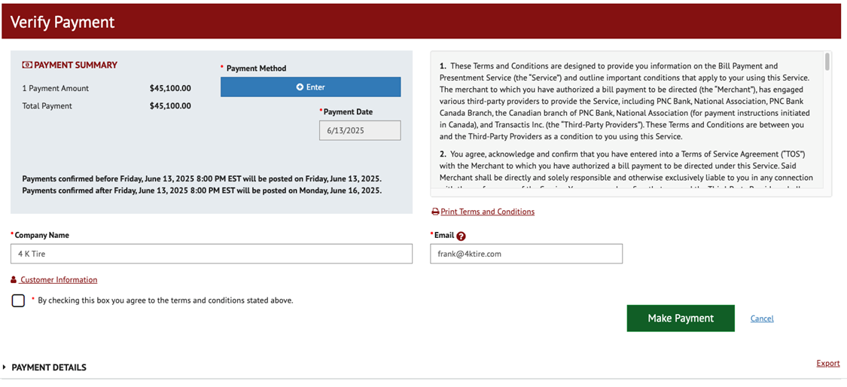
- After clicking “Make Payment,” the transaction will process and give you confirmation.
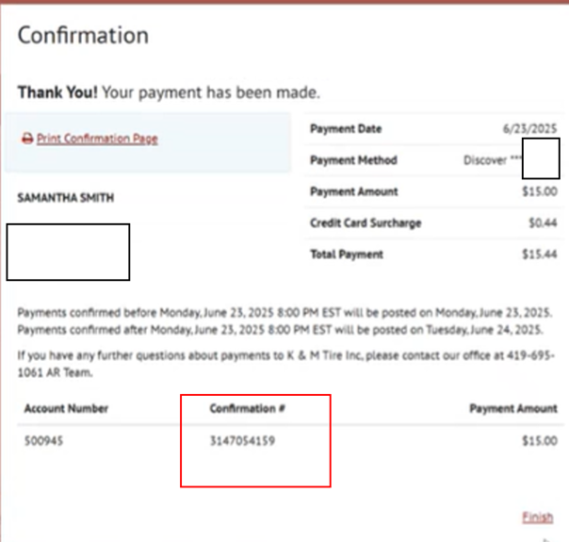

- To have a customer refunded or a transaction cancelled you will need to contact:
  - AR Manager
  - Credit & Collections Manager
  - Director of Accounting

Credit Card Fee Processing
Customers are charged a 2% fee when paying with a credit card in some locations based on the state and if they are paying COD or from statement. That is not included with the invoice. It is manually calculated and added to the customer’s balance due.
To Bill out the Fee
- Log into MaddenCo:
  - Tire Dealer System
  - 8 – Point of Sale Menu
  - 4 – Counter Billing

- Enter the Store Number to be used based on the Location
  - Example – Loc 2 = 002
  - Example – Loc 15 =015

- Enter the customer number

- Enter

- F6

- F6

- Enter

- Enter your salesman # – Hit Enter

- Enter Product ‘CCFEE’

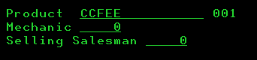

- – Hit Enter

- Enter Quantity 1

- Tab over to Price and Enter the Fee amount.

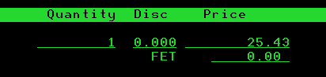

- Enter

- F3

- F3

- Is Invoice to be closed Y/N – Defaults to Y, on the very bottom-line type “P273ZHOLD”– Hit Enter

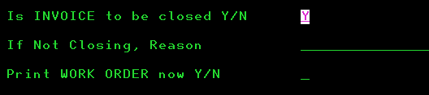

- Hit Enter

- Enter

- Hit Enter to change the status of the invoice from “In Use” to “Invoiced”

Misapplied Payment
Cash Receipt Correction Procedure – Payment was posted to the wrong invoice number and the payment would need to be reversed and reapplied to the correct invoice.

- A misapplied payment was found the next day or within the same monthly bill cycle (ex: payment credited to account 12345 instead of 13345)

  - Reverse the misapplied payment
  - 1 – MaddenCo Tire Dealer System
  - 1 – Tire Dealer System
  - 1 – Accounts Receivable Menu
  - 3 – Cash Receipts
  - F6 for new entry
  - “Check Number” = ‘RVRS check #’
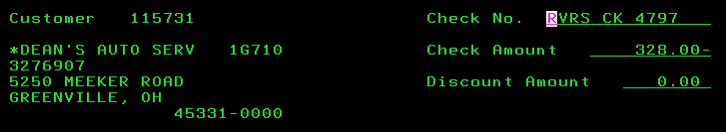
  - “Amount” = dollar amount to correct (if the amount was $328.00 Enter it as $328(-)

  - Enter
  - “Show Only Open A/R items” = N
  - The invoice previously ‘paid’ and reset now shows as open @ $0.
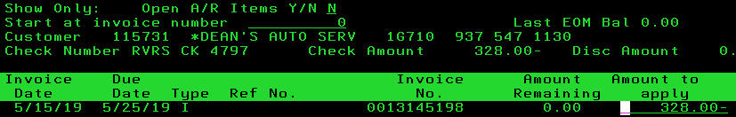
  - In order to put a charge back on the account, enter the appropriate dollar amount followed by a negative sign. (To credit the account, enter a positive dollar amount.)

  - F3 to exit.
  - Apply the payment to the correct invoice (following Cash Receipt Procedure) using ‘check number’ REAPP check #.
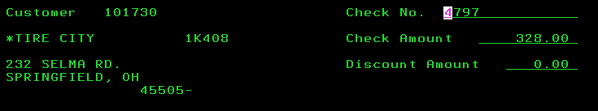

- If the Misapplied payment is discovered prior to the end of the same business day and you wish to “Cancel” the payment entry:
- Find the incorrect entry from the Cash Receipts listing (step 5a-d)
- Type ‘4’ in the field next to the check number to delete the entry

- Enter
- Enter again to Confirm you would like the entry canceled
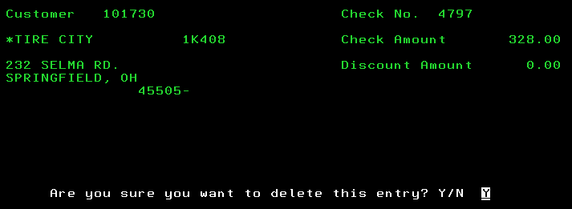

- Re-Enter the payment following as in step 4 above.

- If the Misapplied payment is discovered prior to the end of the same business day and you wish to “Edit” the payment entry:
  - Type ‘2’ in the field next to the check number to edit the entry.
  - Clear out previously Entered amounts till the bottom of the screen shows $0.00 for the Amount Remaining to Apply.

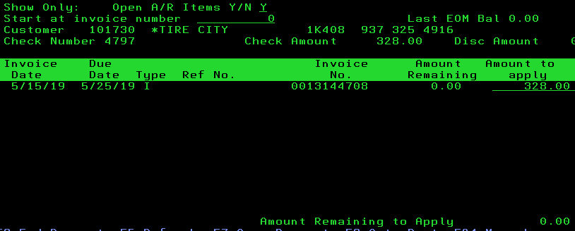

- Reset an invoice from previous monthly bill cycle (ex: payment was credited to the wrong invoice)
  - Open MaddenCo
  - 1 - MaddenCo Tire Dealer System
  - 1 – Tire Dealer System
  - 1 – Accounts Receivable Menu
  - 8 – Customer Inquiries Menu
  - 1 – Customer Balance Inquiry
  - “Enter the Store Number to be Used” = ‘000’ to search in all locations.
  - Type Customer name or F9 to Enter account number
  - Enter ‘6’ in the field next to the appropriate account number to open AR.
  - F10 to view invoice history (closed and open).
  - Shift F4 to ‘Reset History Status’
  - Search for the invoice number that contains the application error.
  - Type an ‘R’ on the line next to the invoice you need to have available
  - Enter to accept
  - F3 to exit.

Credit Card Posting Procedure
Payments that are ran via Merchant Partners; our credit card processing site are applied once they have cleared the bank the next day. A report needs to be pulled and converted into Excel utilizing a Macro in order for instructions on which accounts need to be paid.

- The A/R Supervisor Level 2 or Level 3 Clerk will run the Credit Card Report through Merchant Partners as an excel file and print it out. It will look something like this:
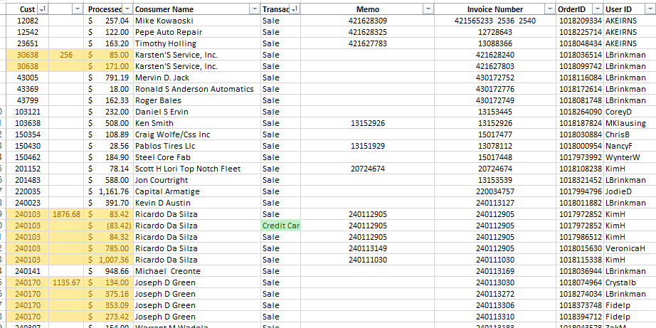

- This next set of instructions is how you would post payments in Madden Co/Please skip to # which is how to apply them via the Dashboard. Again, we only utilize Madden Co with Management/Team Lead approval.

- Once you receive the report record payments listed on the Credit Card report in Madden Co, this will then clear the invoice as showing as unpaid.

- Open MaddenCo
  - 1 – MaddenCo Tire Dealer System
  - 1 – Tire Dealer System
  - 1 – Accounts Receivable Menu
  - 3 – Cash Receipts

- “Enter Store Number to be Used” = ‘001’ always as you are posting payments from corporate/Delphos.

- F6 to add new payment.
  - Enter customer number
  - Enter the 4-digit date and CC (ex: 02/21 CC) cc=credit card
  - Enter credit card payment amount
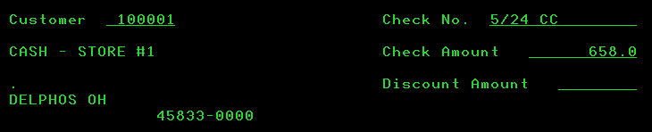
- Apply payments from the report to the invoice number listed on the report following the Cash Receipt procedure.

- If the invoice is not available in “Cash Receipts”, search for the invoice to verify customer number is correct.
  - Hit Escape to open Operations Window
  - Page down to Invoice History Inquiry
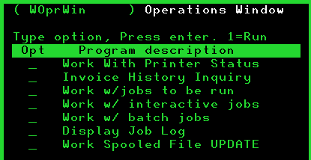
  - 1 – next to Invoice History Inquiry
  - Enter
  - Store Number – leave blank in order to search invoice # in all locations- hit Enter
  - Enter the invoice number you are inquiring about.
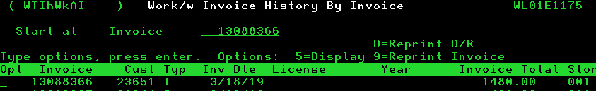
  - Enter

  - Verify the customer number is correct on the credit card report

- If the invoice is not available in “Invoice History Inquiry”, search for the invoice in order entry by following the Open Order Inquiry Procedure.

- If the invoice is not available in Cash Receipts post as an open payment on the account by selecting F7 since the invoice is not an available to match up with the credit card payment.
  - Memo the open payment describing why this was posted this way. (ex. Open payment of $500.00 due to inv 20710161 in order entry)
  - Underline the whole payment on the report and write ‘order entry’

- Credit Card Fees will sometimes be charged to the card but are not billed out following the Processing a Credit Card Fee Procedure.
  - On the excel report underline items that short pay with credit card fees – write ‘ccfee and $ amount’ and post the difference as an open payment by selecting F7.
  - Missed credit card fees will be billed by the Accounts Receivable Clerk that took the payment.
  - All other missed credit card fees will be billed by the person applying the credit card report by following the Credit Card Fee Procedure.

- Verify your total at the bottom of the screen in MaddenCo matches the grand total on the excel sheet.
MaddenCo Total
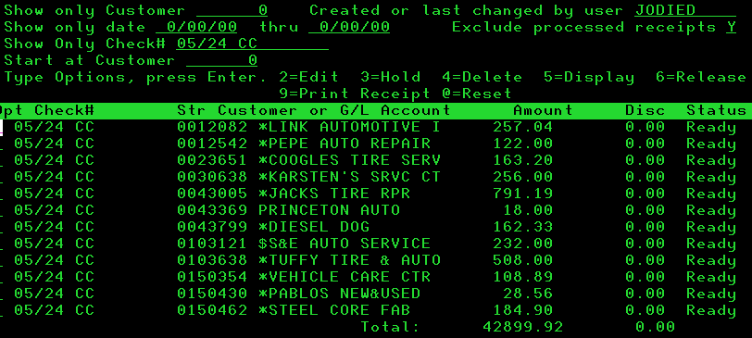

Excel Sheet Total
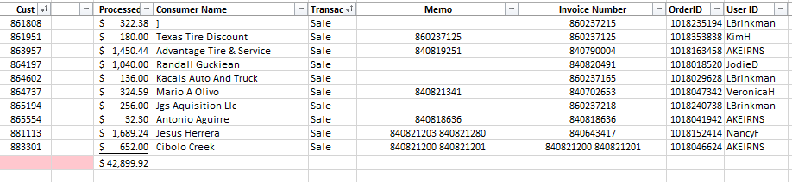

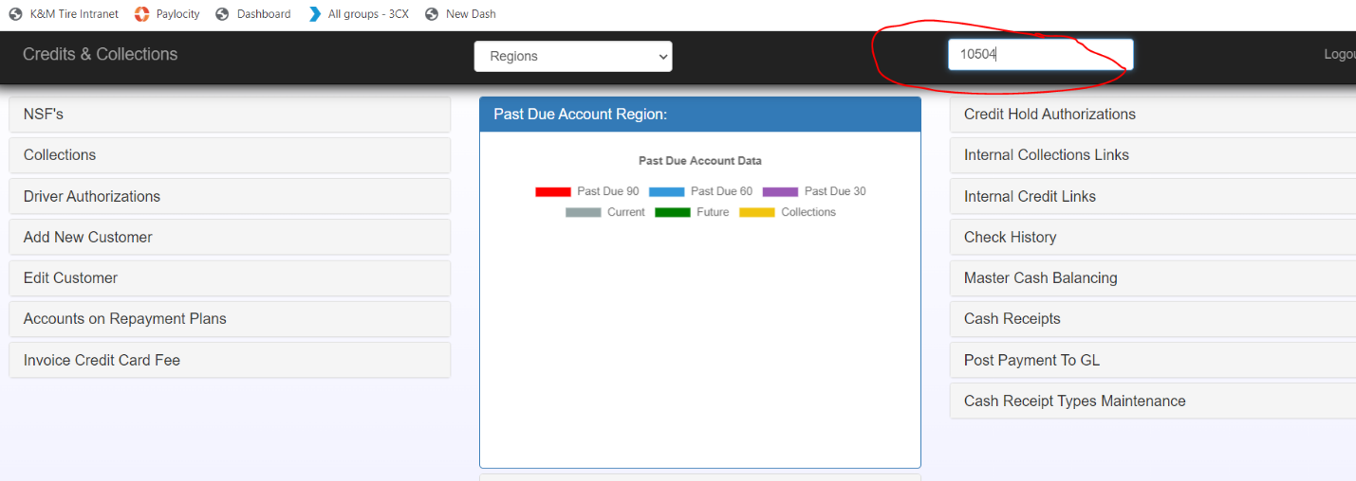
- To Apply Credit Card via the C&C Dashboard: Enter the customer number on the Customer Field, wait for it to pop up and hit enter.

- A screen will pop up specifically tied to that customer’s account, scroll to the bottom, and select “Apply Payment”.
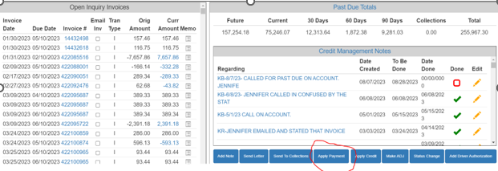

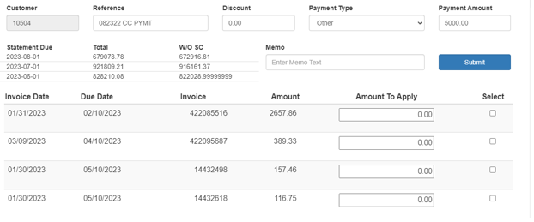
- A new screen will pop up where you can enter the check information: Under Reference, enter the check number as ‘081923 CC PTMT”. This ensures that this goes under the right total under your user.
- Select the invoices that you want to pay, ensuring that your total applied equals to the amount of your payment, in example, it’s $5,000.00.

- For reference, if you scroll to the bottom of the Customer Apply Payment Screen, it will give you an amount remaining that needs to be applied. Once that total is $0 you can click submit:
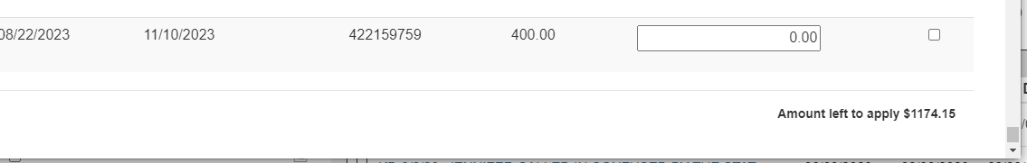

- The above will result in an error pop up because it’s not at $0.00 remaining:
- Once you have $0.00 remaining as is below, click submit:

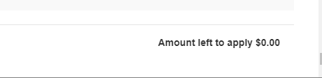

- If it has been successful, you will receive the following pop notification:
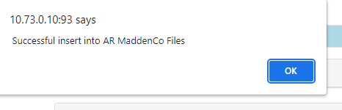

- Once all payments are posted, go back to the main screen, and select “Cash Receipts”.
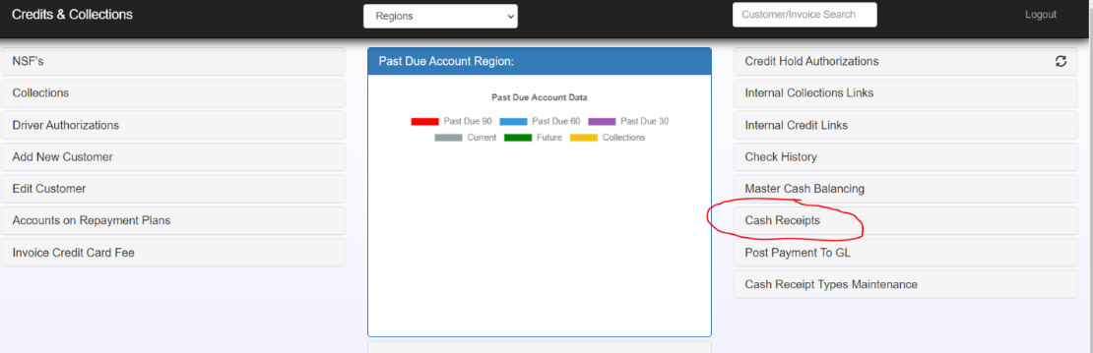
- This is your individual user total.

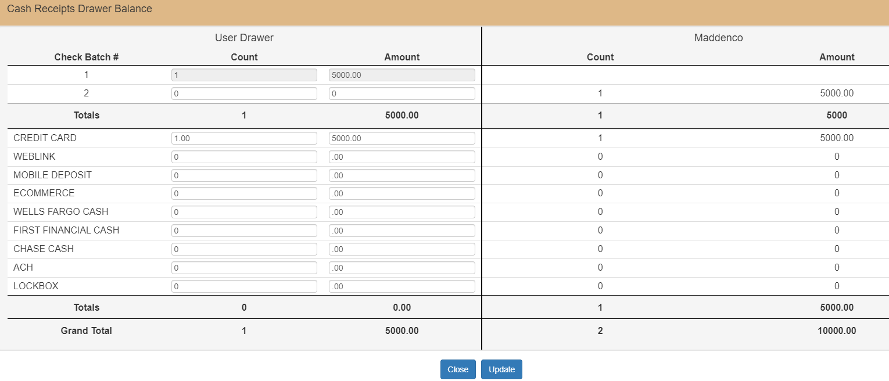
- Enter the # of Credit Card payments entered along with the total dollar amount and click update:

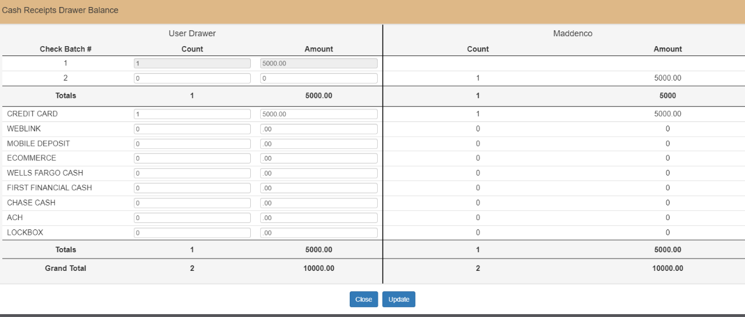
- Please be sure that your individual totals match up with the Madden Co totals. If it doesn’t, please work with your Team Lead or a Level 3:

Pulling the Remittance File for Weblink payments
Purpose: To outline the process for pulling the remittance file of Weblink payments that cleared our bank account. The AR Manager pulls this file from the PNC PayerExpress website daily. This file of cleared payments is then used by the AR team for posting in SOP 3.15 Weblink Payments Posting Procedure.
- Navigate to the Biller Portal: https://www.payerexpress.com/ebp/kmtire/Login/Index

  - Sign in using your login and password.
    - If you do not have a login, contact the Director of Finance to have one issued.
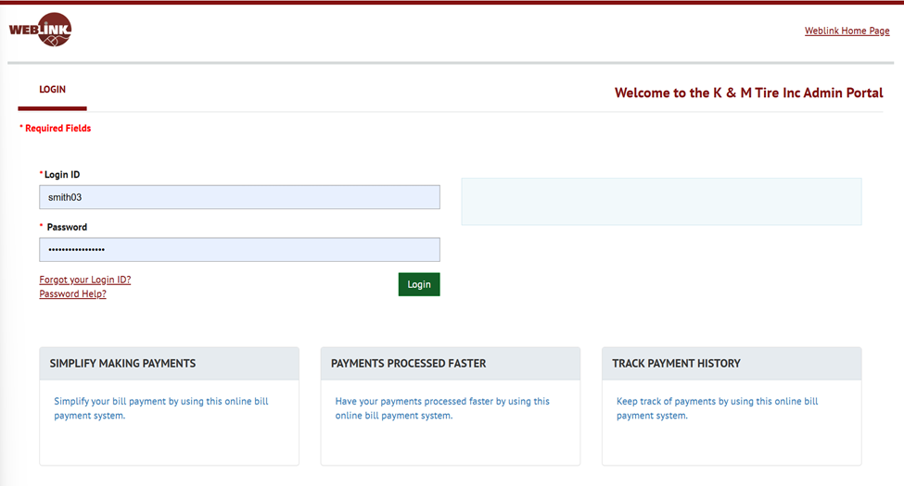
- Click on Reporting Portal.
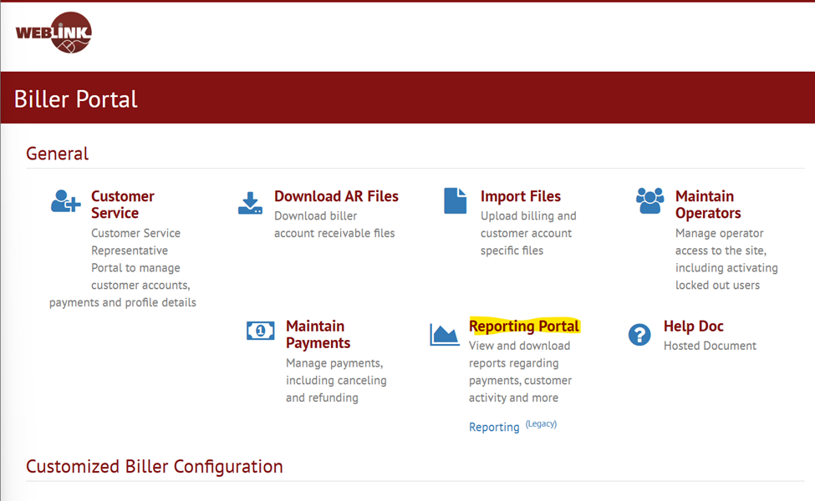
- Click on Remittance File Download.
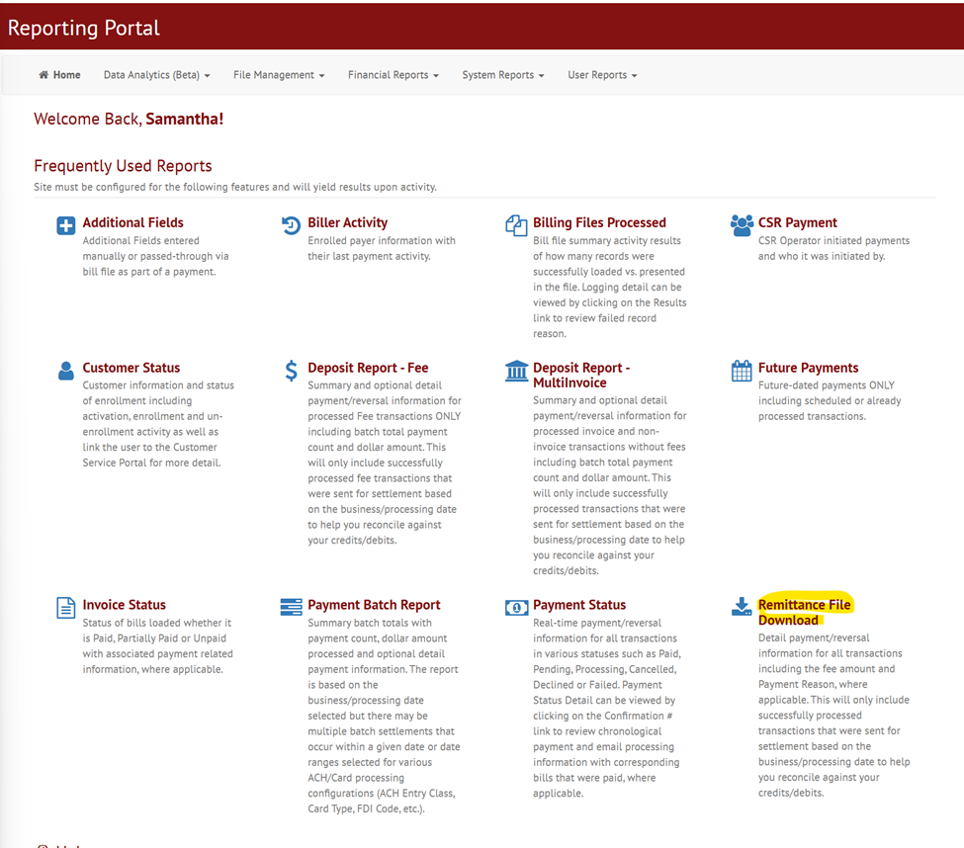

- Enter two business days back in the date range.
  - Example: If today’s date is Thursday 7/3/25, run the date range for Tuesday 7/1/25.
  - If running for a Friday, include Saturday and Sunday.
  - Click Search.

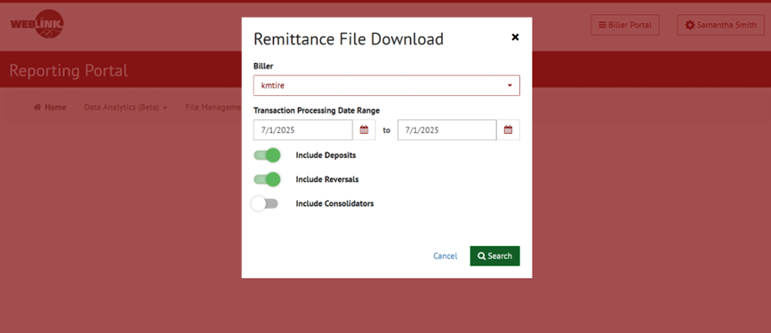
- Click the floppy disk icon and download to Excel.

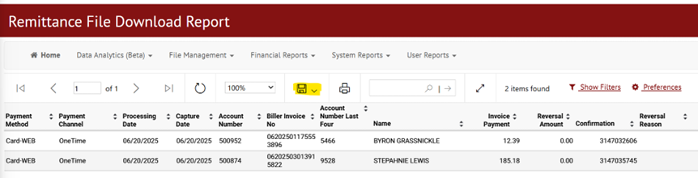

- In Excel, highlight all rows containing information.
- Click the Insert ribbon, then select Pivot Table.
  - Ensure “New Worksheet” is checked.
  - Click OK.
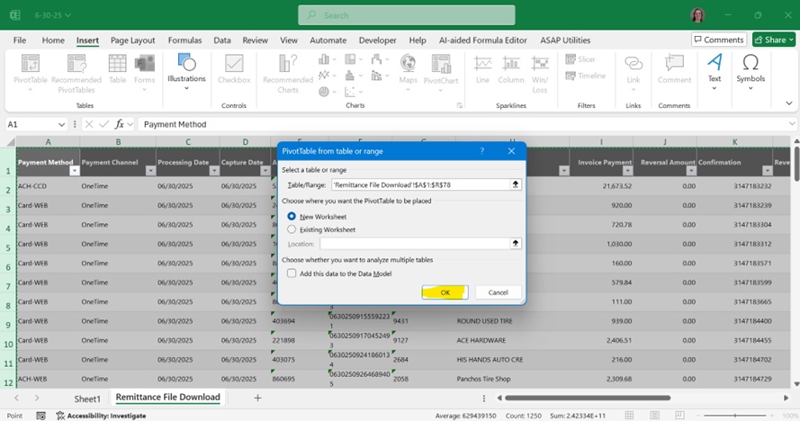

- Populate the Pivot Table fields so that the table is arranged as required.
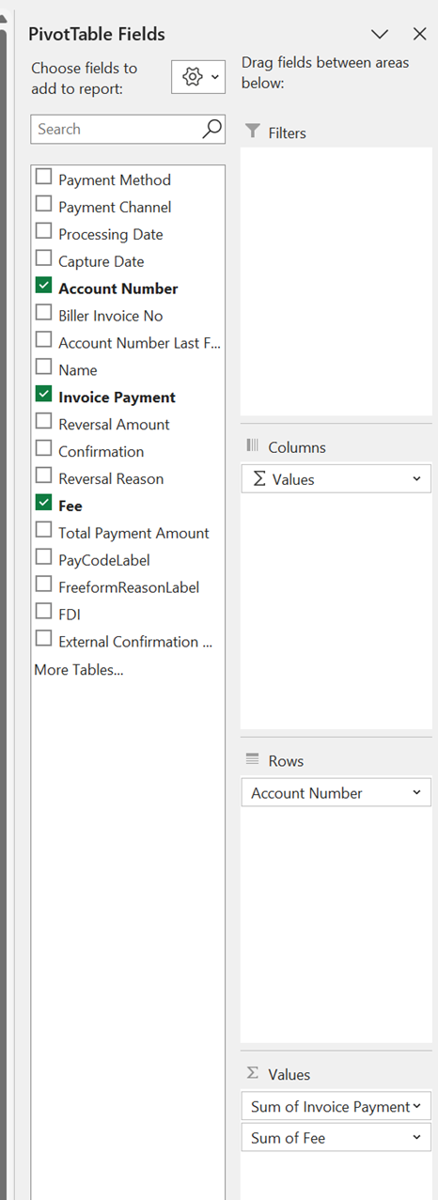

  - The final Pivot Table should match the standard layout shown in the screenshot below.
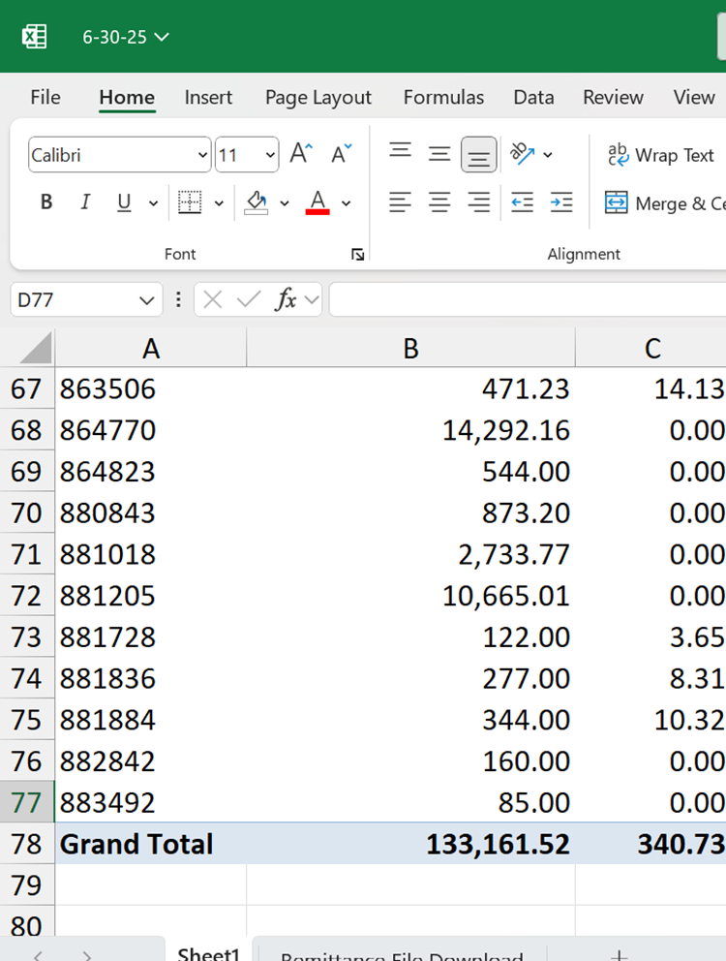

- Validate that the Pivot Table total matches the PNC Ledger:
  - Go to: F:\Accounting\Shared\Bank Ledgers\K&M Inc\PNC\PNC AR 1016
  - Open file: 1016-1 Bank Ledger.
    - Note: Column A “Maddenco Date” should be blank, as these items have not yet been posted in MaddenCo.
  - Add the Pivot Table grand total together and ensure it matches the ledger amount.
    - Example: 133,161.52 + 340.73 = 133,502.25.

- Save the file to:
F:\Accounts Receivable\Shared\Deposits\PNC Merchant\Year\Month\Date you are running it for.

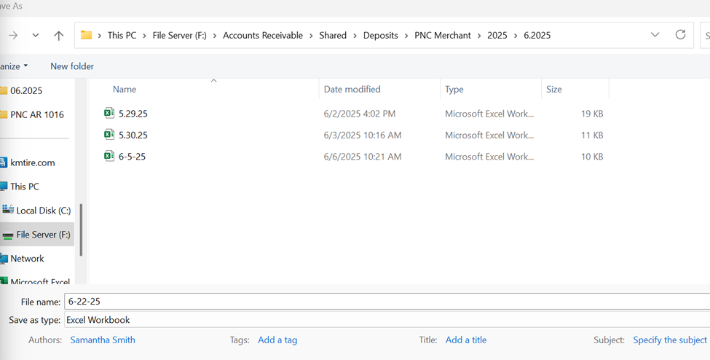

AR Pending Payments #868686
This SOP outlines the use of AR Payments accounts#868686 as a temporary holding location for payments with insufficient information to post to the correct customer account or those unrelated to customer accounts, pending transfer to a GL account. The AR Manager will ensure the account is used correctly and cleared promptly, with monthly reviews by the AR Team Lead, AR Manager, and Controller.
3.13.1 Objective: Account #868686 is used as a holding place for payments that:
- Lack sufficient information to locate the correct customer account.
- Do not belong to any customer account and need to be posted directly to a General Ledger (GL) account.
3.13.2 Use Cases: The following situations justify using AR Pending Payments account #868686:
- Check Scanned via Mobile Deposit (Non-Customer Account)
  - Occasionally, the warehouse may accept and scan a check through the Mobile Deposit App for asset sales or other items unrelated to customer accounts.
  - Mobile Deposit Exceptions do not allow for direct posting to a GL account.
- Payment Requiring Further Research
  - If a payment needs further research to identify the correct customer account, account #868686 can be temporarily used to record the payment.
  - This ensures the Cash GL account remains accurate while the correct customer account is identified.
NOTE: Entries posted to #868686 should be posted as an Open Payment
  - Avoid posting unrelated entries on one entry to keep the account ‘clean’ and easy to see what’s there
3.13.3 Monitoring and Review
- The statement for customer account #868686 will be automatically emailed monthly to the AR Team Lead, AR Manager, and the Controller for review.
- The AR Manager will monitor the account to ensure proper usage and timely clearance.

Weblink Payments Posting Procedure
Purpose: To outline the process for posting Weblink payments, verifying amounts, and recording associated fees in MaddenCo.
Procedure:
- Access PNC PayerExpress Cleared Deposit Files
  - These files are downloaded daily by AR Manager in SOP 3.14 Pulling the Remittance File for Weblink Payments
  - Navigate to:
    - F:\Accounts Receivable\Shared\Deposits\PNC Merchant\Year\Month\Processing Date
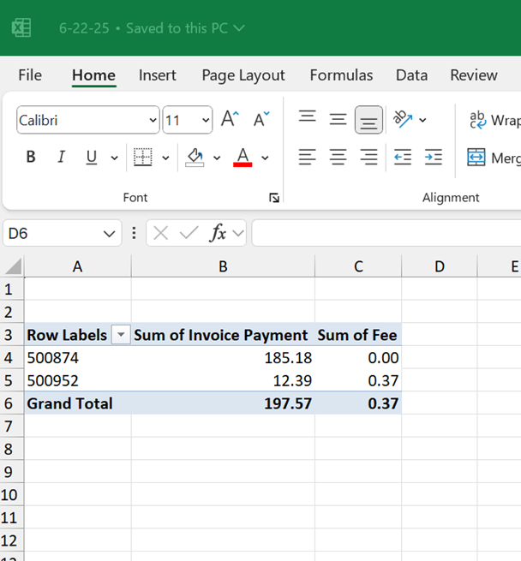

- Run Intranet ACH/CC Payment Processing Report
  - Open the intranet.
  - Go to AR – ACH/CC Payment Processing (PNC).
  - Payments Through Date will default to yesterday’s date. (that’s correct)
  - Click Run Report.
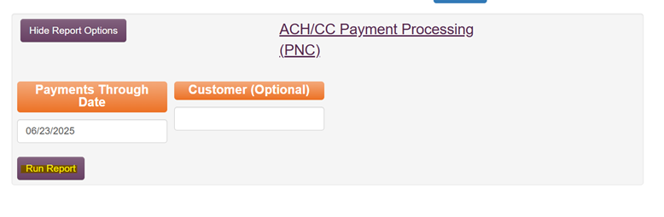
  - A list of “Payments” and “Lump Sum” entries will appear.
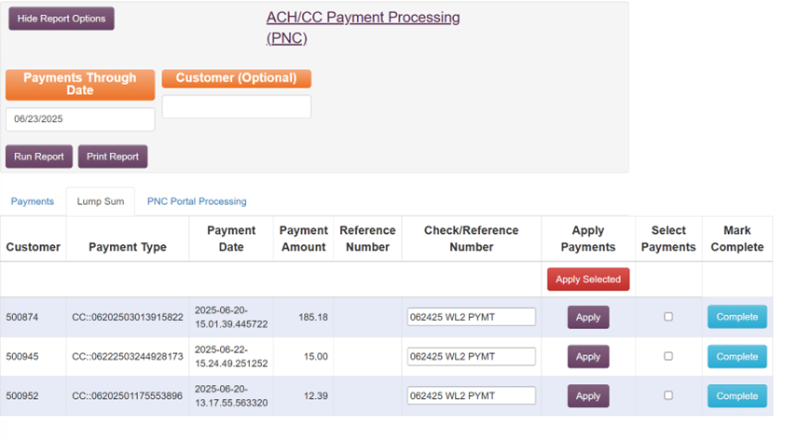

- Match above Weblink ACH/CC Payments to Pivot Table Excel sheet cleared payments
  - Use Control + F to locate the customer number.
  - Confirm that the Payment Amount matches the Pivot Table amount that PNC shows cleared K&M’s account.

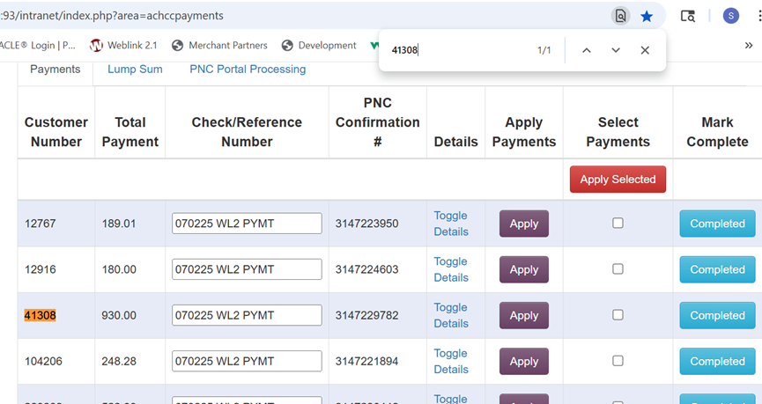

- Select and Apply Payments
  - Check the Select Payments box for each matching payment.
  - Repeat until all entries from the spreadsheet are selected.
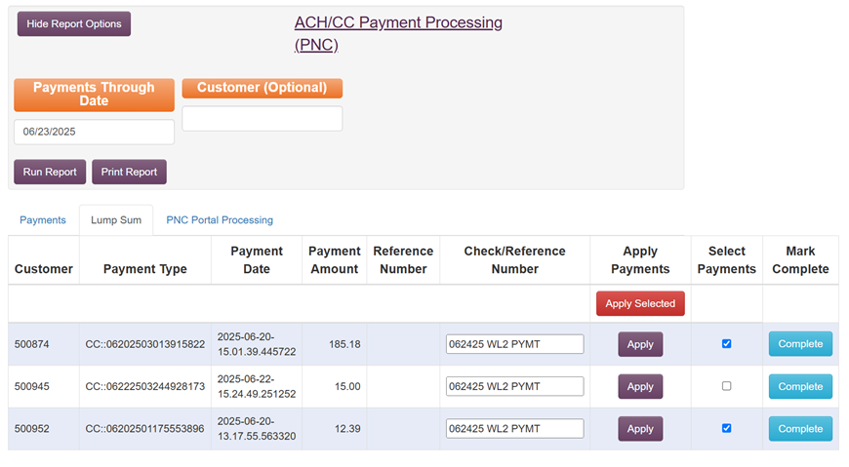
  - Click Apply Selected.
  - Complete this process for both the Lump Sum side and the Payments side.
  - Research and apply lump sum payments in MaddenCo, as they will come through as Out of Balance until applied.

- Record Credit Card Fee Income in MaddenCo
  - Navigate through the following menu path:
    - 1 – Tire Dealer System
    - 1 – Accounts Receivable Menu
    - 3 – Cash Receipts
  - Enter 001.
  - Press F7 to add a miscellaneous G/L cash receipt
  - Enter Check No. in the format: Process Date PNC Fees (e.g., 092225 PNC Fees).
  - Enter Check Amount, which is total PNC CC fees from remittance
  - Confirm Discount Amount is 0.
  - Enter G/L Account. 5460-1-1

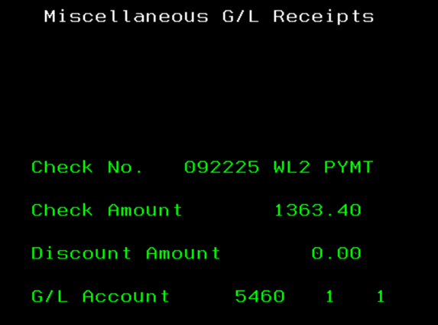

  - Press Enter.

- Validate Daily Totals
  - Ensure your daily total matches the posted amounts.
  - Refer to the Balance Daily Deposit SOP for verification steps.

Morning Reports
Purpose: The purpose of this SOP is to outline the standard daily process for pulling, saving, and distributing A/R morning reports from MaddenCo.
- In MaddenCo – Click ESC to open the operations window
- Then select “Work Spooled File Update”. (You may have to page down).

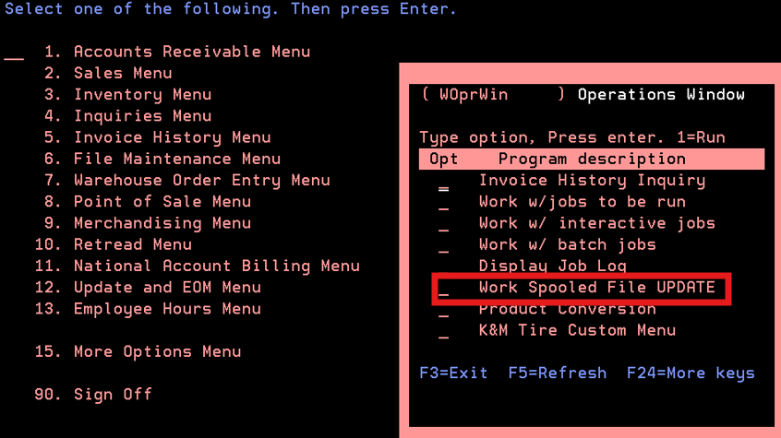

- Put a 1 on the line and Enter
- Put a 4 in front of the following group of reports to delete them, then Enter twice.

PTAVGCST | NEW AVERAGE COST LIST
RTITRCPU | INVOICE AUDIT LIST

  - Note – if the morning reports have been pulled for the day, these reports will no longer show as they had already been deleted.
- The process to run morning reports is different Monday’s or on the day after a Holiday (Example Friday after Thanksgiving).

- When doing morning reports for Tuesday – Friday, skip steps A - C below and start at step D.
- Hit F11 to view the report dates.

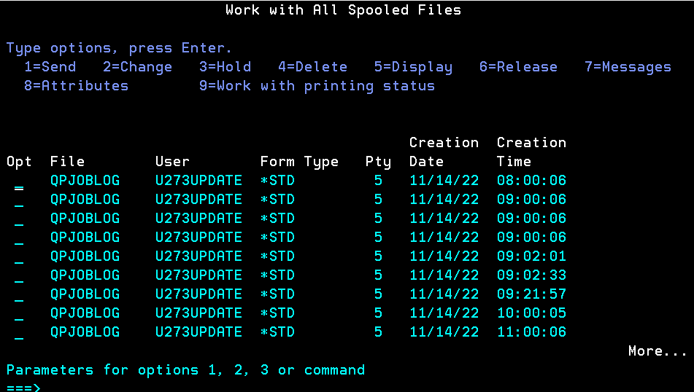

- Look for reports dated Saturday, Sunday and Monday
- Put a 2 in front of all Saturday/Sunday/Monday reports to move to the Access Client Solutions.
  - On the bottom-line type: outq (P273K0Z1) – press enter twice. (No space after outq)

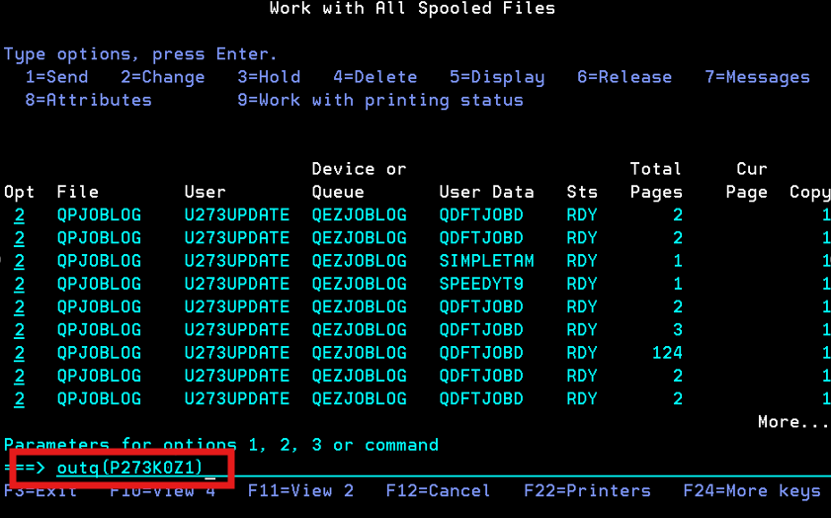

- Open Access Client Solutions on your desktop.

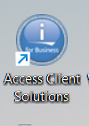

- Select Printer Output

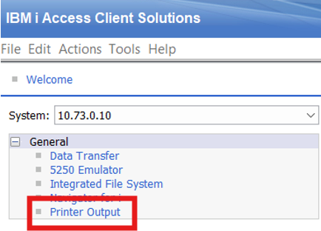

- Open F:\Accounts Receivable\Shared\MaddenCo Reports\Year\Morning Reports.
- Select month and create a new folder for the day you are working on.
- Save the reports below into the newly created folder by dragging them from Client Access to the empty folder.

TARUPBAL | A/R BALANCE REGISTER – Administration Group
TUPSLS | A/R SALES UPDATE – Administration Group
SYERRP | ERROR LOG LIST – Administration Group
- Email the reports above to the Administration Group – admin@kmtire.com
- Open F:\Accounts Receivable\Shared\MaddenCo Reports
  - Select year
  - Select month
- Highlight all reports for user U273UPDATE (This includes the reports you emailed to Admin).
  - Right Click and Download Only
- Drag all downloaded files into the Shared Drive Open file.

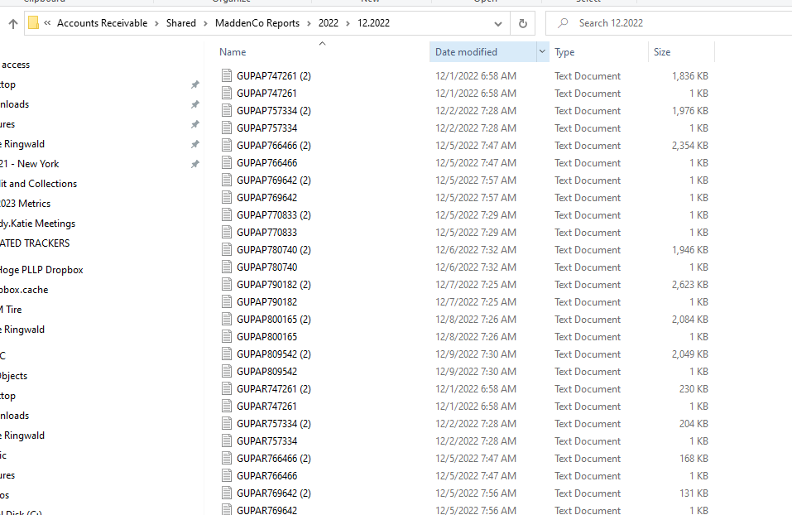

- Once reports have been moved, emailed and/or copied to the folder, they can be deleted from the Access Client Solutions.
  - Do this by clicking delete in the bottom left corner.
  - Then right click the highlighted lines and hit delete.

End of Day Reporting
To ensure accurate end-of-day reporting by verifying and properly saving both Cash Receipts and A/R Adjustments reports from MaddenCo and the Intranet. Saving these reports on the F: drive is also important because they are only accessible in MaddenCo for up to 30 days.
- Pre-Reporting Check
  - Before running end-of-day reports, verify all items in Cash Receipts and A/R Adjustments are in "Ready" status in MaddenCo.
  - To review:
    - Go to: 1 – Tire Dealer System
    - Select: 1 – Accounts Receivable
    - Choose: 3 – Cash Receipts or 4 – A/R Adjustments
    - Enter: Store Number 001

- Running the Cash Receipts Report
  - Go to: 1 – Tire Dealer System
  - Select: 1 – Accounts Receivable Menu
  - Choose: 10 – AR Report Menu
  - Click: 12 – Cash Deposit Slip Report
  - Press Enter through Store Number
  - Press Enter through Report Date
  - At Place report on hold, enter Y
  - Press Enter through Email prompt
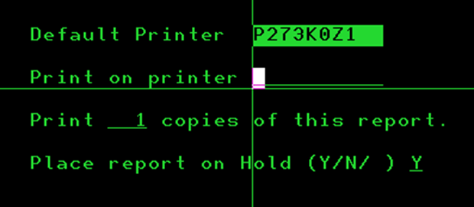
- Retrieving and Saving the Report:
  - Open Access Client Solutions on Desktop
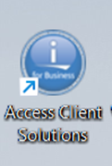
  - Click on Printer Output
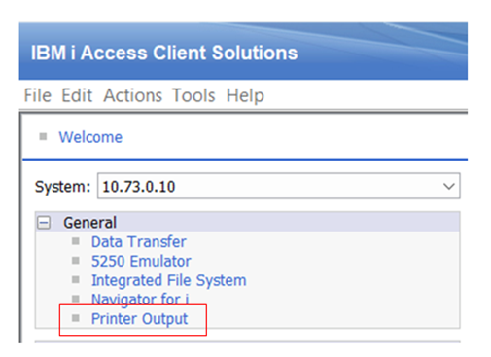

  - Locate your name and the Cash Deposit Report
  - Drag the file to your Desktop
  - Open a blank Excel document
  - Drag the report file into the Excel document
  - Save the file as an Excel file to:
F:\Accounts Receivable\Shared\End of Day Reports\Cash Deposit Slip Report\Year\Month\Today’s Date
- Running the A/R Adjustments Report:
  - Go to the Intranet
  - Navigate to: Accounts Receivable - Adjustment Report
  - Enter both Start Date and End Date as Today’s Date
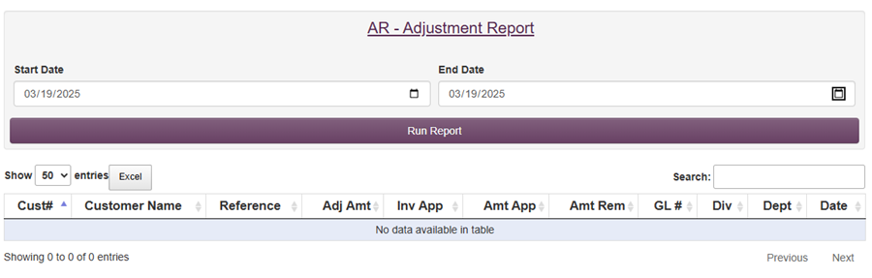
  - Click Run Report
  - Click the Excel button
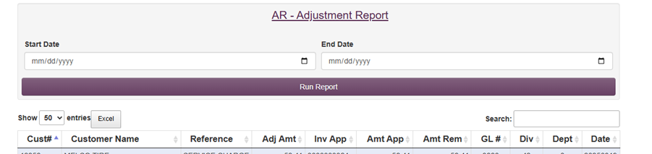

- Saving the A/R Adjustments Report:
  - The file will be downloaded to the top right corner of your screen
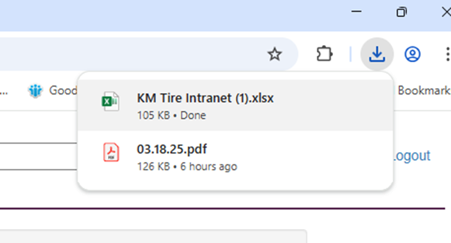
  - Click to open the file
  - Click Enable Editing at the top of the screen
  - Save the file as an Excel file to:
  - F:\Accounts Receivable\Shared\Adjustment Report\Year\Month\Today’s Date

Customer Inquiry

Allowable Adjustments
Purpose: This SOP will show you how to perform allowable adjustments from the Credit and Collections Dashboard and within MaddenCo if the Dashboard is not accessible. Allowable adjustments include invoice variances up to $10 and Service Charge adjustments within the 3-day grace period.
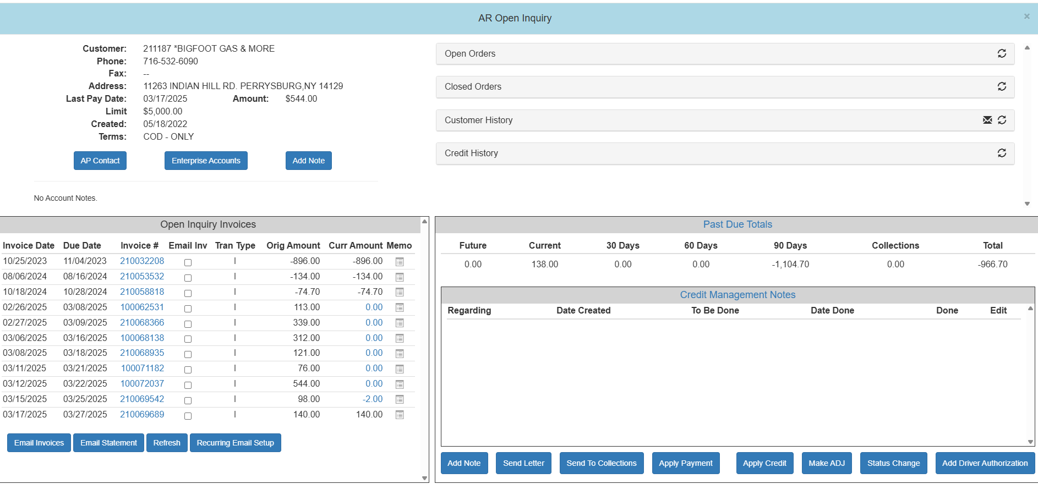
- Open CC Dashboard, Enter Customer Number

- Click on “Make ADJ” and a pop-up will appear.
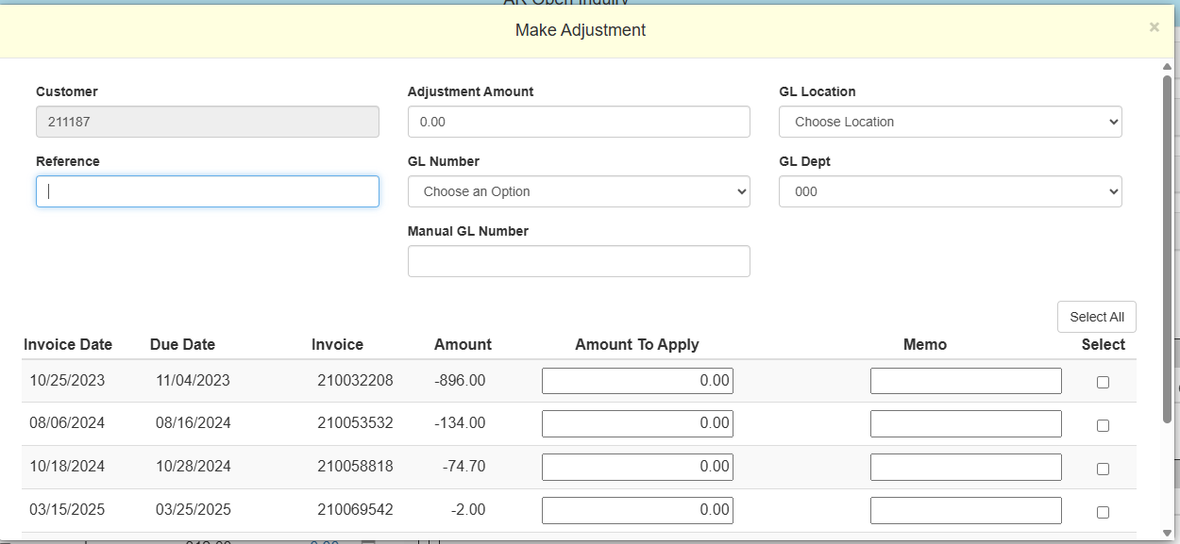

  - Reference = Employee’s Initials and Reason (EX: SR Variance, SR Waive SC)
    - Variance (invoices with a balance due over/under the absolute value of $10.00)
    - Service Charges under the 3-day grace period (see Service Charge Waiver procedure)
    - All other Adjustments need to be made by other departments.
  - Adjustment Amount = Amount being adjusted off.
  - GL Number = Account where the adjustment will go (This is a drop down to click the appropriate account.)
    - Variance – 03950
    - Service Charge - 03880
  - GL Location = Warehouse Location based on the customer number. (Ex. A location 1 customer should go to 1-Delphos)
  - GL Dept = “000”
  - Under Select, click the box attached to the invoice you are adjusting.
  - Make sure the “Balance to apply” at the bottom of the screen is $0.00
  - Click “Create Adjustments for selected invoices”
  - Click “Refresh” to validate the Adjustment went through.

- If CC Dashboard is unavailable
  - Open Maddenco
    - 1 – Maddenco Tire Dealer System
    - 1 – Tire Dealer System
    - 1- Accounts Receivable Menu
    - 4 – A/R Adjustments
  - Enter store number = “001”
  - F6 to add an adjustment
  - Enter the customer’s number
  - Enter reference number (See Step 2a. above)
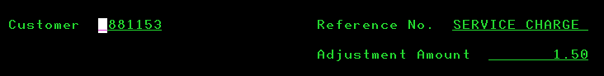
  - Enter the amount of the adjustment (this is a credit so there will be a “-“ behind the amount)

  - Hit Enter
  - Type a ‘1’ on the line next to the appropriate invoice
  - Hit Enter
  - Enter the adjustment amount and the corresponding GL #. (See Step 2c. above for the types.)

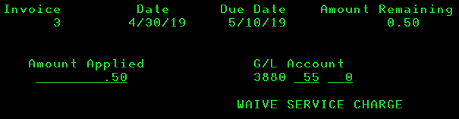

  - Enter - at the bottom of the screen the amount remaining to apply should be $0.00

  - F3 to end adjustment and exit.

Customer Account Balance Inquiry
Customers will call in to check their balance or verify a payment was received for an invoice.
This will show a list of invoices that have been posted to the customer’s account and allows you to confirm if a payment was received for an individual invoice. This view will list all invoices prior to last statement date. The invoice will not show if it was paid in the previous month.

- To determine payment status of an invoice

- Open MaddenCo

  - 1 – MaddenCo Tire Dealer System
  - 1 – Tire Dealer System
  - 1 – Accounts Receivable Menu
  - 8 – Customer Inquiries Menu
  - 1 – Customer Balance Inquiry

- “Enter the Store Number to be Used” = ‘000’ for all stores

- Customer Balance Inquiry

  - Type Customer name or F9 to Enter customer number
  - Enter ‘6’ in the field next to the appropriate customer number to open AR
  - Search for the invoice that you are inquiring about

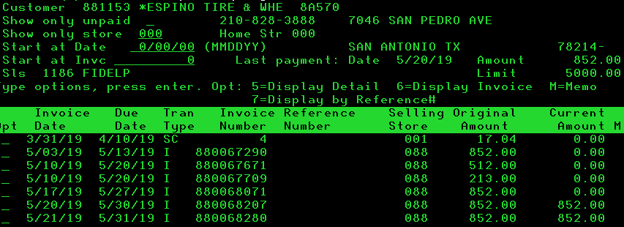

- A/R Open Inquiry

  - “Start at Date” = MMDDYY in question
  - “Current Amount” = 0 – the invoice has been paid, or the credit has been used.
  - “Current Amount” = a negative number – the credit has not been used.
  - F10 to view all invoices on account older than 30 days

- Customer Aging Inquiry

  - Type Customer name or F9 to Enter account number
  - Enter ‘7’ in the field next to the appropriate account number to open Aging balance.
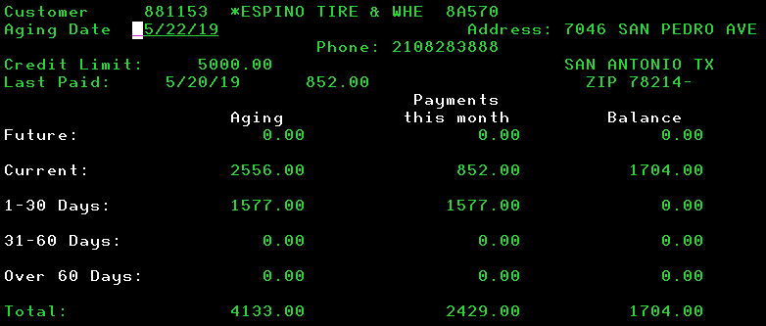

- To view customer payment with a check number used for the payment follow steps 2.a. – d. above.
  - 4 – Inquiry by Customer Reference#
  - Enter ‘000’ for all stores.
  - Enter customer number and check number.

Discrepancies
This process is followed to identify and resolve open balances on COD deliveries.
- Go to payment notes on the intranet, pick the location you’re working on, all routes. Start date should be the first day of the previous month and end date should be 3 business days prior to today. Show “NOT RECEIVED” and click “ALL” under show discrepancies.

  - For example, if today is December 23, 2021, and reviewing Toledo:

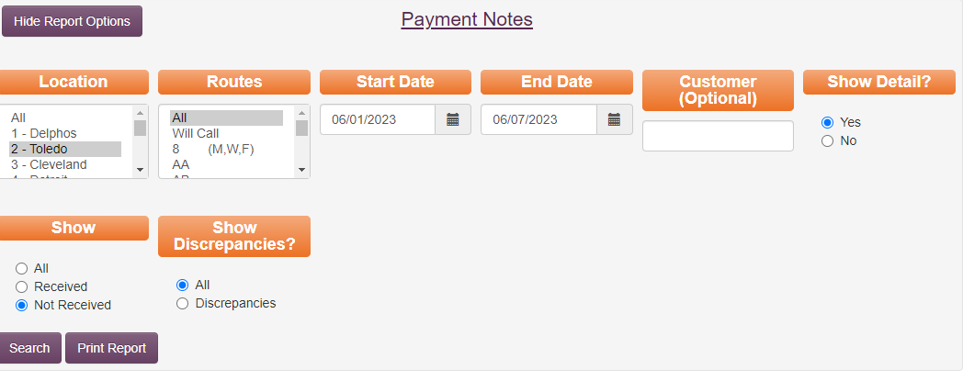

- Click search and every payment that is unchecked will appear.



- Sort this list by payment method, then by date,
  - Cash- should be at the top.
    - After applying offsets, if there are any that have no credits for rejected/short tires- Hit discrepancy and specify that a credit may need issued.
    - For the rest of the unchecked cash (with amounts). If it should have been applied already, check the customer balance screen to make sure it hasn’t been applied.


    - Sometimes customers will round up, leaving a small credit. In this case, check off the payment note and move the small amount to variance.
    - If no cash has been applied, make sure that the invoice is signed and doesn’t day rejected/short before hitting discrepancy.
Note: “Cash not yet received, please send for processing.”
  - Checks- According to your end date, the location should have had at least 2 days to scan their checks into the chase app. Before clicking the discrepancy button- Review the following to ensure check aren’t getting deposited twice.

    - Mobile deposit exceptions- was the check scanned but didn’t match payment notes or the invoices delivered.



    - Review cash receipt if the check was received in the current month. Check to ensure the check wasn’t deposited. If the check has been deposited Review to see why it is showing up as not received. In Madden Co -1. Tire Dealer System,1. Accounts receivable, 3. Cash Receipts, Store number 1, you can enter the customer number and put an “N” on “Exclude Processed Receipts”. This will bring up all payment processed for that customer.

    - Look up the check number if the check was received in the prior month -Look up the check number on the customer account number or look up the check number to see if it has been applied to an incorrect account. 1. Tire Dealer system ,1. Accounts Receivable, 8. Customer Inquiries, 5. Inquiry by reference #.



    - If the check cannot be found in the previous 3 spots, hit discrepancy to have the warehouse re-scan it. Add note: check not in mobile deposit, please rescan.
      - If the warehouse has already sent to corporate the checks for the month you are reviewing, the original check must be found and applied to the account manually.

  - Credit Card/Credit Department/Prepaid

    - Credit Card- These are payments that are made through Merchant Partners. If these payments are checked by phone, it could take 3-5 days to process.
    - Credit Department- These are usually driver authorizations where credit should be applied.
    - Prepaid- These are usually employee purchases. Verify that the payroll deduction is being taken out by viewing the employee account and then they can be marked off.

- Every location should be reviewed weekly. Discrepancies that are “hit” should be followed up every 2-3 business days until resolved. If you do your discrepancies on Monday, you should do them again on Wednesday and then again on Friday.

Statements at Customer Request
Allows you to print an updated statement mid-month for the customer to view “All Activity” up to the day before transactions.

Customer request a statement from “Previous Month(s)”:
- Obtain customer’s account number and the month for which a statement is needed.

- Log in to the “Intranet”

- Click on AR-statements

- Fill in the customer number and select the month and year for the statement you need.

- Click on Run Report.

- E-mail or mail as per customer’s request.

Customer would prefer to see “All Activity” up to the day before:
Printing a new statement in MaddenCo during the middle of the month will show all recent account activity rather than stopping at the previous month’s end.
- Open MaddenCo
  - 1 – MaddenCo Tire Dealer System
  - 1 – Tire Dealer System
  - 1 – Accounts Receivable Menu
  - 10 – A/R Report Menu
  - 6 – Statements – End of Month
  - “Enter for all stores.
  - Enter “Report Date” to the 1st of the month (ex. 09/01/2016)
  - Enter “10” for Customer Number
  - Enter
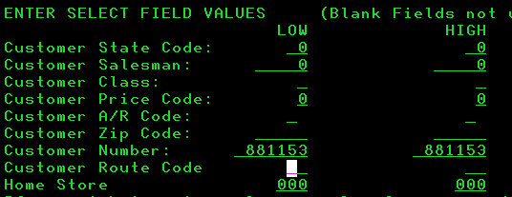
  - Enter the “Customer Number” in the “Low” and “High” fields.

  - Enter
  - “Enterprise Customer” = ‘N’ to only print the statement of the customer Entered; ‘Y’ to print branch information.
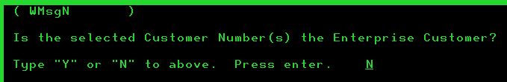

  - Enter through the next two screens.
  - Change the Print on Printer to PKONICA3
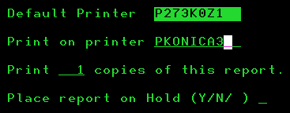

  - Enter

- E-mail or mail as per customer’s request.

Payment History at Customer Request
Purpose: To outline the process for providing customers with their payment history for a specified timeframe upon request.
- Access the Payment History Tool
  - On the K&M Intranet, navigate to:
    - Accounts Receivable
    - Payment History
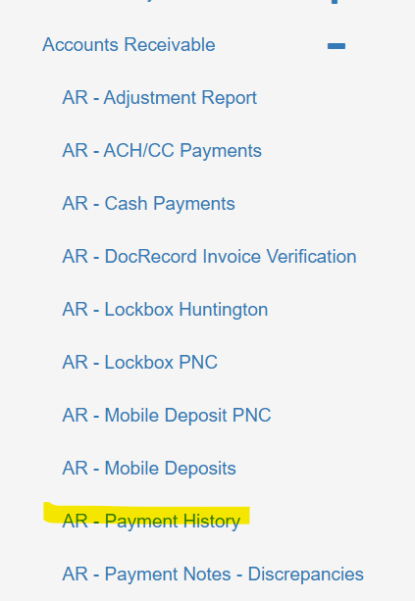
  - Input the customer number and select the requested date range.
    - Ensure Show Only Open Payment Invoices remains unchecked.
    - Click Run Report.
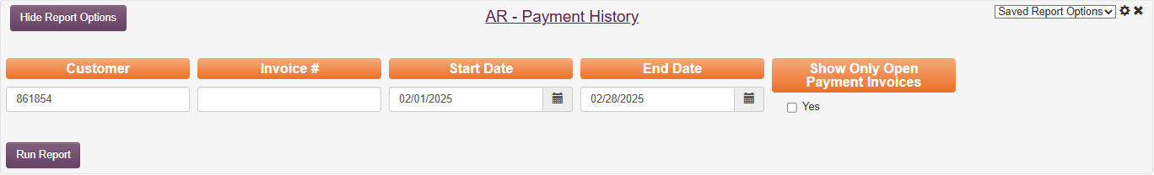

- Export Invoice/Payment Data and Open in Excel
  - Click Excel to export the report.

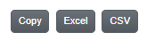

  - Open the file in Excel.

- Filter the Data as necessary
  - In Excel, select Data in the header menu.
  - Click Filter.
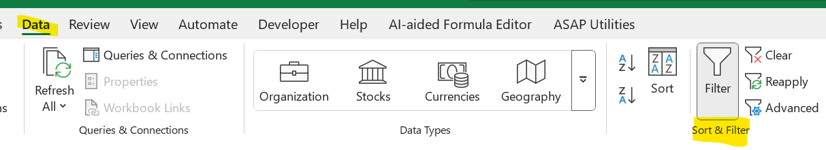
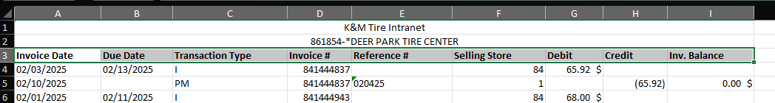

  - Go to Transaction Type (Column C):
    - Select the filter.
    - Uncheck all except "PM".
    - Click OK.
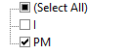

  - Go to Reference # (Column E):
    - Select the filter.
    - If you’re only searching payments and not applied credits,
      - Uncheck all entries labeled "APCR". (applied credit)
      - Click OK.
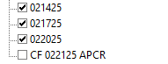

- Calculate Total Payments
  - If looking for the total amount of payments made
    - Highlight all amounts under the Credit column (Column H).
    - View the total (Sum) in the bottom right corner of the Excel window.
  - If analyzing individual payments and how they were applied
    - Copy filtered payment (PM) data from above into a new worksheet
      - Make sure applied credits are included with payment data
    - Use DATA / SUBTOTAL feature and Subtotal by Reference to get individual payment totals with the grouping of invoices where applied.

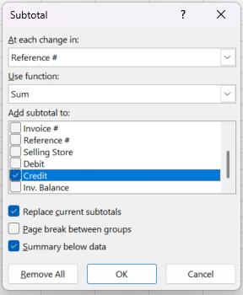

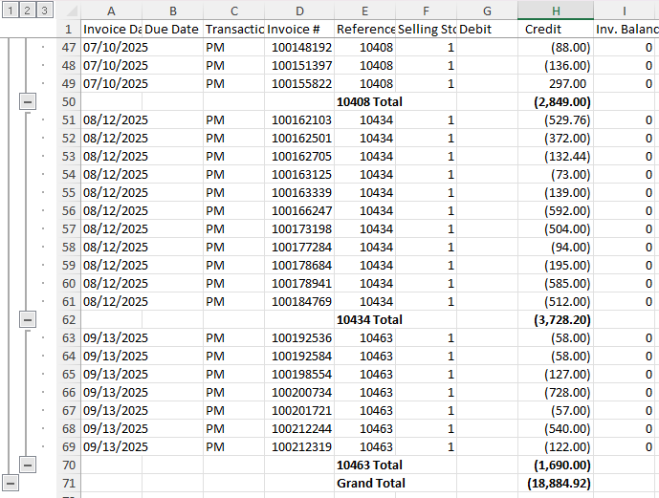

- Provide requested Information to the Customer
  - Share the total payment amount and/or detailed report via the customer’s preferred method.
- Inquire if payment history matches customer’s records
  - This step is critical, as unidentified and unresolved payment GAPs make it difficult for K&M to collect on tires we delivered.
    - If there is a GAP between our records and our customers, identify and resolve, or escalate to Team Lead and AR manager to assist with identifying and resolving.

Order Entry Inquiry
Allows you to view same day open invoices or other items that have not posted to Customer Account Balance Inquiry. Items will show here if they have not shipped or if the tires are invoiced the same day as delivery.

View same day open invoices or other items not yet invoiced, such as
  - Estimate
  - Not Shipped
  - Credit Authorization
  - Automated
  - Shipped
  - Picking
  - Void
  - Invoiced (but not updated)

- Log in to MaddenCo.
  - 1 – MaddenCo Tire Dealer System
  - 1 – Tire Dealer System
  - 7 – Warehouse Order Entry Menu
  - 1 – Order Entry
  - “Enter the Store Number to be Used” = location number shipping the tires (normally the first digits of the invoice number
- Example: invoice number 860232919 would be found in location 86
- Example: invoice number 480005701 would be found in location 48
  - Enter
  - Enter to view all open orders for the location.
1. Or, search by customer number.
2. Or, search by order (invoice) number.

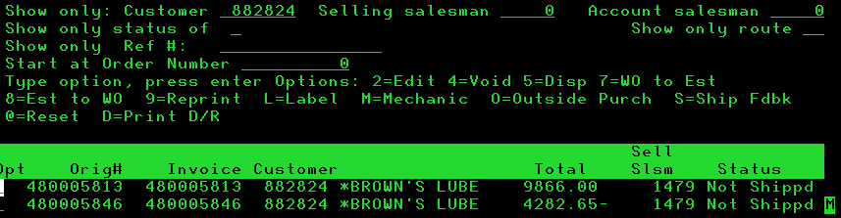

  - Type ‘5’ in the field next to the appropriate order to view.

  - Check the order status in the far-right column. (F8 to toggle through status detail views)

Service Charge Waivers
Payment is received after the statement is processed but is posted to their account within three days of the new month.

General rules applicable to service charge waivers.

- All accounts have an unstated grace period of the first three days of the next month.
- Example: The merchandise on an invoice due February 10th is paid in full on March 2nd = service charge with a due date of March 10th. This can be fully waived and adjusted off marked as “grace period”

- Customers sometimes pay everything on their account except for service charges from the prior month.
- If the payment brings the account current, charges can be waived as follows:
- Credit and Collection Specialist may waive up to $50.00.
- Credit Manager may waive over $50.00.

- All waivers are handled as adjustments.
  - Follow Adjustments Procedure
  - Be sure to use reference number “SVC CHG” or “grace period”
  - The General Ledger account to which the adjustment is written will always be 3880-XX (XX = location number).

DocRecord Review Procedure
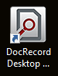
The signature on an invoice is not captured electronically so a hard copy is signed and manually scanned. Some of the items that are scanned have poor image quality and require the invoice number, customer number or date to be manually added before an electronic version can be saved.
- Open the “DocRecord Desktop Client Icon on your desktop.

- Click “OK” on the DocRecord 4 pop up.
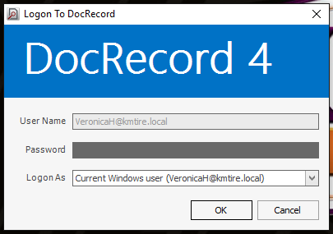
- When it opens, on the left side of the screen double click on the “Awaiting Commit” folder.

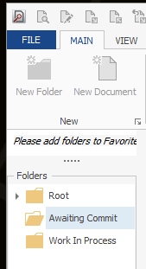

- If there are documents that need reviewed it will look like the image below.

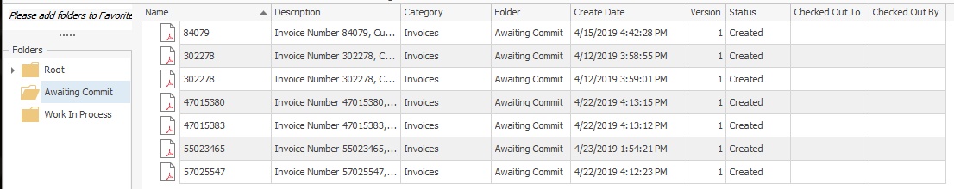

- Double click on a document to get started.

- The pop up where you review the document will look like the image below.
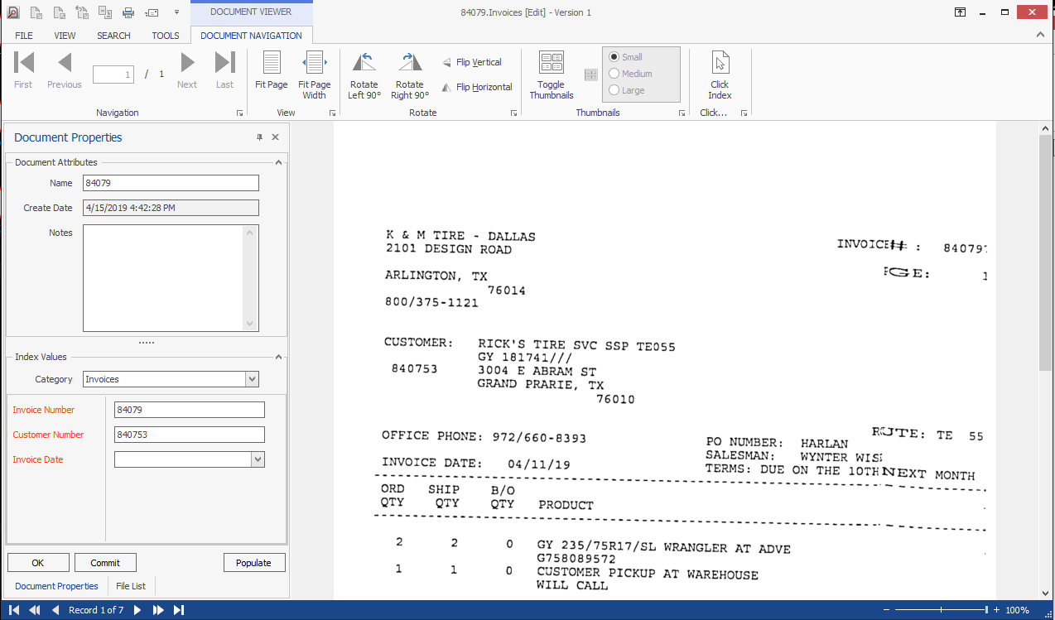

- In this screen you will make sure the following information is correctly filled out or research it with MaddenCo in order to fill in the information.
  - Name = Invoice #
  - Invoice Number = Invoice #
  - Customer Number = Customer #
  - Invoice Date= Date on the invoice

- Next, click on the “Populate” button. (When all fields are filled out correctly the invoice date will generate).
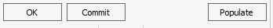
  - An invoice date will not generate if it is dated the same date you are reviewing or if it is an estimate. These are the only instances where you should manually Enter the Invoice Date

- When the Invoice Date generates you may now click “Commit” to submit the document and clear it out of DocRecords.

Statement Day Procedure
Mail out statements on the first business day of the month to customers allowing them to see what invoices are open and need paid.

- Customer account (charge customers) statements are generated through end of month procedures completed by the Controller on the 1st day of each month.

- The Controller will advise the Accounts Receivable Supervisor and Level 3 when it is clear to release the statements to the printer (PKONICA3).

- Accounts Receivable Supervisor and/or Level 3 will release the statements to the printer (PKONICA3)

  - Statements print by location
  - alphabetical order
  - one-page statements print first
  - multiple page statements print second

- Accounts Receivable Supervisor will sort and fold the statements

  - The single page statements run through the folding machine and give to A/R clerks to stuff into envelopes.
  - The multi-page statements need to be sorted
      - Pull out the statements that 7 pages or more because these need to go in a large envelope for mailing.
      - Statements that are less than 7 pages are run through the folding machine and given to the A/R clerks to stuff into the envelopes

- All A/R personnel will work together and put the statements into envelopes.

- Place postage on each envelope and have them ready in time to make the afternoon mail run.

Refund/Check Request Procedure
For a check request
K&M does not issue refunds via check and/ or credit card, especially if the customer is current and actively buying – special circumstances could apply upon approval. Refunds are typically not approved for adjustment/marketing or credits issued by National Accounts. To have the requested reviewed for approval, do the following:

            - Send an email to the AR & Credit Manager- Include the customer’s name, account number, the amount of the refund being requested and what the credit is for (i.e. returns, adjustments, etc.)
            - Notate Madden Co in credit management notes that a check request has been sent out for approval. Also notate the invoice(s)

Upon approval fill out the check request form-

            - This form can be found at F:/credit&collections/shared/credit/forms/checkrequest

            - Save the Check Request to F:/Accounts Receivable/Check Request. Use the format “CKRQT CUST XXXXX DATE.”
            - Forward approval email to AR Team Lead and Invoice@kmtire.com

REFUNDS TO CREDIT CARDS
K&M pays fees on all transactions, including credits. To help minimize fees, not every customer needs their credit card refunded - the overage can be utilized on the next delivery.

- Email AR & CC Manager with customer name, account number and amount of requested refund.
  - If a credit/debit card refund is approved, the refund can be done only by an AR/C&C Manager, Credit Analysts -level 3 C&C team leader and Account Specialist Level 3.

IF AN ISSUE IS FOUND SAME DAY, A CC TRANSACTION CAN BE VOIDED! THIS DOESN’T CHARGE A FEE TO K&M TIRE AND MERCHANT PARTNERS ACTS LIKE THE TRANSACTION NEVER HAPPENED. PLEASE DO THIS IF AT ALL POSSIBLE.

How to Tell if a Customer Account is Inactive
Purpose: To outline the process for checking to see if a customer account is inactive. In MaddenCo, customer account status can be active or inactive. Inactive customers can’t be accessed by anyone for anything. When a customer’s account status is inactive, they can’t be selected to issue credits, run reports, or viewed on the Credit & Collections Dashboard. If a report needs run or a credit needs issued to an inactive customer, the customer must first be made active.
Note: Only the Credit department can change status between Active/Inactive.
- To check status using the Intranet Customer Search
  - Open Intranet, CC - Customer Search
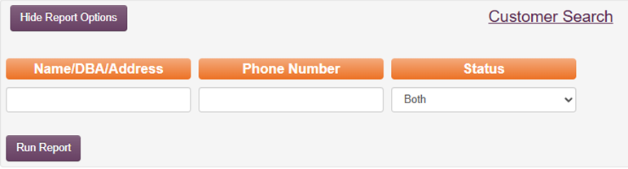
  - Change Status to “Both”
  - Enter the customer’s name or account number in the “Name/DBA/Address” field
  - Click “Run Report”
  - Toggle status from Both to “Inactive” or “Active”
    - Click “Run Report” again
    - Depending on your selection, only the “Inactive” or “Active” accounts will remain visible
- To check status using MaddenCo Customer Balance Inquiry:
  - Navigate to:
    - 1 – Tire Dealer System
    - 1 – Accounts Receivable Menu
    - 8 – Customer Inquiries Menu
    - 1 – Customer Balance Inquiry
    - Enter 000 for all stores → Press Enter
  - Search for the customer:
    - Type the customer name in the search field
    - Tab to the “Active/Inactive” field and enter B (Both) to display both active and inactive customers
    - Press Enter to display the customer list
    - The customer you entered should appear at the top of the list
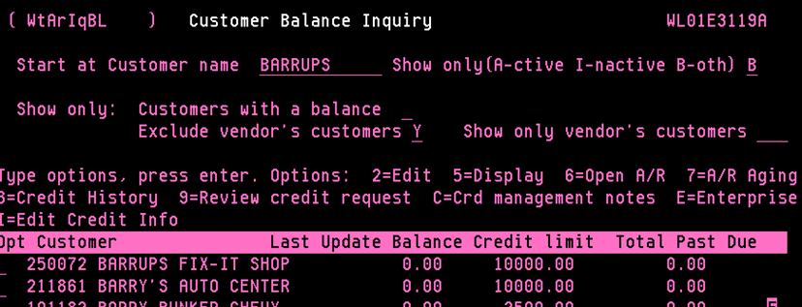
  - Check active status:
    - Tab back to the “Active/Inactive” field and change the value to A (Active)
    - Press Enter
    - If the customer no longer appears, the account is inactive
    - If the customer remains, the account is active

Issuing Refunds via Merchant Partners
This SOP outlines the process for issuing credit card and ACH refunds through Merchant Partners, detailing valid scenarios for refunds, such as voided invoices and duplicate payments. When a refund needs to be processed it would be a result of posting an over payment or open payment (due to a duplicate payment) to the customer’s account.
4.10.1 Types of Refunds:
Refunds through Merchant Partners can be processed in two primary ways:
- Credit Card (CC) Refunds – Refund payments made via credit card are credited back to the customer's card
- ACH Refunds – Refund payments made through the customer’s bank routing and account numbers. Funds are deposited from a 'prefunded' account with Merchant Partners.
  - ACH refunds should be used infrequently, as they require funds to be available in a prefunded account; Check Requests through AP would be preferred (see SOP for check issuing Check Requests)
  - Accounting & AR Manager can verify balance of prefunded account if an ACH refund is needed.
4.10.2 Valid Scenarios for Issuing Refunds:
Refunds are typically processed under the following circumstances:
- Voided Invoices – When an invoice is canceled, and the payment needs to be returned to the customer.
- Duplicate Credit Card Payment – A credit card payment was processed more than once in error.
- Other Duplicate Payment – A payment was made by check for a delivery, but a CC payment was also processed.
Note: Always refund the credit card if a double payment occurs, as it prevents charge disputes. If a check is issued in place of a credit card refund, the customer may dispute the charge, resulting in a potential payment loss for K&M.
4.10.3 Approval and Authorization:
All refunds processed through Merchant Partners require secure authorization through a PIN. The process is as follows:
- Merchant Partners Refund Approval
  - Merchant Partner refunds can only be approved by the AR Manager, Controller, or Director of Finance.
  - Above managers will need to enter a PIN to approve in section 4 below.
- Refund Request & Verification Process
  - Ask for Reason: Obtain a valid reason for the refund.
  - Check for Void & Rebill: Verify if the refund request is due to a voided invoice and if it has been rebilled.
    - If the invoice was rebilled, confirm that payment was collected for both the voided invoice and the rebilled invoice.
    - If no rebill occurred, approve the refund after confirming payment receipt.
  - Confirm Payment Receipt: If the invoice was voided, confirm whether payment was received.
    - Same-day Payments: Payments voided on the same day do not require a refund, as they can be canceled directly.
    - If the payment has already been processed and posted to the customer's account, proceed with the refund.
4.10.4 Steps to Issue a Refund:
- Gather Required Information
  - Collect all necessary transaction details, including customer number, invoice number, payment type, amount, and reason for the refund.
- Process the Refund via Merchant Partners & Present refund details to the AR Manager, Controller, or Director of Finance for review.
  - NOTE: In later steps, an authorized individual will enter their secure PIN to approve the refund transaction.
- From Merchant Partners Transaction Search:
  - Enter Customer number in Search by Custom Fields
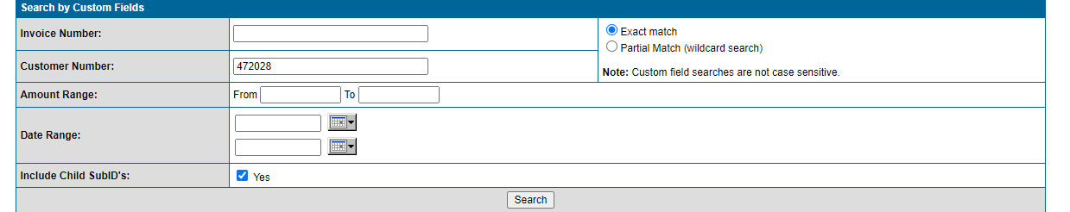
  - Click on the Order ID next to the amount of the payment being refunded, verifying the correct payment by checking the SubID field which contains our reference number, i.e. invoice # or “statement”
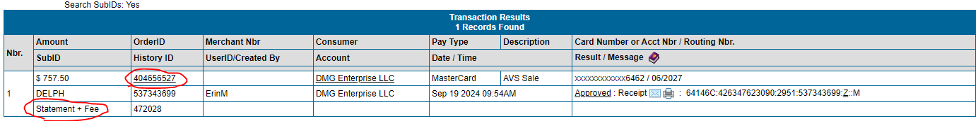
  - Select “Issue Refund for $
757.50
    - Enter correct amount for refund in box
  - Click Submit and OK to pop from www.onlinemerchantcenter.com
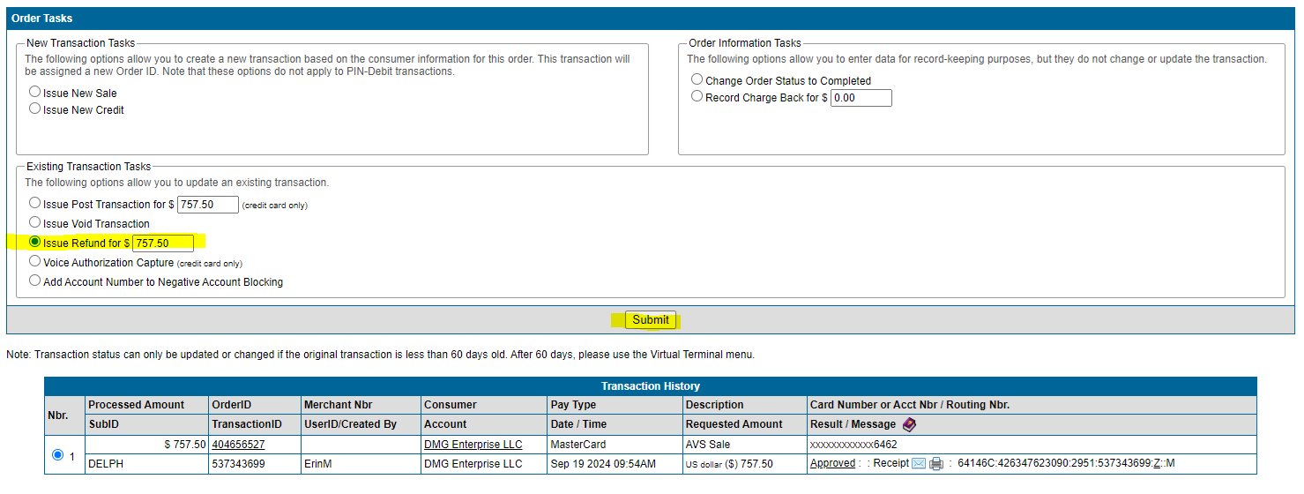
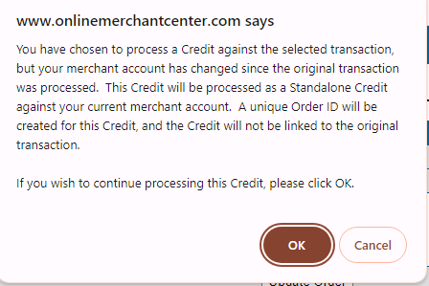
- AR Manager, Controller or Director of Finance will enter PIN:
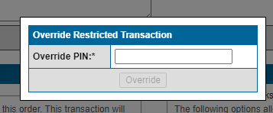

- Document the Refund
  - Record the refund in the Dashboard Notes with all relevant details: reason for refund, amount, method (CC or ACH), and authorization reference (copy below for reference)
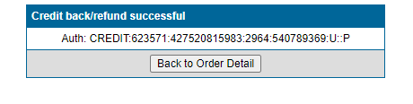
  - Provide the customer with a confirmation of the refund, including an expected processing time frame.
- Follow-Up and Reconciliation
  - Verify that the refund has been processed correctly and funds have been returned to the customer.
  - Reconcile the refunded transaction against the original payment and ensure the accounting records reflect the refund accurately.
    - The refunded transaction will be on the credit card report and will be posted to the customer’s account as part of the Credit Card Posting Procedure and can be found in the SOP.

General Ledger

Balance Individual Daily Deposit
The total payments posted in Cash Receipts under each User Id should always match the individuals running total. The individual running total is combined with the days running total showing in Cash Receipts for the day.

Balance Check Payments with MaddenCo
- Apply payment in Cash Receipts (see Cash Receipt Procedure)
- As you apply the individual check payments, arrange checks by size to facilitate ease of scanning.
  - Keep check bundle small (approximately 50 per bundle) by location

- Run a calculator tape for each bundle of checks.
  - Verify that the check total matches the total applied (under your user ID) in MaddenCo.
    - If there are multiple bundles, track a running total of “all” the bundle of checks.
    - If there is a variance between your running calculator tape and MaddenCo, rerun the calculator tape total and/or verify the amount Entered in MaddenCo for each check. You cannot move on without matching to ensure balancing.
  - Clip the calculator tape to the batch of checks.
  - Write your initials along with either “Mail” or “COD” on the calculator tape and the location #.
  - Follow the Electronic Deposit Procedure when scanning checks into Wells Fargo.
Balance Cash Payments with MaddenCo
1. Apply payment in Cash Receipts (see Cash Receipt Procedure)
2. Count all cash and coin(s).
- Verify that the cash total matches running total in MaddenCo (under your user ID).
- Reconcile if there is a difference.
- Complete a bank deposit slip. It can be found on the F-drive/AR/Shared/Forms if need to print more.
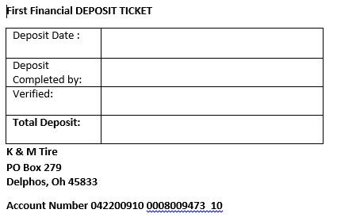

- Log your Cash Payment total on the Electronic Deposit Log
- Give your cash to the person to your right to double count and initial before placing in the daily bank deposit bag.

- Verify that your overall payments applied total matches what was applied in MaddenCo for your overall total for the day
  - Checks- All check bundles
  - Cash
  - Texas Cash- per location

- Confirm all your entries are in “Ready” status in MaddenCo to make sure everything processes correctly overnight like it should.

- Staple your remits together and write your name on a sticky note. This makes it easier to sort in case we need to find a specific remit later on.

- Attach it to your remits.

- Give your remits to the person responsible for Entering G/Ls. They are responsible for giving them all to the supervisor at the end of the day.

Electronic Deposit Procedure
Checks posted into MaddenCo through Cash Receipts are scanned individually to the bank each day. This balance should always match the checks that are listed in Cash Receipts.

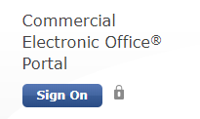
- Deposit preparation is completed on the computer designated for Wells Fargo Online Banking at www.wellsfargo.com using Internet Explorer.

- Select = Commercial
- Select – Commercial Electronic Office Portal Sign On
- Enter Sign On information (it is not case sensitive) Shown in the picture below.
  - Company ID = KMTIR299
  - User ID = LANDT299
  - Password = changes frequently- is posted near the computer,
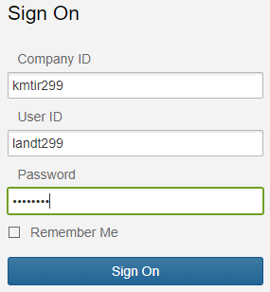

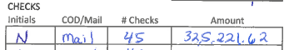
- Select – Sign On

LOC #
- Select Desktop Deposit

- Enter and track COD checks separate from mail checks

- Log your check bundle on the Electronic Deposit Log
  - Your initials
  - Log COD checks on the left side ‘COD’ section.
  - Amount of checks in the bundle
  - Calculator tape total
  - Log mail checks on the right side in the mail section in the same fashion.
- Add your calculator tape total to the running total on the calculator next to the computer.
- First Deposit scan to Wells Fargo for the day Click on “Create a Deposit” (Only if you are the first person to open the daily deposit)
- Add to an existing deposit * the max amount of checks that can be scanned under one Desktop Deposit is 1,000 checks. A new Desktop Deposit will need to be created to complete scanning the remainder of the daily checks Entered. *
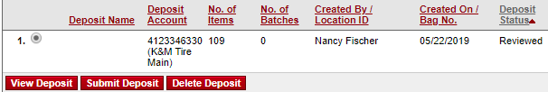
- Click on the circle under ‘which deposit you are adding to’ and click on View Deposit to add to an existing deposit
COD

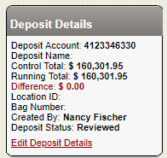
- Click “Edit Deposit Details” under Deposit Details to add your $ amount to the existing total.

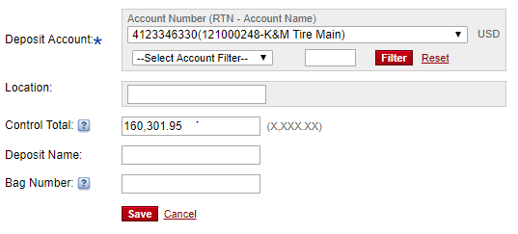
- Add your check batch total from the Calculator to the “Control Total” and “Save”
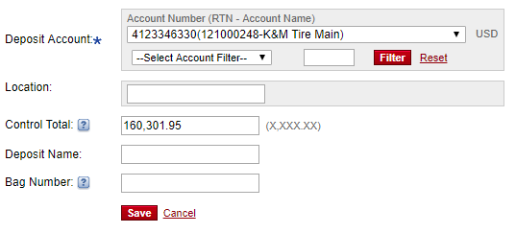



COD

- Align your check bundle so that they all line up on the right side of the checks. Feather them out for easier scanning.
- Place the checks on the check scanner and Click on “Scan More Items” this will turn on the check scanner and scan each check individually.
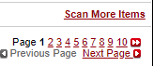

- After all your checks have been ran through the scanner make sure the total number of checks in your batch matches “items being scanned” for accuracy.

- “Review Now” and it will display the checks that it could not clearly scan. This could be due to image quality or duplicate check scans.
- Review the checks with your calculator tape and correct any errors.
    - If MICR was unreadable, you need to rescan the check
    - If the check is still unreadable, click on repair MICR and type the bank information in manually.
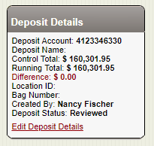
- Once checks are all scanned and reviewed – Make sure the “Difference Total” is always $0.00
This means everything in your bundle was scanned in correctly and you can move on to the next bundle.

End of the Day Electronic Deposit Reconciliation
- Once everyone in the department has scanned the checks entered into MaddenCo into Wells Fargo. Total up the checks listed on the Electronic Deposit sheet. Make sure the electronic log sheet matches with the total deposit details listed on the Wells Fargo website.
- If the dollar amount of all the entries listed on the Electronic Deposit sheet matches everyone’s totals in MaddenCo grand total the Wells Fargo deposit(s) can be submitted, for both COD and mail checks.
  - Click the Red “Submit Deposit” button (if more than one deposit, submit each one)
  - When complete – click “Complete Deposit”
If you do not match- reconcile each individual person’s totals until you find the variance and correct it. You will need to re-verify match cash receipts in Maddenco.

General Ledger Entry Procedure
All payments collected throughout the day in Cash Receipts are automatically posted to the same GL, but they require a separate GL classification. This will allow you to move and separate each classification to its correct GL at the end of the day.
- Calculate all the totals from the Electronic Deposit Log
  - Checks
  - Cash
  - Walmart
  - Amazon
  - Credit Cards
  - Merchant Partners
  - Mobile Deposit
- Match the calculated total with the total showing in MaddenCo under Cash Receipts.
  - If there is a variance, review the individual total from each daily deposit sheet and compare it to the individual totals with MaddenCo Cash Receipt to zoom in and find which A/R Clerk has the variance.
  - The A/R Clerk would then search for the variance and make the correction.

- Reconcile and confirm the total between MaddenCo Cash Receipts matches the total on Electronic Deposit Log
Manually Update the General Ledger
- Open MaddenCo
  - 1 – MaddenCo Tire Dealer System
  - 3 – General Ledger
  - 2 – Input & Update Menu
  - 1 – Work with outstanding JEs
  - F6 to create a new journal entry

- Journal Entry Input

a. F2 to assign the next record number
b. “Year/Period” = add three months to the current month, as the General Ledger is based on our fiscal year. See quick reference guide below.

Current month is: GL period is:
January 4
February 5
March 6
April 7
May 8
June 9
July 10
August 11
September 12
October 1
November 2
December 3
c. Reversing Year/Period 0000 / 00
d. “Description” = MM.DD.YY Cash Receipts

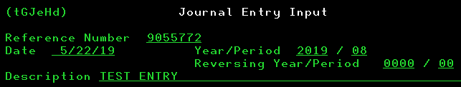

- Input JE line
  - First line would be a Credit to 1020-1 for the grand total of Cash Receipts
  - List each debit entry for every total on the verification sheet.
  - F3 to verify accuracy.
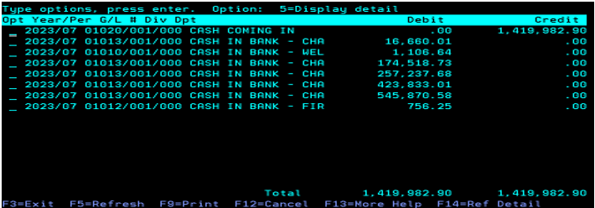

  - Take note of the reference number assigned and document on the Electronic Deposit
  - F3 to exit.

- Add the entries into the K&M Inc spreadsheet.
  - Cash is documented for each bank.
    - Z:\Accounting\Shared\Bank Ledgers\K&M Inc\First Financial\1012-1 Bank Ledger- 2023.xlsx

    - Z:\Accounting\Shared\Bank Ledgers\K&M Inc\JP Morgan Chase\AR\2023\1013-1 Bank Ledger- 2023.xlsx

    - Z:\Accounting\Shared\Bank Ledgers\K&M Inc\Wells Fargo\2023\1010-1 Bank Ledger- 2023.xlsx

  - Credit cards (Rbs Worldplay), Checks (Deposit), Merchant Partners, and Mobile Deposit is documented under the excel tab “JP Morgan Chase”
  - Do not document cash, Amazon, or Walmart on the spreadsheet as these are already logged into the spreadsheet by accounting.

General Ledger Entry Correction
The bank finds that a check is written for a different amount than what was posted to the customer’s account in Cash Receipts. This would require a correction to the GL entry and the customer’s account/invoice payment.

When an error is discovered in an entry to the General Ledger, determine the type of error and proceed as follows.
SAME DAY GL ENTRY CORRECTIONS
- Working from step 2.d. of General Ledger Entries:
a. The incorrect entry has not been updated:
1. Put a ‘4’ on the line next to the incorrect entry and enter to delete it. Then re-enter the correct entry.
2. If the entry does not balance, MaddenCo will not post it; put a ‘2’ on the line next to the ‘out of balance’ entry to edit / add to it.
NEXT DAY “DOLLAR AMOUNT” CORRECTIONS with a “NEGATIVE AMOUNT”
- Log the incorrect entry on the Electronic Deposit Log Sheet
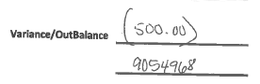

- Follow steps 1. – 2.e. of General Ledger Entries.
- Description = “(today’s date) DEPOSIT CORRECTION”
- Enter the correction amount first as a credit to GL Account 1010-1.

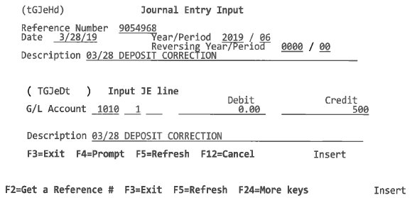

- Enter the correction amount as a debit to GL Account 1020-1.
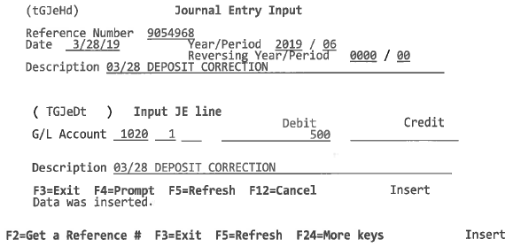

- When finished, hit F3 to review. The debit and credit amount should match. See below example.

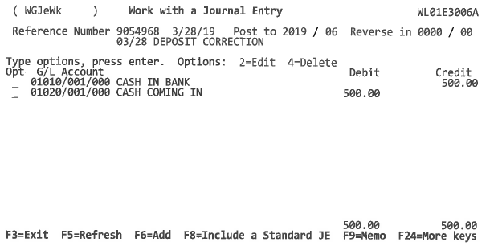

NEXT DAY “DOLLAR AMOUNT” CORRECTIONS with a “POSITIVE AMOUNT”
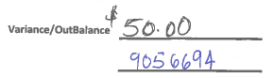
- Log the incorrect entry on the Electronic Deposit Log Sheet

- Follow steps 1. – 2.e. of General Ledger Entries.
- Description = “(today’s date) DEPOSIT CORRECTION”
- Enter the correction amount first as a debit to GL Account 1010-1.

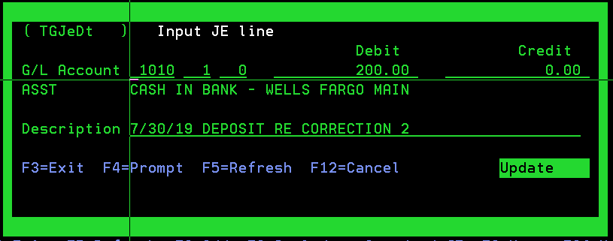

- Enter the correction amount as a credit to GL Account 1020-1.
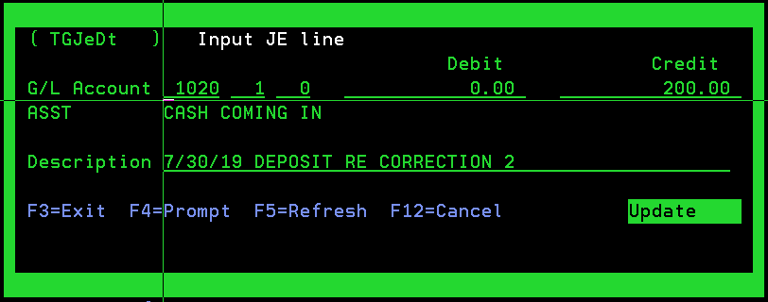

- When finished, hit F3 to review. The debit and credit should match. See below example.
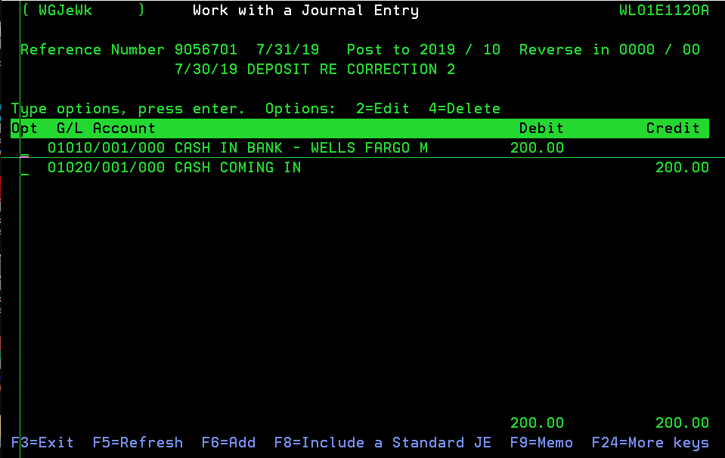

General Ledger Inquiry Procedure.
Allows you to view detail of each GL classification and confirm your balance matches.

- To view detail of daily activity in a General Ledger account.

- Open MaddenCo.
              - 1 – MaddenCo Tire Dealer System
              - 3 – General Ledger
              - 3 – Inquiry Menu
              - 1 – Balance Inquiry
              - “Enter the Store Number to be Used” = Enter for all stores

- G/L Balance Inquiry

- “G/L Account” = account and location (ex: 1020-1) to verify all the payments balanced and there was no discrepancy in the prior days Cash Receipts. Ending balance should always be $0.00 for account 1020-1.
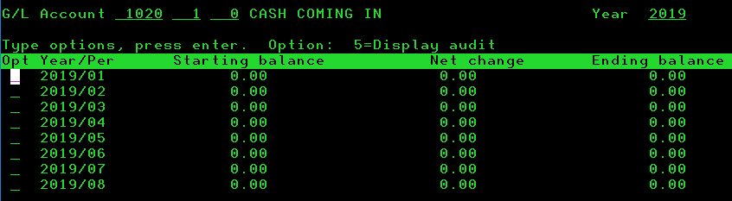

              - Type a ‘5’ to Display Audit next to the year/period to be viewed. (Ex 2012/07 for April 2012). This will provide details from what was entered with prior days General Ledger, and let you know if an entry was mistyped.

- Type a ‘6’ in the line next to the day’s activity to be viewed. The 1010/001/000 debit balance should match the 1020/001/000 credit balance.
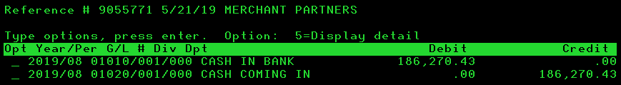

Miscellaneous

Billing Employees for Concur Personal Expenses
Purpose: To outline the process for billing personal expenses from Concur expense reports back the employee. The AR Manager completes this process monthly as notified by accountant.
- The accountant reconciling Concur will send AR manager an email with details of any personal expenses run on the company credit card that need rebilled.
  - Email will include a Concur screenshot with employee’s name, dollar amount of personal expense, date, place where card used, and any other information related to the expense
  - These emails will come throughout the month as expense reports are submitted, and any personal expenses are noted.
- Access MaddenCo and open the Counter Billing screen:
  - Go to:
    - 1- Tire Dealer System
    - 8- Point of Sale Menu
    - 4- Counter Billing
  - Enter location 1 → Press Enter
  - Press F6 to create a new invoice
  - Press F6 for next invoice number
  - Enter the customer number
    - To locate the number, type XX (Last Name) into the Customer Name search in MaddenCo or search screen on Credit and Collections Dashboard
    - If the account is not set up, email CreditApps@kmtire.com to request setup
- Enter sales and product information:
  - Input your salesman number in the Sell Salesman field → Press Enter
  - Enter Product Code: PASS → Press Enter
    - This code inserts 99 PASS THROUGH, which posts to 1550-1
  - Enter Quantity: 1
  - Enter the billing amount in the Price field
  - In the Description field, state the reason for bill (e.g., Chargeback for Concur) → Press Enter
- Close the invoice:
  - Press F3 twice
  - When prompted, Is Invoice to be Closed (Y/N) will default to Y → Press Enter
  - Obtain Credit Authorization approval before closing the invoice
  - Once approved in Credit Authorization → Press Enter to finalize
  - The invoice is now closed
- Email the Employee
  - AR manager emails the employee to make them aware the personal expense has been charged back to their account
    - Ask how they would like to repay it.
    - Copy accountant reconciling Concur on this email
    - Process is complete once payment has been received

Desktop Scanners

Desktop Scanner Cleaning SOP
Purpose: To ensure the proper maintenance and longevity of desktop check scanners by implementing a regular cleaning schedule and process across all warehouse locations. Regular cleaning of scanners promotes accurate data capture from MICR line of checks.

- Cleaning Frequency & Responsibility
  - To maintain a consistent schedule, each scanner will be cleaned at a minimum of once every three months.
  - The Warehouse Manager at each location is responsible for either doing or ensuring the Primary User is performing the quarterly cleaning.
  - The Accounts Receivable Team Lead is responsible for doing the quarterly cleaning at Corporate.
- Quarterly Cleaning Kit Distribution
  - At the beginning of each quarter (Jan/Apr/Jul/Oct), the Director of Finance will:
    - Order cleaning kits for each warehouse location.
    - Work with the Admin Team to distribute the kits to each warehouse.
      - Admin will affix mailing labels on 6x9 envelopes.
      - Two kits will be sent to each warehouse via USPS mail.
    - Send out notification email to Warehouse Managers communicating cleaning kits are being mailed out and include in email the cleaning process as described below.
  - Cleaning kits will be ordered directly from Vecmar.
  - If you order 10 kits or more, a bulk discount is available.
- Desktop Scanner Cleaning Process
- Log in to the PNC Remote Deposit portal as you normally would for processing deposits.
  - Initiate a new deposit and enter $1 as the deposit amount.
  - Insert the cleaning card into the scanner as if it were a check.
  - Scan the cleaning card 5–6 times to ensure thorough cleaning of the scanner’s internal components.
- Once scanning is complete, delete the $1 test transaction from the portal.
- You’re done! The scanner is now clean and ready for regular use.

For questions or replacement kits, contact the Director of Finance.

Desktop Scanner Replacement Process
Purpose: To outline the process for addressing malfunctioning desktop scanners to ensure prompt resolution and minimal downtime at warehouse locations.
Vendor Information
- Vendor: Vecmar
- Warranty: One-year replacement warranty on all units
Procedure
- Initial Troubleshooting
  - The Accounts Receivable team member will direct the warehouse employee to contact IT Help Desk to attempt basic troubleshooting (e.g., restart scanner, check cables, verify software).
  - Accounts Receivable team member should tell the warehouse employee to call them (AR) back if unresolved after working with IT Help Desk.
  - At that point, proceed to the next step.
- Contacting Vecmar
  - AR team member to initiate a three-way call with Vecmar’s service department (440-953-1119 x201), keeping the warehouse employee on the call.
  - This ensures our AR team maintains control over the support and replacement process.
  - Vecmar service department will assist with additional troubleshooting.
  - If unresolved, proceed to the next step.
- Warranty Verification
  - Confirm with Vecmar whether the scanner is still under the one-year replacement warranty.
- Next Steps Based on Warranty Status
  - If Covered by Warranty:
    - Coordinate directly with Vecmar to have the replacement unit shipped to the warehouse.
  - If Not Covered by Warranty:
    - Do not authorize a replacement purchase independently.
    - Contact the Director of Finance who will coordinate the deployment of a spare unit or replacement purchase.
- Spare Unit Deployment
  - If a scanner is urgently needed, the Director of Finance will coordinate shipping to the warehouse.
    - There is typically a minimum of three spare scanners available for immediate use to minimize operational disruption.
- While Scanner is Down: Temporary Check Handling Plan
  - If they have not already, the warehouse manager should immediately notify AR once the scanner is confirmed as non-functional.
  - The warehouse manager should secure all checks in a designated area (e.g., secure drawer or safe) with access limited to management or designated personnel.
- If Scanner Is Down More Than 3 Days: Escalated Action Plan
  - If the scanner is still non-functional after three business days, the warehouse manager must overnight the checks to the Corporate Office:
    - K&M Tire Inc
Attn: Accounts Receivable
965 Spencerville Road
Delphos, Ohio 45833
  - The shipment must include tracking, and the tracking information must be emailed to both the AR Manager and the Director of Finance immediately after the package is sent.
  - AR will process the checks upon arrival and notify the warehouse manager once completed.
  - d. This process should repeat every three business days until the scanner is back in service.
Note:
This contingency plan ensures minimal disruption to daily cash application and protects against misplaced or delayed deposits.

Appendix H: Revision History Tracking
The following table records information regarding changes made to the Operations Binder.
Table 1 - Revision History Tracking
Version Number | Date | Author/Owner | Description of Change
4.2.9 | 11/6/2020 | Joni Zerkel | Few updates on Texas cash deposits
 | 03/2/2023 | Jody Keller | 4.2.9 Removed Texas Cash Posting & updated with Cash Posting
4.3.8 | 4/20/23 | Kayla Perrine | 4.3.8 Added Check/Refund
 | 5/9/2023 | Angie Prichard | 4.2.2 Added 4.2.2 Mobile Deposits pp 14-20.
 | 7/5/2023 | Kayla Perrine | Added Discrepancies
 | 7/6/23 | Kayla Perrine | Added Discrepancies
 | 7/19/23 | Kayla Perrine | Updated 4.4.3 General Ledger Entries Procedure
 | 10/20/2023 | Kayla Perrine | Updated Posting Payments
 | 11/8/2023 | Kayla Perrine | Updated Posting Payments
 | 12/22/2023 | Kayla Perrine | Updated SOP
 | 12/3/24 | Kayla Perrine | Added 3.14 Petty Cash Reimbursement
 | 12/3/24 | Kayla Perrine | Added 3.13 Pending Payments #868686
 | 12/4/24 | Kayla Perrine | Added 4.10 Issuing Refunds via Merchant Partners
 | 12/6/24 | Kayla Perrine | Added 2.5 Phone Queue Status- Logging In and Out
 | 12/11-24 | Barb Suever | Added 6.4 Huntington Exceptions Tracking & placeholder for 6.1, 6.2, 6.3 to come
 | 5/15/2025 | Angie Prichard | Updated section 3.14 Petty Cash Reimbursement
 | 6/11/2025 | Angie Prichard | Updated Section 3.7 Processing Mail Payments
 | 6/19/2025 | Angie Prichard | Added Section 3.15 End of Day Reporting
 | 7/31/25 | Barb Suever | Replaced Section 3.2 Cash Posting Procedure
 | 8-4-25 | Barb Suever | Added Section 7 Desktop Scanners, 7.1, and 7.2
 | 8-4-25 | Barb Suever | Inserted 3.15 Morning Reports & moved End of Day Reporting to 3.16
 | 8-4-25 | Barb Suever | Replaced 3.8 How to Handle Driver Calls with NEW 3.8 Driver Authorizations
 | 8-6-25 | Barb Suever | Replaced 4.1 with new Allowable Adjustments. Removed old Adjustment Procedure.
 | 10-23-25 | Jody Keller | Removed Section 6.4 Huntington Exceptions Tracking
 | 10-24-25 | Jody Keller | Section 6 Change Title to Miscellaneous Add new to this section
 | 10/29/2025 | Shaina Johnson | Add section 4.5 Payment History at Customer Request
 | 11/12/25 | Angie Prichard | Added Section 3.9 Credit Card and Check by Phone Procedure
 | 11/12/25 | Angie Prichard | Added Section 3.14 Pulling the Remittance File for Weblink payments
 | 11/12/25 | Angie Prichard | Updated Weblink Payment Posting Procedure Now 3.16
 | 11/12/2025 | Angie Prichard | Added Section 4.11 How to Tell if a Customer Account is Inactive

